VERTECO SMARTJOB



FINAL REPORT: SYSTEM ANALYSIS, DESIGN AND IMPLEMENTATION DOCUMENTATION

Information Systems 3E
Work Integrated Learning
Module Code: INSY7315

Prepared for:
VERTECO

Prepared by:
Group 20 (TEAM VANTAGE)
Moegammad Alexander ST10453511 (Group Leader) Group 2
Caleb Forbes ST10438433 Group 1
Alexandro Ornelas ST10437348 Group 1
Erin Sarjoo ST10450571 Group 2
Keeran Perumal ST10367702 Group 3
Isaac Phiri ST10074970 Group 3

Submission date: 03 November 2026
Contents
1 Introduction 7
2 Final Report: Updates and Feedback Applied Since Task 1 and Task 2 8
2.1 Purpose of This Section 8
2.2 Response to Task 1 (Documentation and Prototype) Feedback 8
2.3 Response to Task 2 (Code and Implementation) Feedback 8
2.4 Development Progress Since Task 2 9
2.5 Final Submission Links 10
3 Functional Requirements 10
3.1 User Login and Access 10
3.2 Customer and Site Information 10
3.3 Creating and Assigning Jobs 11
3.4 Job-Card Templates and Checklists 11
3.5 Technician Mobile Job Card 11
3.6 Photographs and Evidence 12
3.7 Sign-Off and Job Submission 12
3.8 Job Status Tracking 12
3.9 Search and Historical Records 13
3.10 Dashboard and Reporting 13
3.11 Notifications 13
3.12 Offline Functionality 13
3.13 Audit Trail 14
3.14 AI Report Analysis 14
3.15 Working Alongside SafetyCulture 14
4 User Roles and User Stories 15
4.1 Manager 15
4.2 Field Technician 15
4.3 Customer or Site Representative 16
5 User Stories 16
5.1 Manager User Stories 16
5.2 Field Technician User Stories 17
6 UX Journey Map 19
6.1 Manager UX Journey 19
6.2 Field Technician UX Journey 20
6.3 Prototype Screens: Manager Web Application 24
6.4 Prototype Screens: Field Technician Mobile Application 32
7 Work Breakdown Structure 47
7.1 SmartJob Task 1 WBS 47
7.2 Team Member Responsibility Across the WBS 53
7.3 WBS Phase Grouping 53
8 Non-Functional Requirements 55
9 Performance 55
9.1 Availability 55
9.2 Offline Capability 55
9.2.1 Compatibility 56
9.2.2 Scalability 56
9.2.3 Usability 57
9.2.4 Security 58
9.3 Privacy and POPIA 58
9.4 Reliability and Data Integrity 59
9.5 Backup and Recovery 59
9.6 Maintainability 59
9.7 Cost Efficiency 60
9.8 Logging and Monitoring 60
9.9 Overall Non-Functional Requirement Summary 61
10 Domain Class Diagram 62
10.1 Core user role 62
10.2 Customer, Site and JobCard 63
10.3 Job Lifecycle 63
10.4 Template Versioning 63
10.5 Job Revisions, Responses and Evidence 63
10.6 Flags, Corrective Actions, Notifications and Audit 63
10.7 Domain Relationship Summary 63
11 Design Class Diagram 66
11.1 Entity Classes and Operations 67
11.2 Specialised Repository Interfaces 67
11.3 Service Layer 67
11.4 AI Report Analysis 68
11.5 Offline and Synchronisation Alignment 68
11.6 Optimistic Concurrency 68
11.6.1 Key Enumerations 68
12 Choice of Technology for Data Storage 69
12.1 Primary Data Store: SQL Server / Azure SQL Database 69
12.2 Media Storage: Azure Blob Storage 69
12.3 Offline Mobile Store: SQLite / Private App Storage 69
12.4 Scalability, Indexes and Schema Evolution 69
12.5 Alternatives Considered 70
13 Entity Relationship Diagram 71
13.1 Major Database Entities 71
13.2 Referential Integrity 72
13.3 Unique and Integrity Constraints 73
14 Normalisation 74
14.1 First Normal Form (1NF) 74
14.2 Second Normal Form (2NF) 74
14.3 Third Normal Form (3NF) 74
15 Traceability to System Requirements and Design 75
16 UML Sequence diagrams 76
16.1 Manager creates and assigns a JobCard 77
16.2 Field technician opens and updates a JobCard 78
16.3 Field technician uploads evidence 79
16.4 JobCard submission and sign off 80
16.5 Manager approves or reopens JobCard 81
16.6 Offline synchronisation 82
17 UML Job Card state diagram 83
17.1 State definitions 83
17.2 Transition rules 83
18 Architecture pattern 84
18.1 Client server and Clean Architecture 84
18.2 Solution Structure 85
18.3 Key architectural decisions 85
19 Design patterns 86
19.1 Pattern interaction example 87
20 Deployment plan 87
20.1 Environments 87
20.2 Rollout strategy 88
20.3 How users will access the system 88
20.4 Rollback 89
21 Azure cloud architecture 89
21.1 Azure service selection 89
21.2 Authentication and Authorisation 90
21.3 Network and Security Boundaries 90
21.4 Backup, retention and recovery 91
22 Security 91
22.1 Security Objectives 92
22.2 Authentication 92
22.3 Role-Based Access Control 92
22.4 Application and data security controls 93
22.5 Mobile and Offline Security 94
22.6 POPIA Considerations 95
22.7 Threat, Risk and Mitigation Table 95
22.8 Security Controls Implemented in the Final System 96
23 DevOps 97
23.1 Repository and Branching Strategy 97
23.2 Pull Requests and Reviews 97
23.3 CI/CD Pipeline 97
23.4 Testing within DevOps 97
23.5 DevOps in Practice: Final Status and Response to Task 2 Feedback 98
24 Running Costs 99
24.1 Pricing basis and assumptions 99
24.2 Month by month cost projection 99
24.3 Scalability Estimate 100
24.4 Cost Control 100
25 Change Management and Handover 100
25.1 Adoption Objectives 100
25.2 Resistance to Change 101
25.3 Training 101
25.4 Pilot Rollout 101
25.5 Parallel Transition 101
25.6 Handover Package 101
25.7 Post-Implementation Support 102
25.8 Adoption Roadmap 102
25.9 Final Training, Handover and Support Status 103
26 References 103

Introduction
Verteco is a South African technology company that was established in 2013 and specialises in power and IT infrastructure solutions across Africa. The company works with renewable energy systems, solar installations, battery storage, generators, hybrid and off-grid power systems, telecommunications infrastructure, data centres and specialised steel enclosures. Verteco also provides services such as project management, system monitoring, maintenance, SLA (service level agreement) management and warranty support.
A large part of Verteco’s work involves technicians travelling to customer sites to install, inspect, or maintain equipment. These activities are recorded using job cards. The current job card system contains important information like the customer and site details, equipment information, checklist responses, photographs, compliance information, comments and signatures from both the technician and the customer. The sample job card provided by Verteco also shows that photographs are an important part of the process and that completed job cards can include a completion score, issues on site/with equipment and unfinished tasks.
Although Verteco already uses digital tools such as SafetyCulture, there are still several parts of the process that require manual work. Technicians need to enter equipment details and serial numbers, take photographs, evidence and complete different parts of the job card during the installation process. As the number of jobs increases, it can become more difficult to manage completed job cards and find older records if they are ever needed.
To improve this process, the proposed system is Verteco SmartJob, a Job Card Management System. SmartJob will bring the main parts of the job-card process into one system by allowing jobs to be created, assigned, completed, reviewed and stored digitally. The system is intended to make it easier for technicians to capture information at the sites and for managers look at the current work being completed as well as the work that has already been completed.
SmartJob will work alongside Verteco’s current SafetyCulture process rather than replacing it during the beginning stages. This allows Verteco to continue using the system it already has while SmartJob introduces a more focused solution for managing the job cards.
SmartJob will have two main user roles: Manager and Field Technician. Managers will create and assign jobs, manage job-card templates, monitor job progress, review submitted job cards and approve completed work. Field Technicians will use the mobile application to view assigned jobs, complete the checklists, capture equipment and serial-number details, upload photographs, add comments and capture technician and customer signatures.
Offline functionality is also important because Verteco technicians may work at sites where the internet connection is weak or not available. The mobile application must allow technicians to continue completing job cards while offline and synchronise the saved information with the central system once an internet connection becomes available again. Verteco has also confirmed that the mobile application must support both Android and iOS devices.
From a technical point of view, SmartJob will consist of a web application for managers, a central back-end application and API, a database and a mobile application for technicians. Both the web and mobile applications will communicate with the same back-end API instead of connecting directly to the database.
The system must also be able to support future growth. Verteco expects approximately 5-10 users and around 50 job cards at the start, increasing to 10-50 users and 50-200 job cards after one year, and possibly 51-100 users with more than 201 job cards after two years. Microsoft Azure is Verteco’s preferred cloud platform, with an estimated hosting budget of around R1,500 to R2,000 per month.
The aim of SmartJob is not only to turn the existing job card into another digital form but to improve the overall job-card process by reducing unnecessary manual work, keeping information in one place, supporting technicians in the field, giving managers better visibility of job progress and making previous job cards easier to find if they are needed.

Final Report: Updates and Feedback Applied Since Task 1 and Task 2

Purpose of This Section
This section has been added for the Task 3 final submission. It summarises the formative feedback received on Task 1 (Documentation and Prototype) and Task 2 (Code and Implementation), and explains, in one place, how that feedback has been addressed and how the SmartJob solution has progressed since each submission. The detailed changes are also reflected within the relevant chapters of this document; this section is intended as a single, readable summary.

Response to Task 1 (Documentation and Prototype) Feedback
Task 1 Documentation scored 240/280 and Task 1 Prototype scored 83/100, both at Level 4 overall. The group treated this as a strong foundation and focused its refinement effort on the specific areas the feedback identified for improvement, rather than rewriting sections that already met the standard. The following changes were made for this final submission:
- Work Breakdown Structure (previously 11/15 - “mention a team member assigned to a task”): a new subsection, Team Member Responsibility Across the WBS, has been added directly after the WBS table, explicitly naming the member responsible for each phase of work across Task 1, Task 2 and Task 3.
- Change Management and Handover (previously 14/20): a new subsection, Final Training, Handover and Support Status, has been added at the end of that chapter, with a concrete training plan, a completed handover package description and a defined post-implementation support window, in place of the earlier, more general plan.
- Security (previously 22/25): a new subsection, Security Controls Implemented in the Final System, has been added at the end of the Security chapter, mapping each previously identified risk to the specific control that is now live in the system, rather than only describing controls in the abstract.

Response to Task 2 (Code and Implementation) Feedback
Task 2 scored 173/210 (Level 4). Nearly every criterion was strong, with Front End, Back End and Hosting all scoring in the greatly-exceeds or high partially-exceeds range. The two criteria that scored lower were both in the GitHub section: GitHub Branching & Workflow (7/15) and GitHub CI/CD & Pipelines (9/20). The group followed up with the module lecturer by email to ask specifically what was missing from these two criteria, so that it could be corrected rather than guessed at. The lecturer’s reply was that “this part needs to be added to a Report (Document) and discussed.” This final report responds directly to that instruction. A new subsection, DevOps in Practice: Final Status and Response to Task 2 Feedback, has been added at the end of the DevOps chapter. It describes, with evidence, the branching and pull-request workflow actually used during Task 2, the five GitHub Actions workflows that now make up the project’s CI/CD pipeline, and an honest account of where the team’s own branching discipline slipped during the final days of Task 3, together with what the team has agreed to change about that going forward.

Development Progress Since Task 2
Since Task 2, the group has continued to build out and harden the SmartJob solution rather than treat it as finished. The main additions are summarised here; see the relevant functional and technical chapters of this document for further detail where a feature was already covered at Task 1 or Task 2.
- Evidence capture: technicians can now add more than one photograph per visit from the Photo Capture screen, instead of being forced on to the next screen after a single photo, reflecting that most installation visits generate more than one piece of photographic evidence.
- Offline synchronisation: the offline queue, delta-pull reconnect sync, idempotent push processing and row-version based conflict detection described at Task 1 are now implemented end to end between the mobile application and the API, including conflict handling for checklist items edited both on and off the field.
- In-app notifications: the Notifications screen, previously a static placeholder, is now backed by a real, persisted Notification entity. The dashboard’s notification bell now shows a live, correctly rendered unread count, and marking a notification as read updates that count immediately, rather than only counting every notification ever received.
- Identity, security and audit: real email and password authentication, JSON Web Token access tokens, account lockout after five failed attempts, password reset by email, and role-based authorisation now sit in front of what was, at Task 1 stage, a development-only API key. Security response headers and a Content Security Policy were added to both the API and the web application. Authentication, lockout and password-reset events now write into the same audit trail used for job-lifecycle events.
- Branding: the mobile application icon and splash screen were replaced with an original Verteco mark, consistent with the client’s brand, in place of the default .NET template icon.
- Hosting and CI/CD: the API and web application are hosted on Azure App Service and are deployed automatically by GitHub Actions on every push to main, gated by an automated test run; the Android build pipeline now produces a signed release APK using a securely stored signing keystore. This is described in full in the DevOps chapter.

Final Submission Links
All program source code for SmartJob is hosted on GitHub. The links below are current as of this final submission and are also kept up to date in the project README alongside the source code:
GitHub repository (final project, full source and CI/CD configuration): https://github.com/EMGPRS/insy7315-2026-insy7315-2026-final-project-st10453511
Manager web application (hosted on Azure App Service): https://verteco-smartjob-web-ctatfjduapbcdzb5.southafricanorth-01.azurewebsites.net
API liveness check: https://verteco-smartjob-api-hcdyfgf4cagdh2db.southafricanorth-01.azurewebsites.net/health/live
API readiness check: https://verteco-smartjob-api-hcdyfgf4cagdh2db.southafricanorth-01.azurewebsites.net/health/ready
Video demonstration (YouTube): https://youtu.be/Vq9oaBn_71Y

Functional Requirements
Functional requirements outline what the SmartJob system needs to accomplish. These needs were determined from the job card provided to us from Verteco. The primary goal of the system is to allow job card creation and monitoring for managers while allowing technicians to finish their job cards from the field.

User Login and Access
FR-1: The system must allow registered users to log in using their email address and password.
FR-2: The system must support two main users which are Manager and Field Technician.
FR-3: Managers and Field Technicians must be taken to different dashboards after logging in because they perform different tasks in the system.
FR-4: Managers must be able to create, view, update and deactivate technician accounts.
FR-5: The system must prevent Field Technicians from accessing management features.
FR-6: Users must be able to reset their password if they forget it.
FR-7: Users must be able to securely log out of SmartJob.

Customer and Site Information
FR-8: Managers must be able to create and update customer records.
FR-9: A customer must be able to have one or more sites linked to their record.
FR-10: Site records must store the information needed for a job card, including the site name, site code, address and location details.
FR-11: Managers must be able to search for existing customers or sites when creating a new job.

Creating and Assigning Jobs
FR-12: Managers must be able to create a new job card.
FR-13: Each job card must have a unique job-card number so that it can easily be identified later.
FR-14: Each job must be linked to the correct customer and site.
FR-15: Managers must be able to select the type of work being carried out and provide the technician with the relevant job details.
FR-16: Managers must be able to assign a job to a Technician.
FR-17: The assigned technician must receive a notification when a new job is assigned to them.
FR-18: Managers must be able to view the current progress and status of jobs.

Job-Card Templates and Checklists
Verteco confirmed that only the managers should be allowed to create and change job-card templates. Technicians will only complete the template that has been assigned to them.
FR-19: Managers must be able to create job-card templates.
FR-20: Managers must be able to edit existing job-card templates.
FR-21: A job-card template must be able to contain the questions and checklist fields required for a specific type of job.
FR-22: The system must support different answer types, such as Yes/No, text fields, numbers and selectable options.
FR-23: The correct job-card template must be linked to the job when the job is created.
FR-24: Field Technicians must be able to complete the checklist linked to their assigned job.
FR-25: Required checklist questions must be completed before the job card can be submitted.
The fields used in SmartJob will be based on the sample job card provided by Verteco because it already contains the information they require.

Technician Mobile Job Card
FR-26: Field Technicians must be able to view the jobs assigned to them through the mobile application.
FR-27: A technician must be able to open a job and view the customer, site and job details.
FR-28: The technician must be able to indicate when work has started.
FR-29: Technicians must be able to complete the job-card checklist while working on site.
FR-30: Technicians must be able to capture equipment details and serial numbers.
FR-31: Technicians must be able to add comments about the work completed or any problems found on site.
FR-32: Technicians must be able to save their progress before submitting the job card.

Photographs and Evidence
The sample job card shows that pictures and supporting evidence are an important part of Verteco’s job cards.
FR-33: Technicians must be able to take or upload pictures using the mobile application.
FR-34: Pictures must be stored against the correct job card.
FR-35: The system must support different types of evidence, including before-work pictures, installation pictures and serial-number evidence
FR-36: The system must check the type and size of uploaded files before accepting them.
FR-37: Managers must be able to view the evidence attached to a submitted job card.

Sign-Off and Job Submission
FR-38: The technician must be able to digitally sign the completed job card.
FR-39: The customer or site representative must be able to provide a digital sign-off.
FR-40: The system must record the date and time of each sign-off.
FR-41: The technician must be able to submit the completed job card to the Manager for review.
FR-42: The system must check that all required information has been completed before allowing the technician to submit the job card.
FR-43: Managers must be able to review submitted job cards.
FR-44: Managers must be able to approve a completed job card.
FR-45: If information is missing or incorrect, the Manager must be able to return the job card to the technician for corrections.

Job Status Tracking
SmartJob will use a consistent set of job statuses throughout the system. The main statuses will be “Assigned”, “In Progress”, “Submitted for Review”, “Returned for Correction” and “Completed”. If a job card is returned, the technician will make the required corrections and submit it for review again. Once the Manager approves the job card, its status will change to Completed.
FR-46: Each job card must have a status showing where it is in the job process.
FR-47: The job-card status must update as the job moves from “Assigned” to “In Progress”, “Submitted for Review”, “Returned for Correction” where necessary, and finally Completed after Manager approval.
FR-48: Managers must be able to filter jobs.
FR-49: The system must keep a record of important status changes so that the progress of a job can be tracked.

Search and Historical Records
FR-50: Managers must be able to search for job cards using information such as the job-card number, customer, site or technician.
FR-51: Managers must be able to filter job cards by information such as status and date.
FR-52: Job-card lists must support sorting.
FR-53: Large lists of records must use pagination instead of displaying every record on one page.
FR-54: Completed job cards must remain available.
FR-55: Managers must be able to access previous job cards when they are needed for maintenance, customer queries or future work.

Dashboard and Reporting
FR-56: The Manager dashboard must display a summary of current SmartJob data.
FR-57: The dashboard must show useful information such as jobs in progress, jobs waiting for approval and completed jobs.
FR-58: The system must be able to generate a completed job-card report.
FR-59: The report must include important information captured during the job, such as checklist responses, equipment details, photographs, comments and sign-off information.
FR-60: Managers must be able to export relevant information to a suitable format like PDF or CSV/Excel.

Notifications
FR-61: Technicians must receive a notification when a job is assigned to them.
FR-62: Managers must receive a notification when a technician submits a job card for review.
FR-63: Technicians must receive a notification when their submitted job card is approved or returned for correction.

Offline Functionality
Verteco confirmed that technicians may work at sites where the internet connection is poor or not available. Because of this, offline functionality is a required part of SmartJob.
FR-64: The mobile application must allow technicians to continue working on job cards without an internet connection.
FR-65: Information captured while offline must be stored safely on the technician’s device until there is an internet connection.
FR-66: Information captured offline must synchronise with the central SmartJob system once an internet connection becomes available again.
FR-67: The mobile application must show whether SmartJob is currently online, offline or synchronising.

Audit Trail
FR-68: The system must keep an audit trail of important activities.
FR-69: The audit trail must record which user performed an action and when the action took place.
FR-70: Activities like creating jobs, updating jobs, assigning technicians, changing job statuses and approving job cards must be recorded.

AI Report Analysis
For this system, the AI feature supports the Manager’s reporting rather than being a separate feature with no direct purpose. It is delivered as an AI analysis of the figures on the Reports page, produced by the Google Gemini service with locally generated insights as a fallback.
FR-71: The system must use AI to analyse the statistics shown on the Reports page.
FR-72: The AI analysis must be able to highlight workflow bottlenecks, risks and recommended actions.
FR-73: The AI feature must be able to generate a short summary of the period’s activity to assist the Manager.
FR-74: AI results must only assist the user and must not change, approve or reject any job card.
FR-75: SmartJob must continue to operate, and the Reports page must still load, if the external AI service is temporarily unavailable.

Working Alongside SafetyCulture
Verteco confirmed that SmartJob should work alongside SafetyCulture. The current project therefore does not assume that SmartJob will replace SafetyCulture or directly integrate with it unless the client requests this later.
FR-76: SmartJob must operate without preventing Verteco from continuing to use SafetyCulture.
FR-77: SmartJob must store its own job-card records and supporting evidence while allowing Verteco to continue using its existing SafetyCulture processes.

User Roles and User Stories
User roles define what different users are allowed to see and do in SmartJob. This is important because managers and technicians have different responsibilities in the job-card process and should not have access to the same features.
SmartJob will have two registered user roles the Manager and the Field Technician. A customer or site representative will also interact with the system when signing a completed job card, but they will not need their own SmartJob account.

Manager
The Manager will mainly use the SmartJob web application. The Manager is responsible for overseeing the job-card process and managing the main administrative features of SmartJob.
Managers will be able to create and assign jobs, manage customer and site information, manage technician accounts, create and update job-card templates, monitor job progress and review completed job cards. They will also be able to access reports, historical records, flagged items and other relevant job information.
Verteco confirmed that management functions such as changing job-card templates and approving completed job cards should only be available to the managers.
Manger duties are to:
- Create and manage job cards.
- Assign jobs to technicians.
- Create and update job-card templates.
- Manage technician accounts.
- Maintain customer and site information.
- Monitor jobs that are in progress.
- Review submitted job cards.
- Approve completed job cards or return them for corrections.
- View photographs and supporting evidence.
- Search for previous job cards.
- View reports and dashboard information.
- View outstanding or flagged items.
- View relevant audit information.

Field Technician
The Field Technician will mainly use the SmartJob mobile application while working at on site. The mobile application will give technicians access to the information and features they need to complete their assigned jobs.
Technicians will not have access to management features such as creating templates, managing users or approving job cards. Their main responsibility is to complete the field-work part of the job card and submit it to the Manager for review.
The mobile application will support both Android and iOS devices. It will also allow technicians to work offline because some customer sites no internet connectivity.
Field Technician duties are to:
- View assigned jobs.
- View customer, site and job details.
- Start an assigned job.
- Complete the required checklist.
- Capture equipment details and serial numbers.
- Take or upload photographs as evidence.
- Add commissioning evidence where required.
- Add comments about work completed or problems found on site.
- Save job-card progress.
- Sign the completed job card.
- Capture the customer or site representative’s signature.
- Submit the completed job card to the manager.
- Correct and resubmit a job card if it is returned.
- View notifications about assigned jobs.
- Continue working offline and synchronise information when connectivity returns.

Customer or Site Representative
The customer will be involved in the SmartJob process but will not have their own registered account.
At the end of the job, the technician will allow the customer or site representative to sign the job card using the technician’s mobile device. This avoids creating unnecessary SmartJob accounts for customers who may only interact with the system when a technician visits the site.

User Stories
User stories describe requirements from the user’s point of view. They will help our team to understand what the user wants to do and why the feature is useful.

Manager User Stories
US-M01(User Stories - Manager): As a manager, I want to log in securely so that I can access management features and company job-card information.
US-M02: As a manager, I want to create a new job card so that the work that needs to be done can be recorded and tracked.
US-M03: As a manager, I want to assign a job to a technician so that the technician knows which work they are responsible for.
US-M04: As a manager, I want to view the status of active jobs so that I can keep track of field-work progress.
US-M05: As a manager, I want to create and update job-card templates so that technicians receive the correct checklist for the work they are doing.
US-M06: As a manager, I want to manage technician accounts so that only authorised staff can access SmartJob.
US-M07: As a manager, I want to keep customer and site information up to date so that the correct details are linked to each job.
US-M08: As a manager, I want to receive a notification when a technician submits a job card so that I know when it is ready for review.
US-M09: As a manager, I want to review a submitted job card and its supporting evidence so that I can check that all the required information has been captured.
US-M10: As a manager, I want to approve a completed job card so that the job can be marked as complete.
US-M11: As a manager, I want to return a job card to the technician when information is missing or incorrect so that it can be fixed before approval.
US-M12: As a manager, I want to search and filter job cards so that I can find the information I need without checking every record.
US-M13: As a manager, I want to access previous job cards so that I can use past installation or maintenance information when future work is needed at a site.
US-M14: As a manager, I want to generate job-card reports so that completed work can be reviewed, shared and stored properly.
US-M15: As a manager, I want to view dashboard statistics so that I can quickly see how many jobs are in progress, completed or waiting for approval.
US-M16: As a manager, I want to view flagged or outstanding items so that issues found during field work can be followed up.
US-M17: As a manager, I want an AI analysis of the report figures so that I can quickly see bottlenecks, risks and recommended actions for the period.

Field Technician User Stories
US-T01(User Stories - Technician): As a field technician, I want to log in securely so that I can access the jobs assigned to me.
US-T02: As a field technician, I want to view my assigned jobs so that I know which sites I need to visit and what work needs to be completed.
US-T03: As a field technician, I want to view the customer, site and job details before starting work so that I have the correct information when I arrive on site.
US-T04: As a field technician, I want to start a job through the mobile application so that the system can show that the job is in progress.
US-T05: As a field technician, I want to complete the required checklist on my phone so that the job information is recorded while I am still on site.
US-T06: As a field technician, I want to capture equipment details and serial numbers so that the installed or serviced equipment can be identified later.
US-T07: As a field technician, I want to take photographs through the mobile application so that I can provide evidence of the work completed.
US-T08: As a field technician, I want to attach commissioning evidence to the job card so that the completed work is supported by the required technical information.
US-T09: As a field technician, I want to add comments to a job card so that I can record any problems, observations or additional information from the site.
US-T10: As a field technician, I want to save my progress while completing a job card so that I do not lose information if the work takes a long time or the application is interrupted.
US-T11: As a field technician, I want to digitally sign the completed job card so that my completion of the work is recorded.
US-T12: As a field technician, I want the customer or site representative to sign the job card on my device so that there is confirmation that the work was completed at the site.
US-T13: As a field technician, I want the system to check that all required information has been completed before submission so that I can fix anything that is missing while I am still on site.
US-T14: As a field technician, I want to submit the completed job card to the manager so that it can be reviewed and approved.
US-T15: As a field technician, I want to receive a notification if my job card is returned for correction so that I know what needs to be fixed.
US-T16: As a field technician, I want to correct and resubmit a returned job card so that any missing or incorrect information can be resolved.
US-T17: As a field technician, I want to complete my job card without an internet connection so that poor connectivity does not stop me from doing my work.
US-T18: As a field technician, I want offline information to synchronise automatically when my internet connection is restored so that I do not have to enter the same information again.
US-T19: As a field technician, I want to see whether SmartJob is online, offline or synchronising so that I know whether my latest information has been uploaded successfully.

UX Journey Map
The UX journey map shows the steps a user follows while interacting with SmartJob. SmartJob has two main users, the Manager and the Field Technician, and each user follows a different process because they perform different tasks.
The purpose of the journey map is to show how each user moves through SmartJob and to make sure that the system supports the actual job-card process without adding unnecessary steps.

Manager UX Journey
The Manager mainly uses the SmartJob web application to create jobs, assign technicians, monitor progress and review completed work.
Stage | Manager Action | Main Screen | System Response | UX Consideration
Login |  | Login | Validates the login details and opens the Manager Dashboard | The login process should be simple, and clear error messages should be shown if the details are incorrect.
  Enters email address and password
View Dashboard | Reviews current jobs and system summaries | Manager Dashboard | Displays active jobs, completed jobs, jobs awaiting review and other useful statistics | Shows the current job status, such as Assigned, In Progress or Submitted for Review
Create Job | Selects the option to create a new job | Create Job | Opens a form where the manager enters customer, site and job details | The form should be divided into clear sections so that it is easy to complete.
Select Customer and Site | Selects an existing customer and site or creates a new one if required | Customer/Site Selection | Loads the selected customer and site details into the job | Existing customer and site information should be reusable so that the Manager does not need to enter the same details again.
Select Job-Card Template | Chooses the correct job-card template for the work | Template Selection | Links the selected checklist/template to the job | Templates should have clear names so that the Manager can select the correct one easily.
Assign Technician | Selects a technician and assigns the job | Assign Technician | Saves the assignment and sends a notification to the technician | The Manager should be able to clearly see which technician has been assigned to the job.
Monitor Job | Checks the progress of jobs | Jobs List / Job Details | Shows the current job status and most recent information | Job statuses should be easy to identify and filter.
Receive Submission | Receives notification that a job has been submitted | Notifications / Job Details | Marks the job as ready for review | Updates the job status to Submitted for Review.”
Review Job Card | Reviews checklist responses, photographs, equipment details, comments and signatures | Job Review | Displays all captured job information in one place | Important or missing information should be easy to identify during the review.
Review AI Report Analysis | Opens the Reports page and reads the AI analysis of the figures | Reports | Summarises activity, workflow bottlenecks, risks and recommended actions | The AI analysis should assist the Manager but should not change or approve any job.
Approve or Return Job | Approves the completed job or returns it to the technician | Job Review | Updates the status and notifies the technician | Updates the job status to Completed if approved, or Returned for Correction if changes are needed, and notifies the technician.
Access Completed Record | Searches for the job later if needed | Job History / Search | Displays the completed job card and related evidence | Historical job cards should be easy to search for and retrieve.
Generate Report | Generates a job-card report | Reports / Job Details | Creates a downloadable report | Reports should include the important information from the completed job card.

Field Technician UX Journey
The Field Technician mainly uses the SmartJob mobile application while travelling to and working at customer sites.
Stage | Technician Action | Main Screen | System Response | UX Consideration
Login | Enters login details | Mobile Login | Authenticates the technician and opens the Technician Dashboard | The login process should be quick and easy to use on a mobile device.
View Assigned Jobs | Checks jobs assigned to them | Technician Dashboard / My Jobs | Displays assigned jobs and their current statuses | Assigned jobs and their current statuses should be easy to identify.
Open Job | Selects the job they are going to work on | Job Details | Displays customer, site and job information | The most important customer, site and job information should be visible immediately.
Start Job | Selects the option to begin work | Job Details | Updates the job status to In Progress. | Starting a job should require as few steps as possible.
Complete Checklist | Works through the required questions | Checklist | Saves each response against the job card | The checklist should be easy to complete using mobile touch controls.
Capture Equipment Details | Enters equipment information and serial numbers | Equipment Details | Stores equipment information against the job | Equipment and serial-number fields should be clearly labelled.
Capture Evidence | Takes photographs of the required work and equipment | Evidence / Camera | Stores photographs under the correct evidence category | The technician should be able to clearly see which photographs are still required.
Add Commissioning Evidence | Uploads or captures commissioning information | Commissioning Evidence | Links evidence to the job card | Adding commissioning evidence should not interrupt the main job-card process.
Add Comments | Records additional information or problems experienced | Comments | Saves the comments to the job card | Comments should remain optional unless they are required for a specific type of job.
Technician Sign-Off | Signs the completed job card | Technician Signature | Records the signature and time | The signing process should be simple and clearly confirm when the signature has been saved.
Customer Sign-Off | Hands the device to the customer/site representative for signature | Customer Signature | Records the customer signature and time | The customer should only see the information needed to review and sign the job card.
Validate Job Card | Selects Submit | Submission Review | Checks that mandatory information has been completed | Missing information should be clearly shown before the technician submits the job card.
Submit Job | Confirms submission | Submit Job | Updates the job status to Submitted for Review and sends the completed job card to the Manager | The technician should receive clear confirmation that the job card was submitted successfully.
Receive Feedback | Receives approval or correction notification | Notifications | Shows whether the job status is Completed or Returned for Correction. | Notifications should clearly explain whether the job was approved or returned and what action is required.
Correct Job | Updates missing or incorrect information if returned | Job Details / Checklist | Saves the corrections and allows the technician to resubmit the job card for review. | The technician should be taken directly to the part of the job card that needs correction where possible.

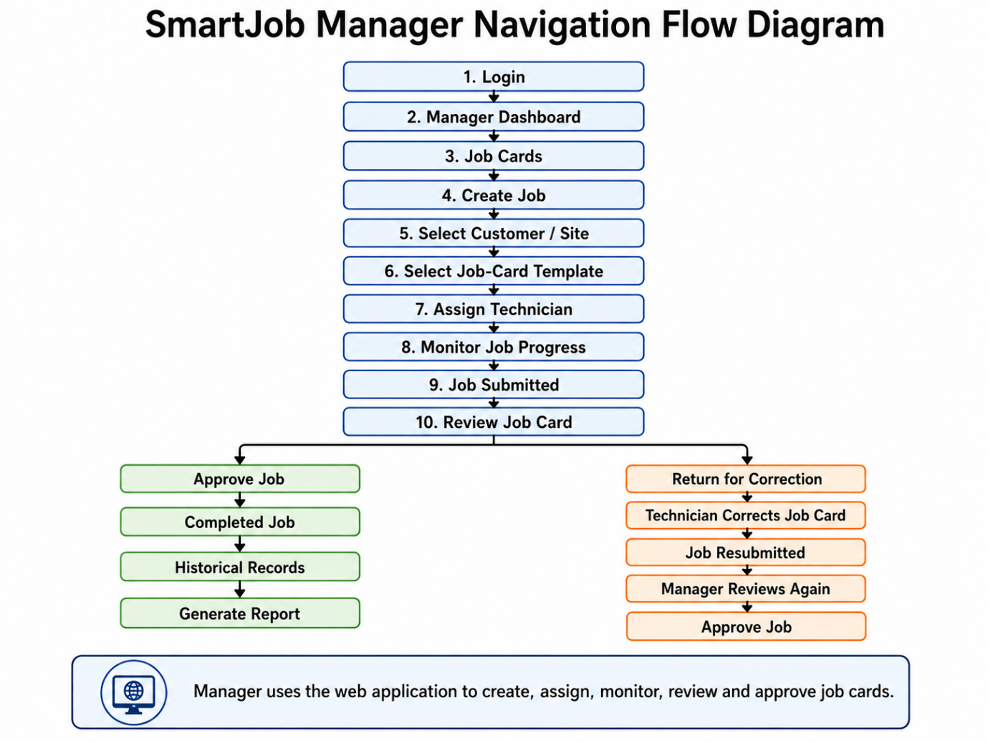
Figure 1 SmartJob manager navigation flow

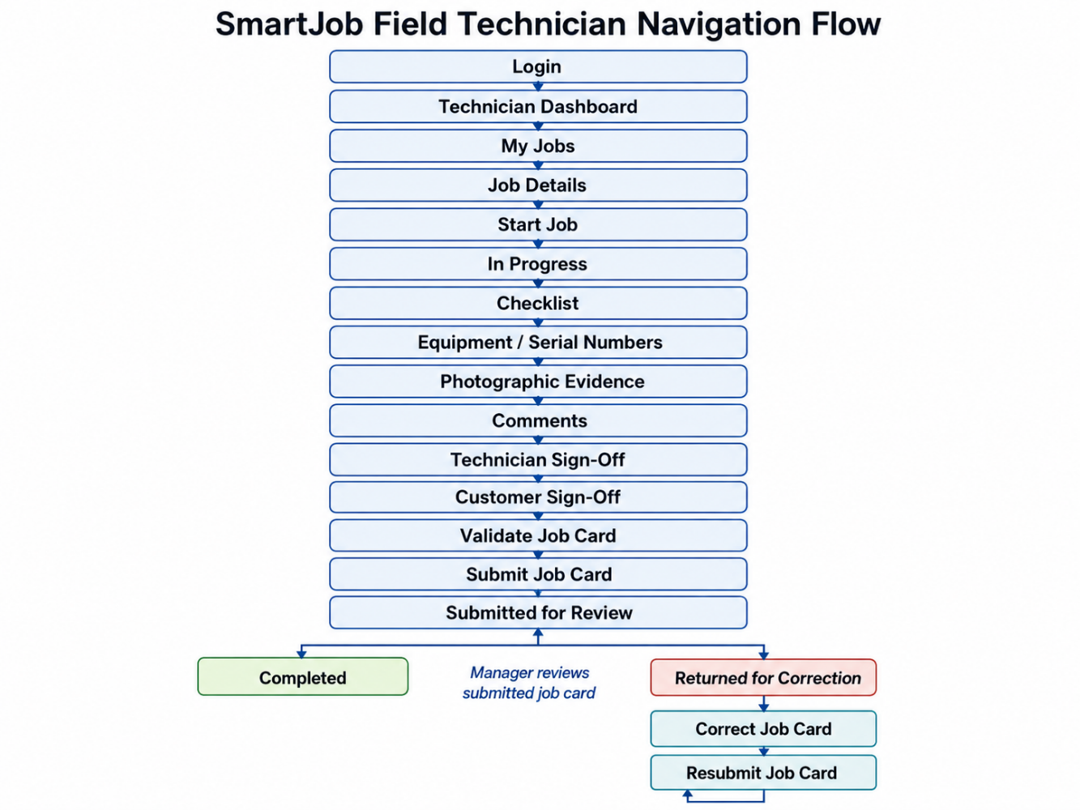
Figure 2 SmartJob field technician navigation flow
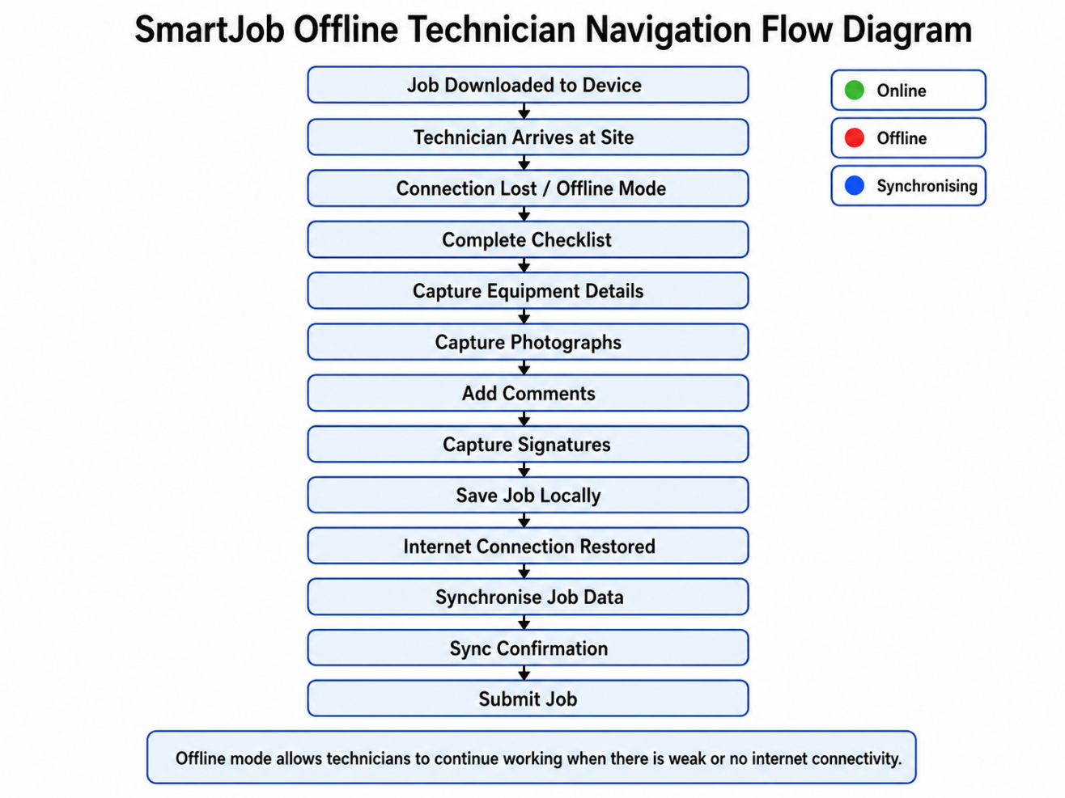
Figure 3 SmartJob offline technician navigation flow diagram
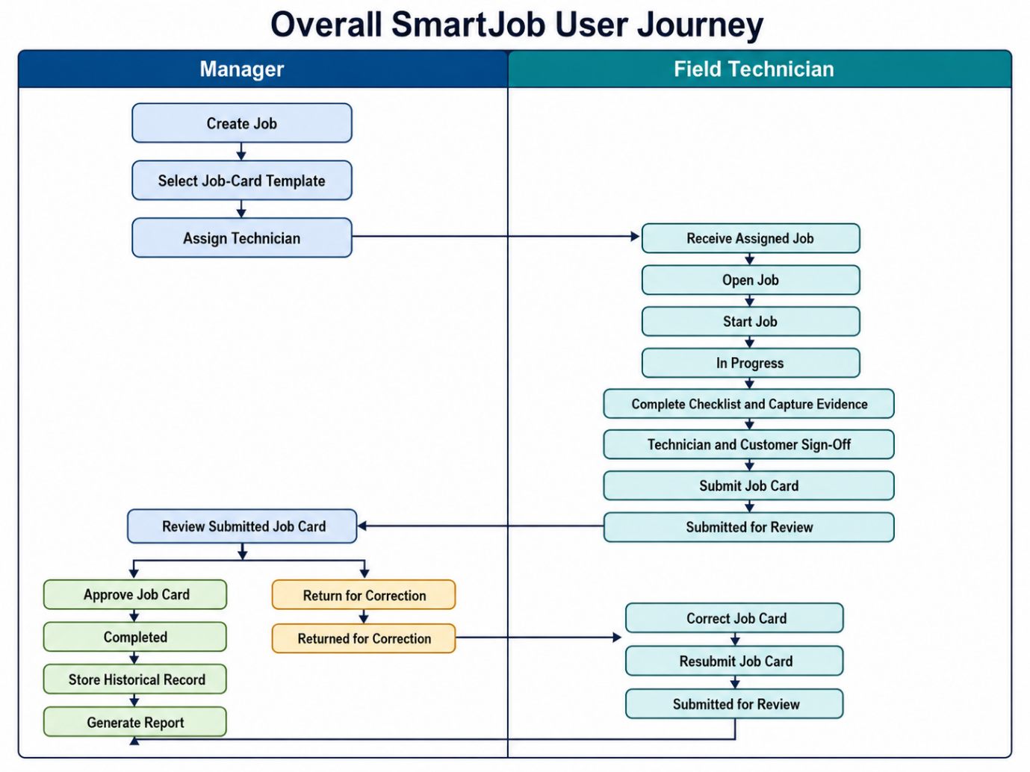
Figure 4 Overall SmartJob user journey

Prototype Screens: Manager Web Application
The following screens from the delivered manager web application are provided in support of the Manager UX Journey above, in response to the Task 1 feedback that the UX Journey Map should include screens from the prototype.
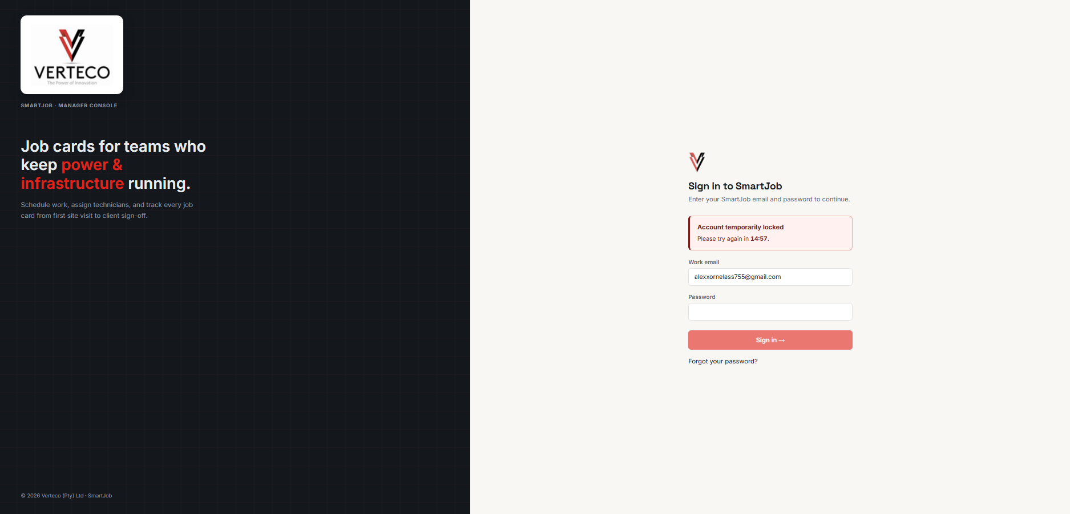
Manager web application: sign-in screen, showing the current branding and the account-lockout message enforced after repeated failed attempts (Login stage)
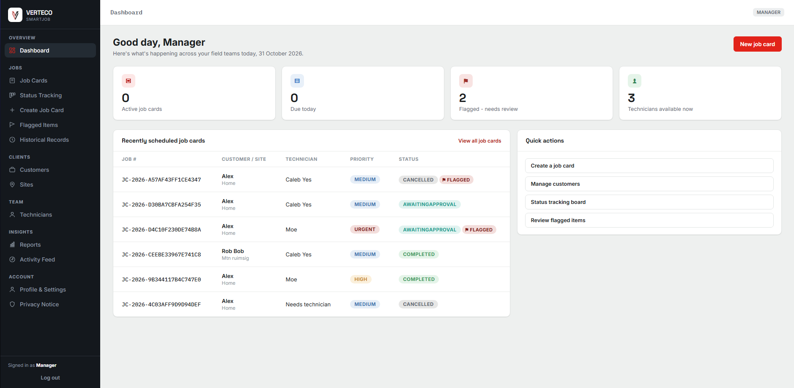
Manager web application: dashboard (View Dashboard stage)
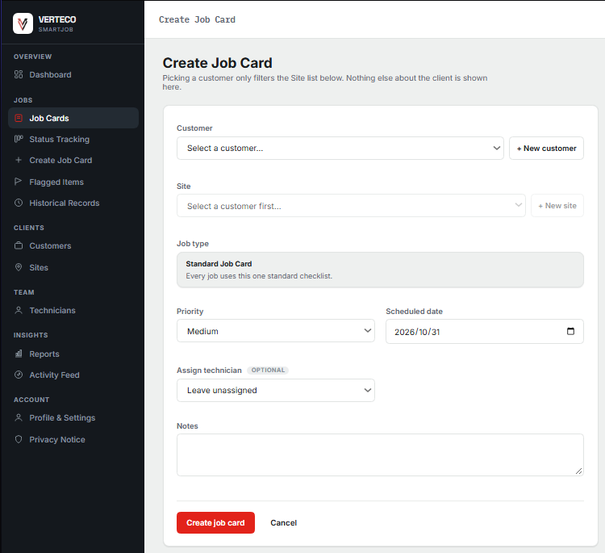
Manager web application: Create Job Card form, with customer, site and job-type selection (Create Job / Select Customer and Site / Select Job-Card Template stages)
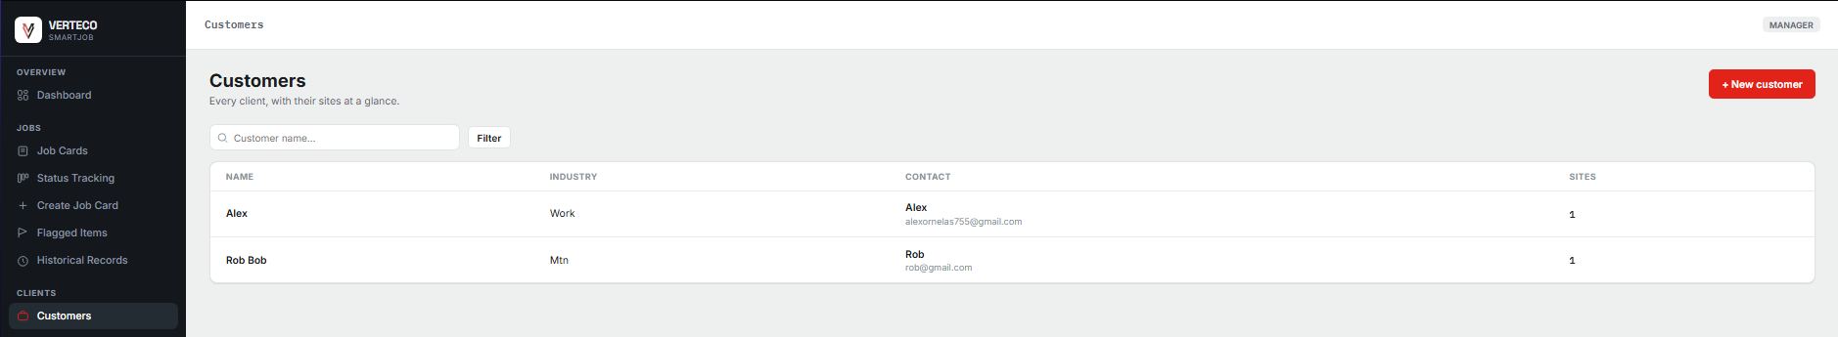
Manager web application: Customers list (Select Customer and Site stage)
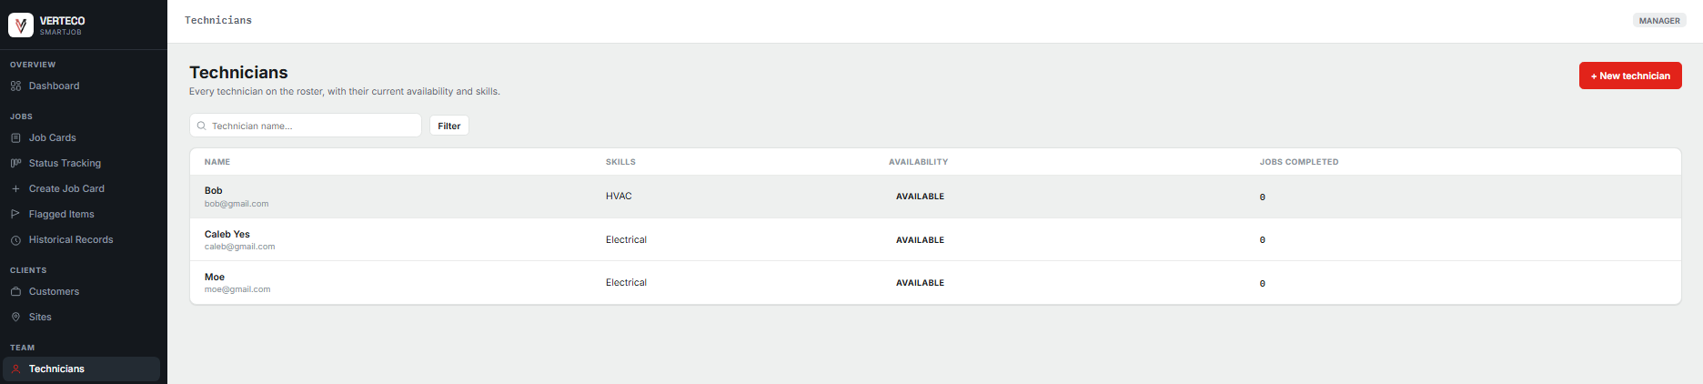
Manager web application: Technicians list, used when assigning a job (Assign Technician stage)
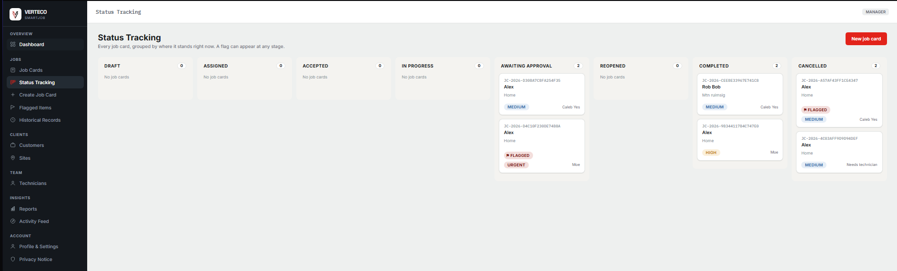
Manager web application: Status Tracking board, showing every job card grouped by its current status (Monitor Job stage)
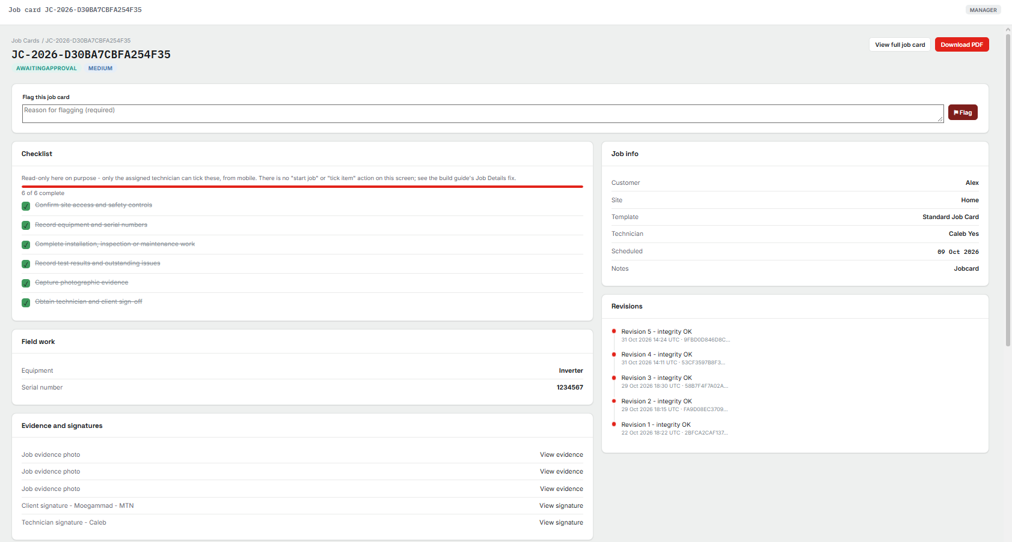
Manager web application: job card detail, showing the checklist, field-work details, evidence, signatures and revision history (Review Job Card stage)
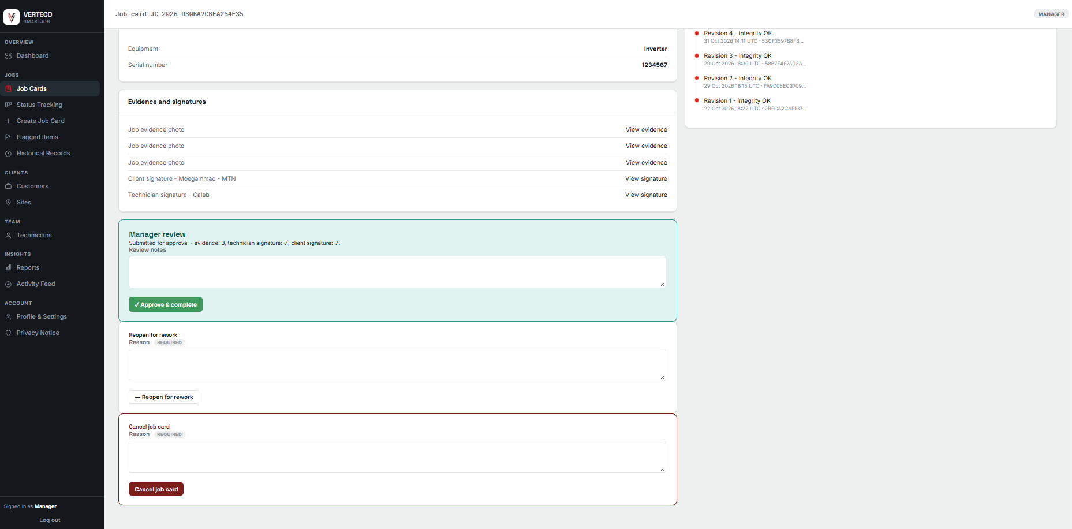
Manager web application: job card decision actions - approve and complete, reopen for rework, or cancel (Approve or Return Job stage)
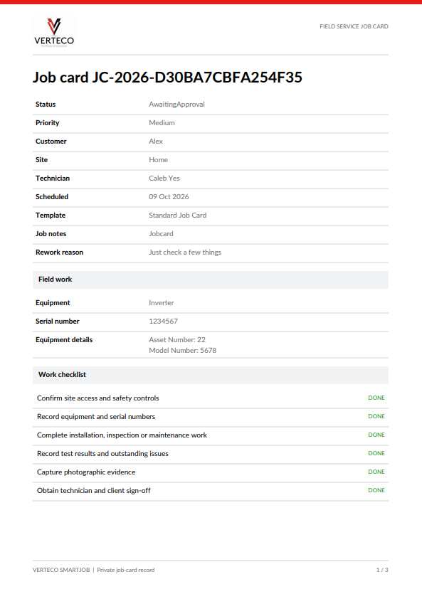
Manager web application: downloadable job card PDF, generated directly from the job card detail view
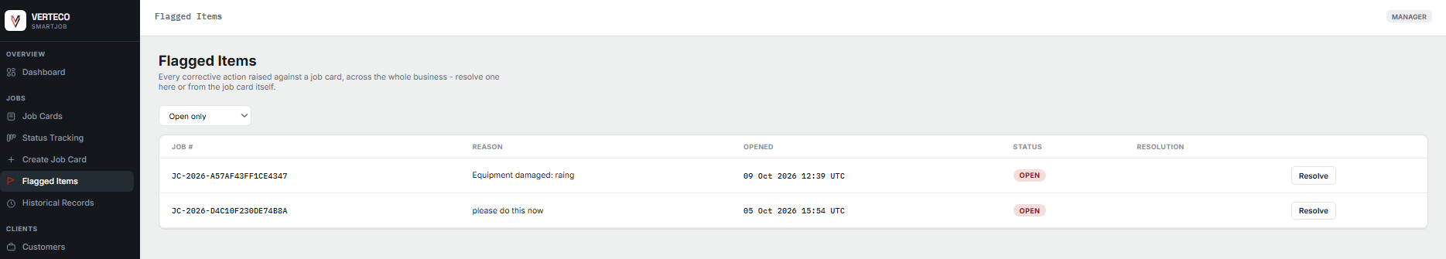
Manager web application: Flagged Items, listing every corrective action raised against a job card across the business
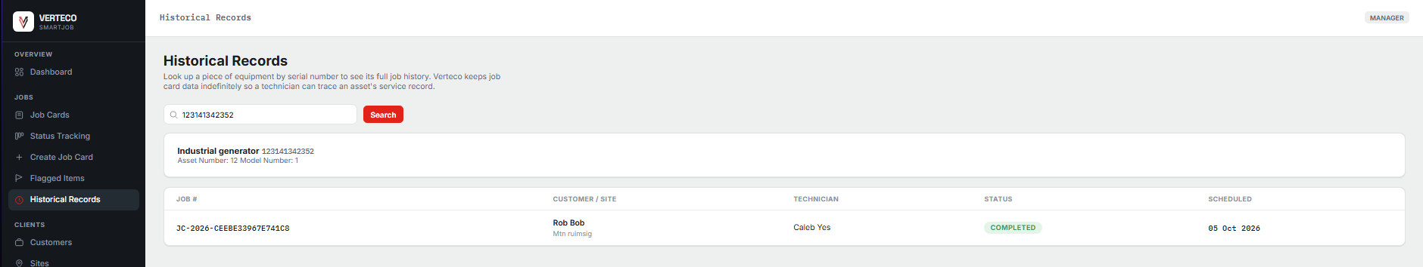
Manager web application: Historical Records, looking up a piece of equipment’s full job history by serial number
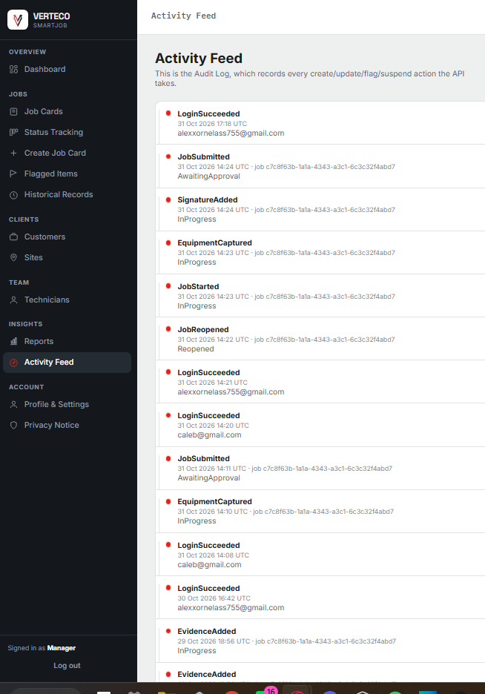
Manager web application: Activity Feed, the audit log recording every create, update, flag and authentication event the API takes
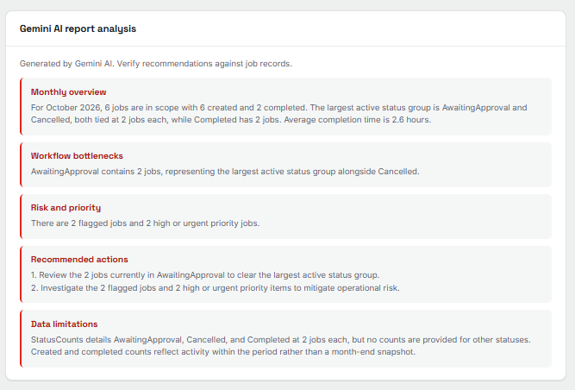
Manager web application: Gemini AI report analysis, an AI-generated summary of monthly activity, workflow bottlenecks, risk and recommended actions
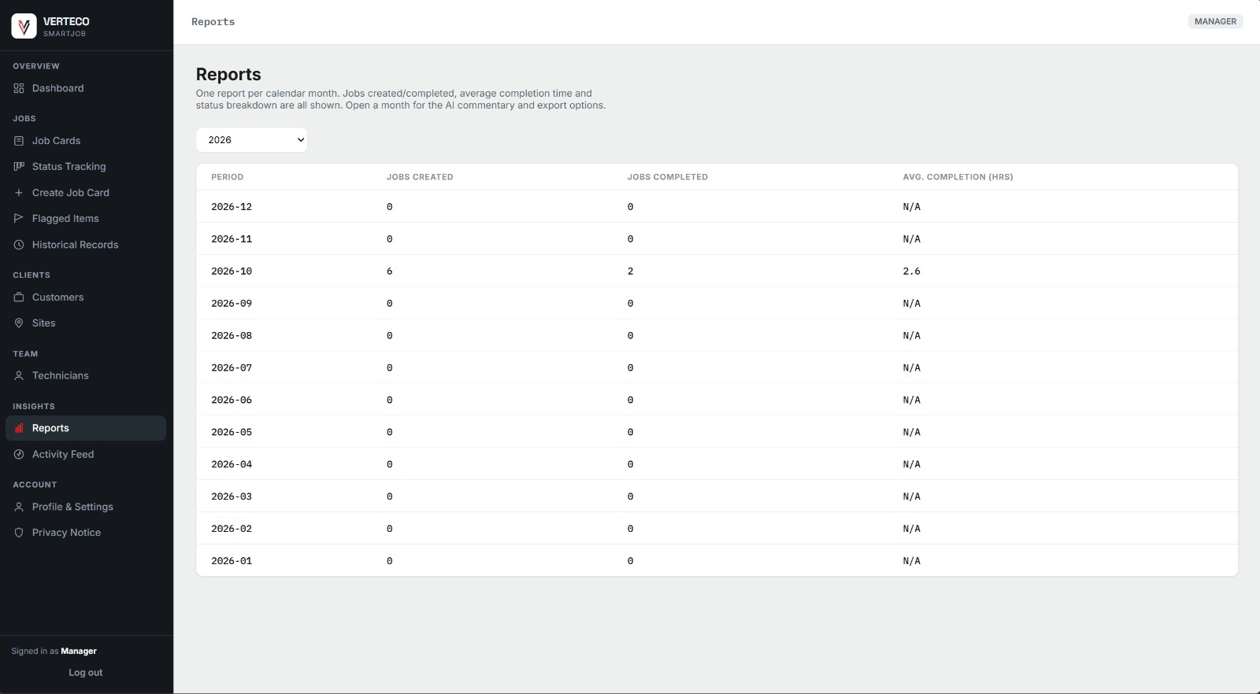
Manager web application: Reports overview (Generate Report stage)
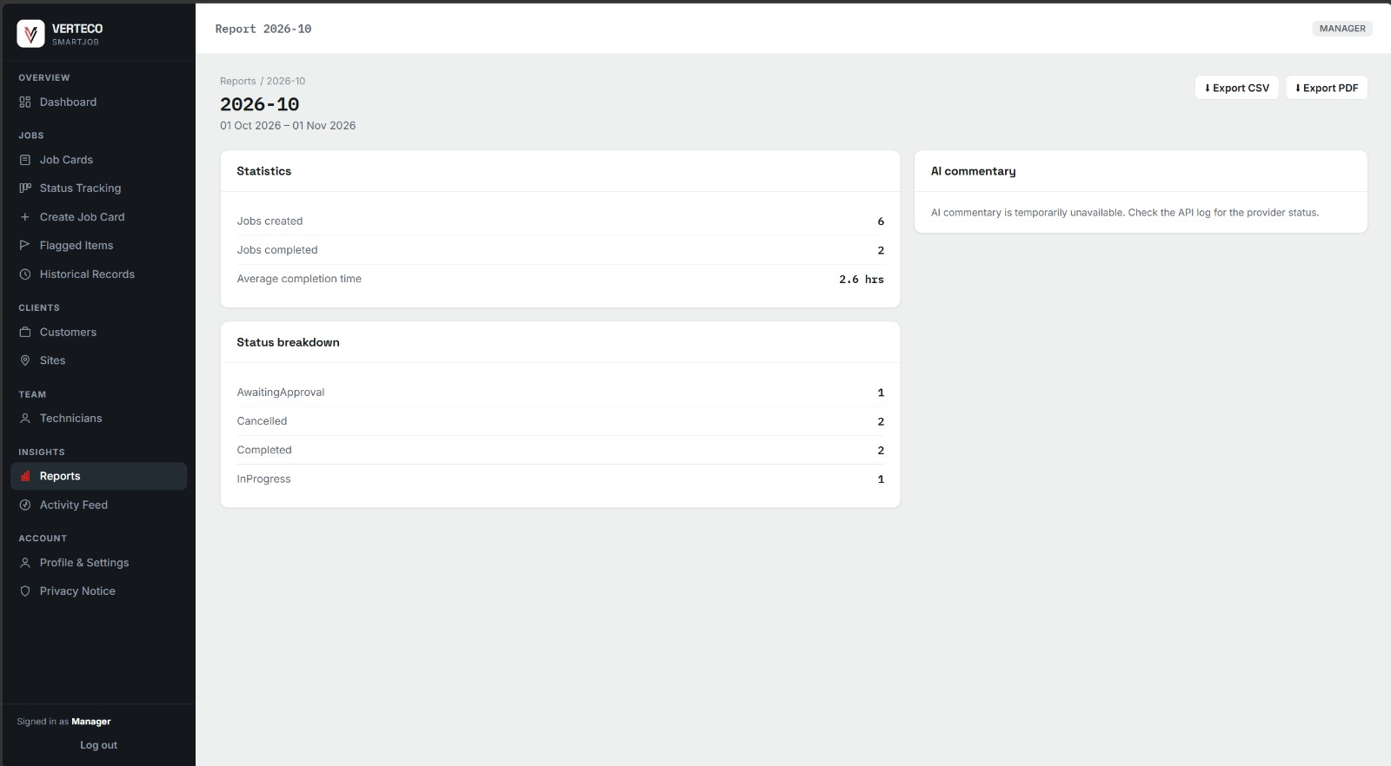
Manager web application: a generated monthly report, with CSV and PDF export (Generate Report stage)

Prototype Screens: Field Technician Mobile Application
The following screens from the delivered technician mobile application are provided in support of the Field Technician UX Journey above, for the same reason.
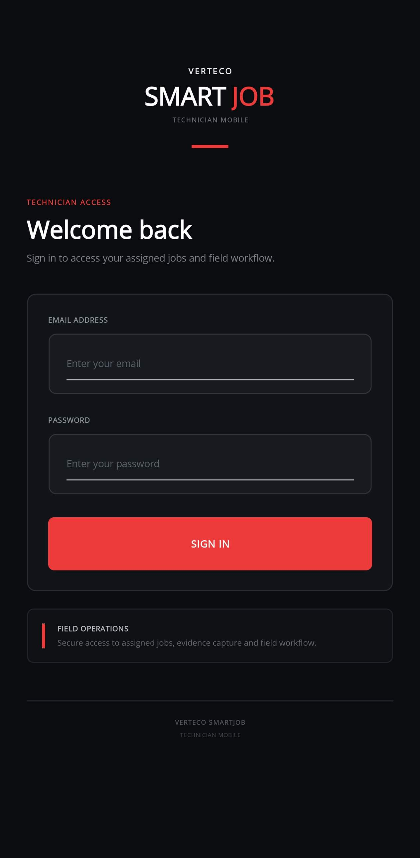
Technician mobile application: sign-in screen (Login stage)
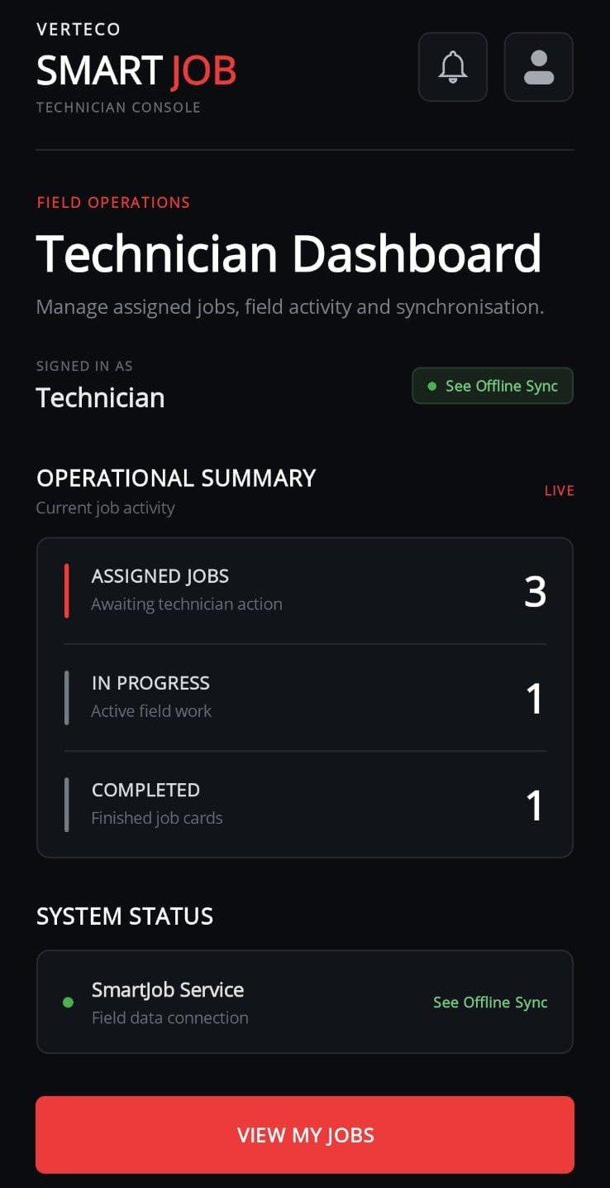
Technician mobile application: Technician Dashboard, showing an operational summary of assigned, in-progress and completed jobs, plus live sync status
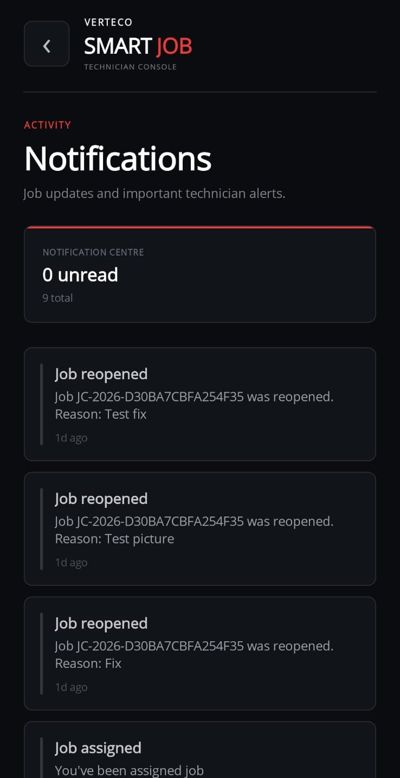
Technician mobile application: Notifications, showing job updates and technician alerts
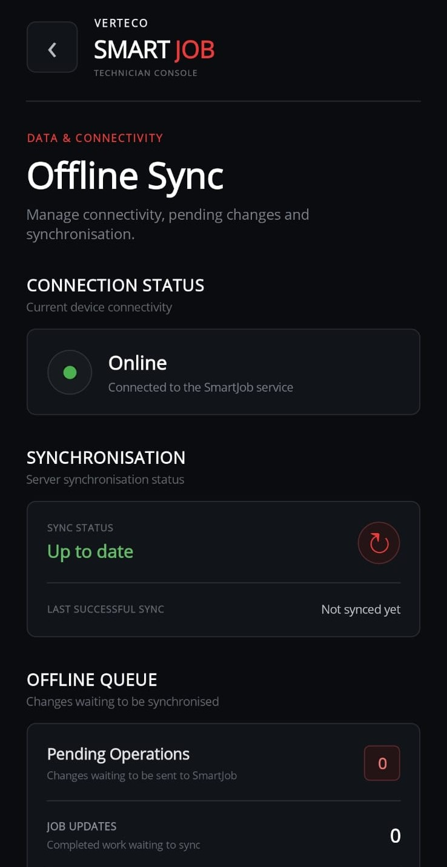
Technician mobile application: Offline Sync, showing device connectivity and synchronisation status
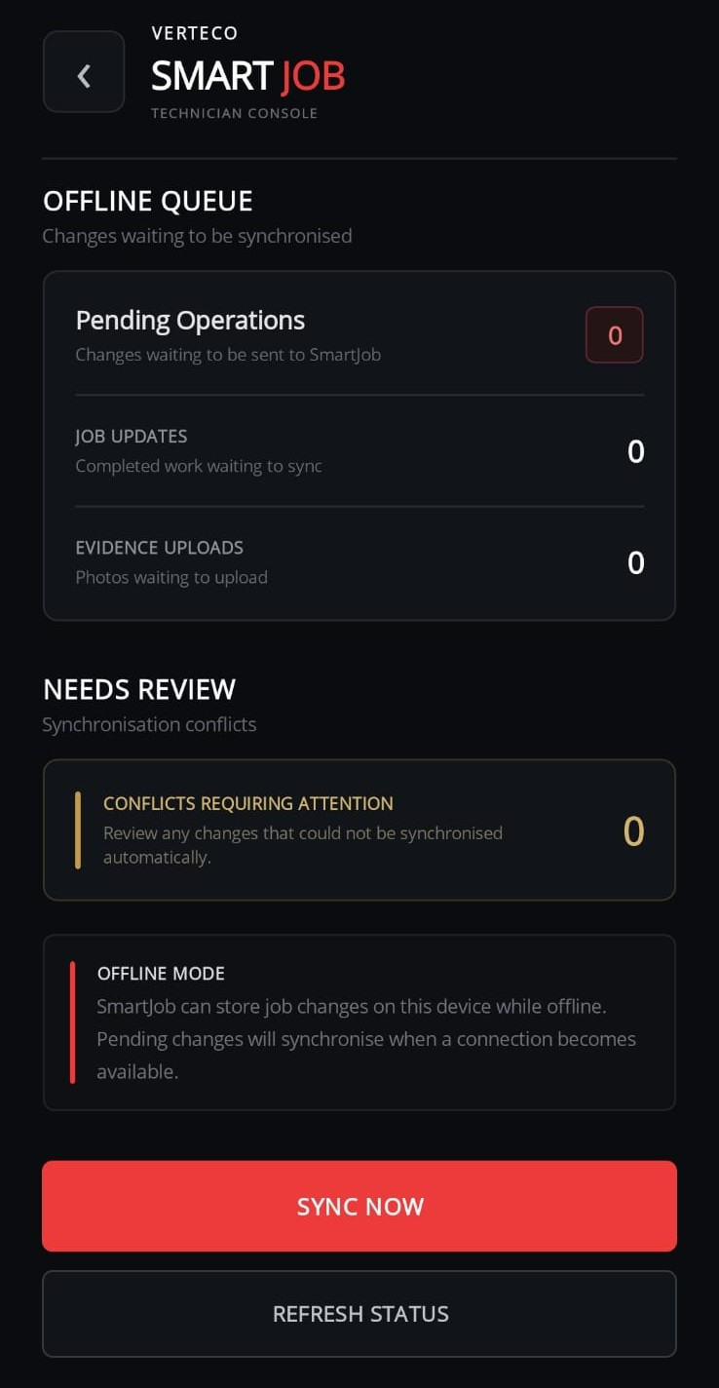
Technician mobile application: Offline Sync, showing the pending-operations queue and manual sync controls
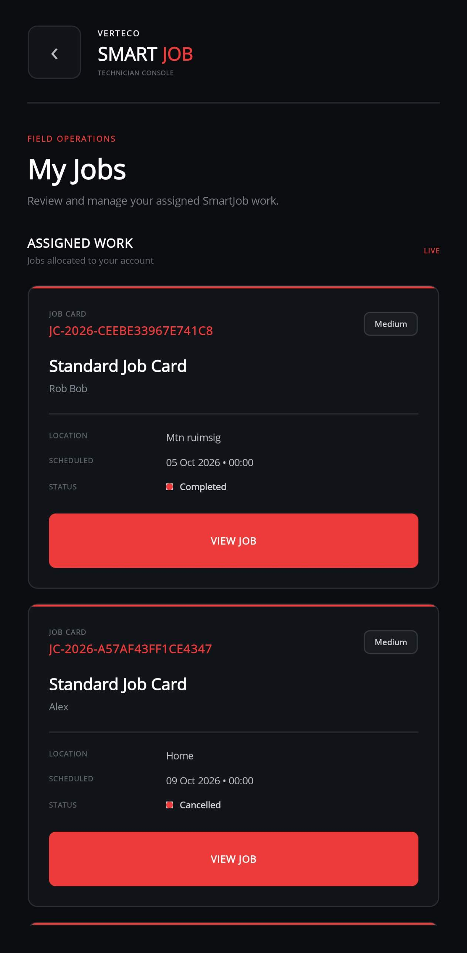
Technician mobile application: My Jobs, listing assigned work (View Assigned Jobs stage)
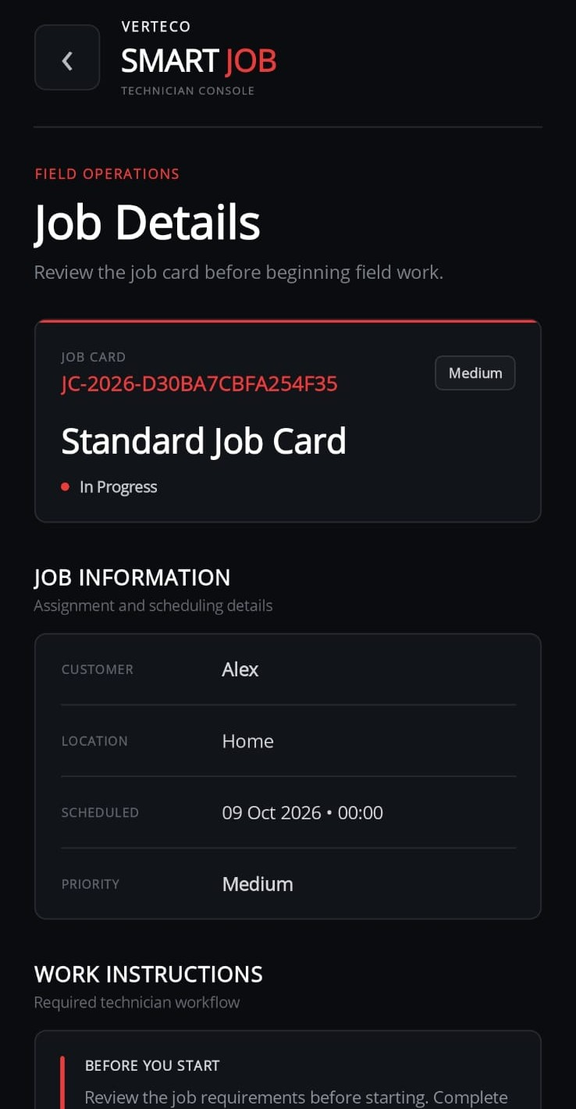
Technician mobile application: Job Details, showing customer, site and job information (Open Job / Start Job stage)
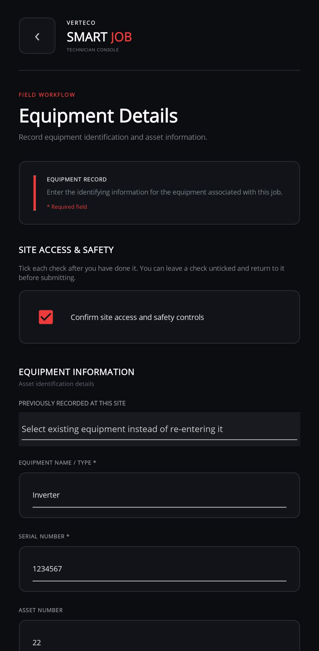
Technician mobile application: Equipment Details (Capture Equipment Details stage)
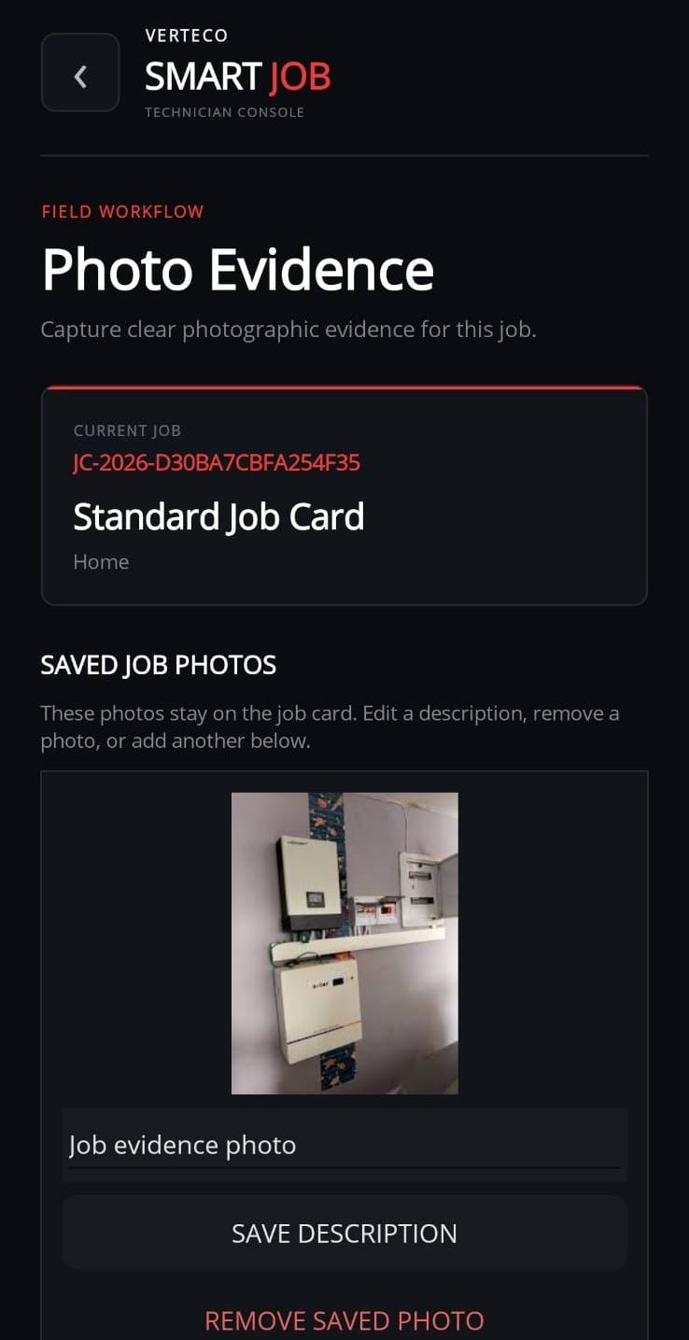
Technician mobile application: Photo Evidence, showing a saved job photo with an editable description (Capture Evidence stage)
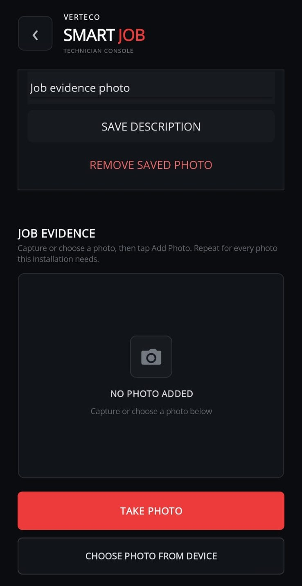
Technician mobile application: Photo Evidence, capturing or choosing an additional photo (Capture Evidence stage)
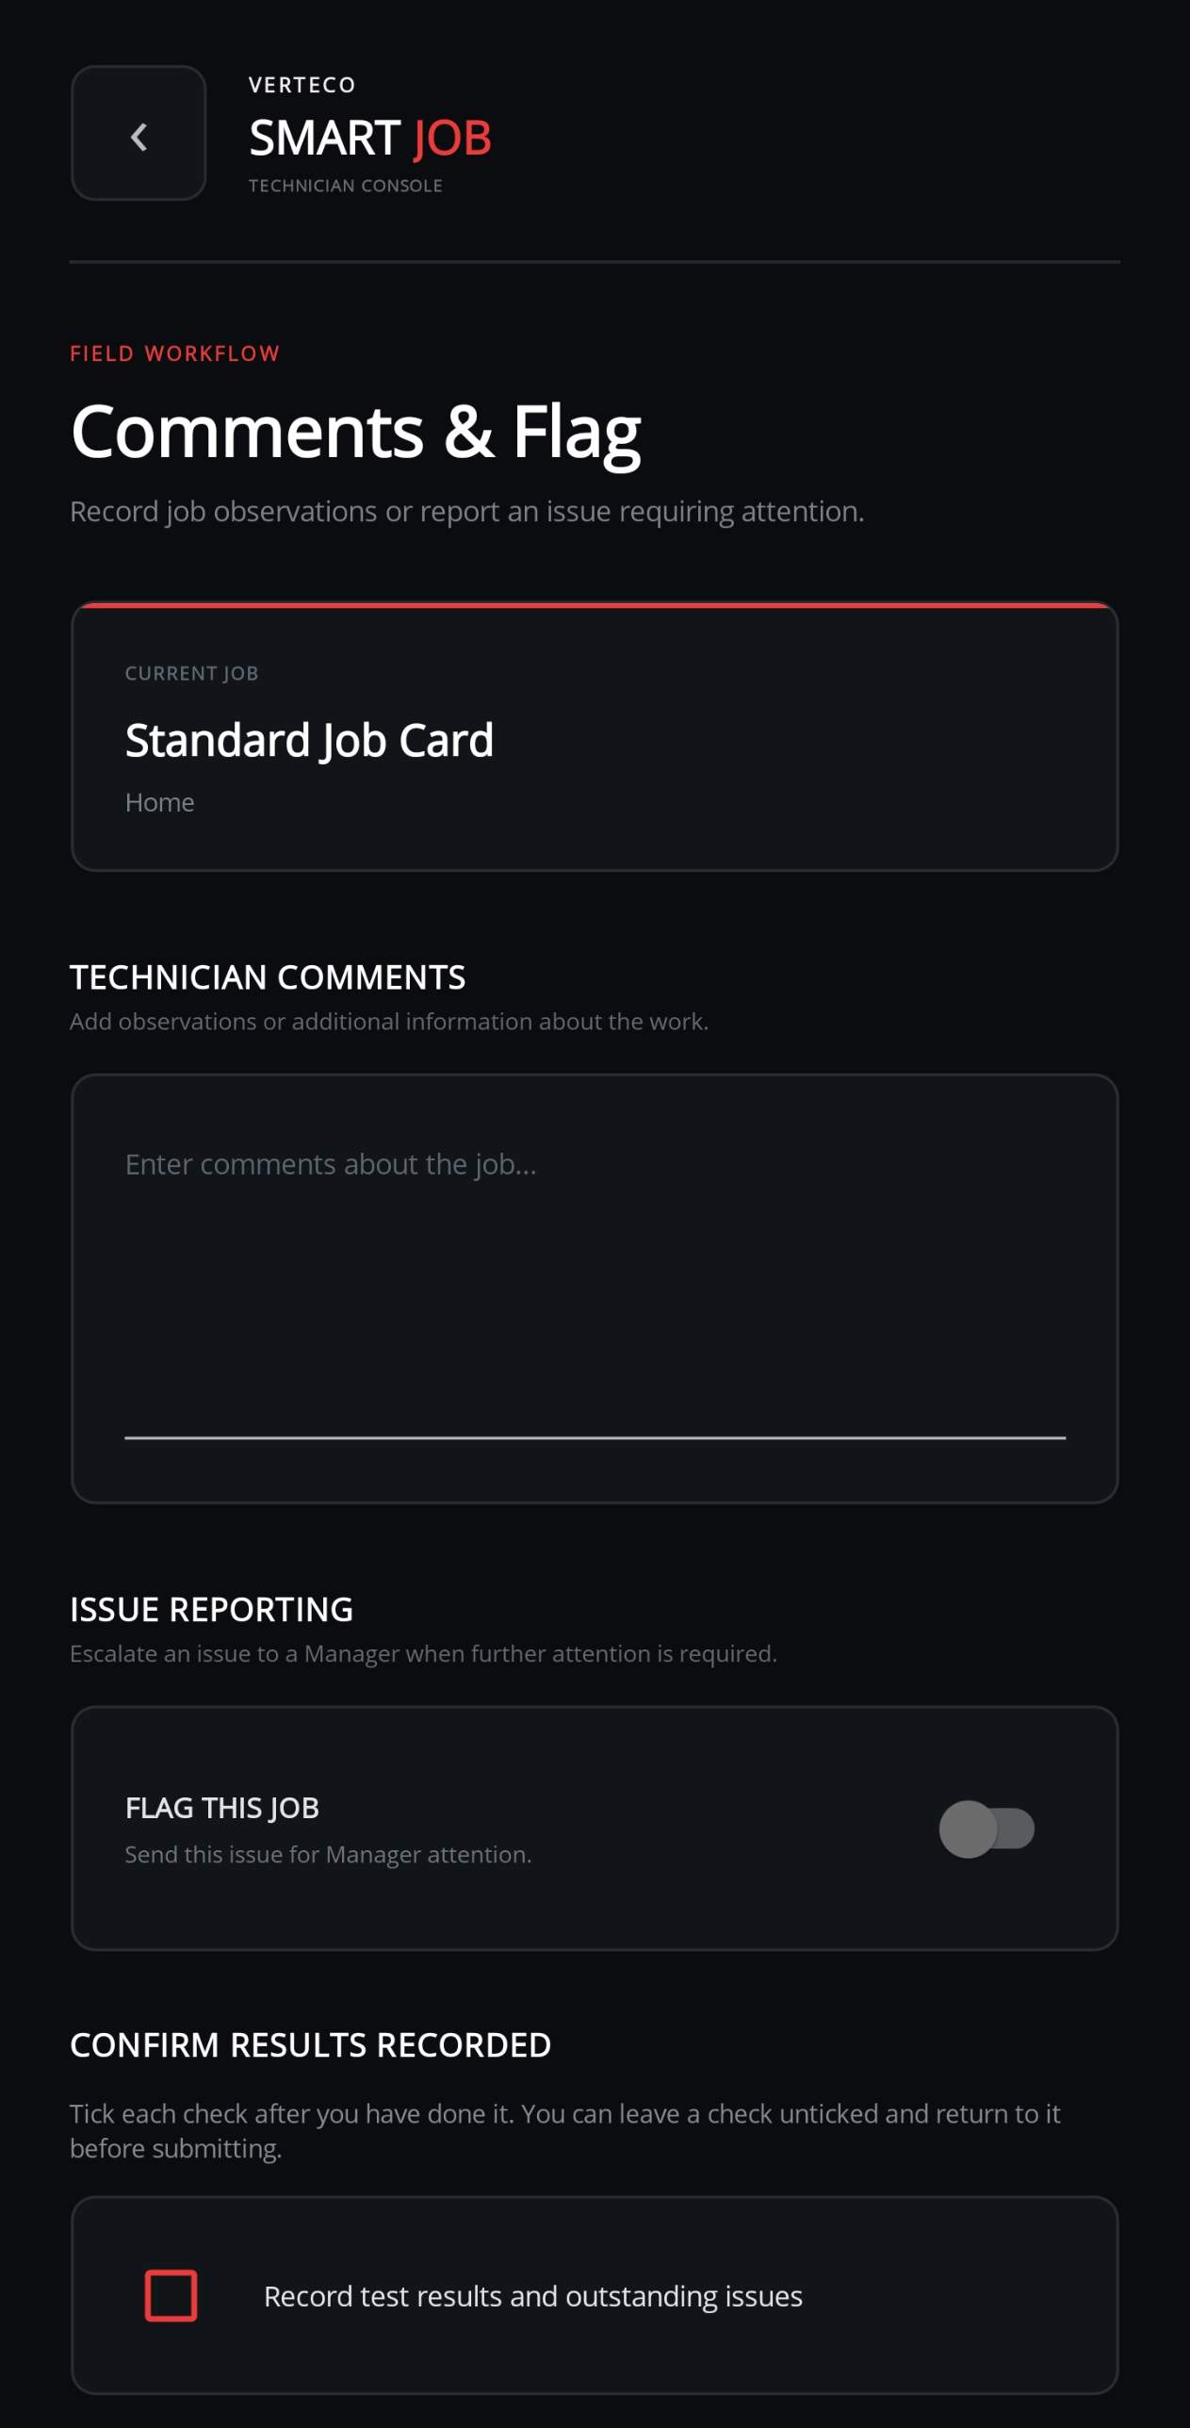
Technician mobile application: Comments and issue flagging (Add Comments stage)
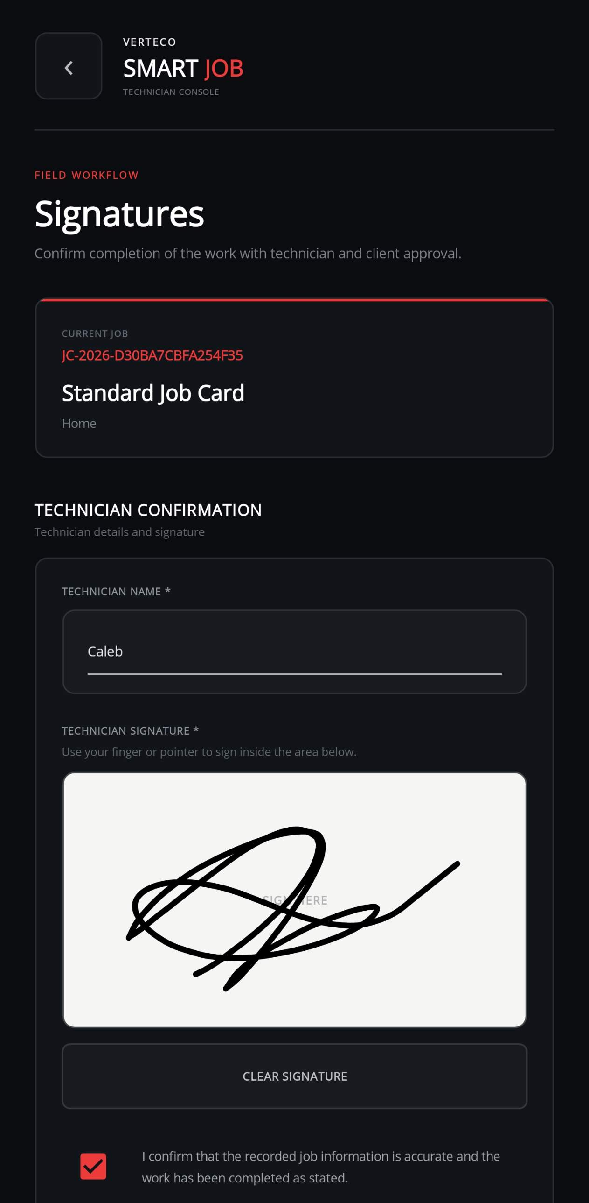
Technician mobile application: technician confirmation and signature (Technician Sign-Off stage)
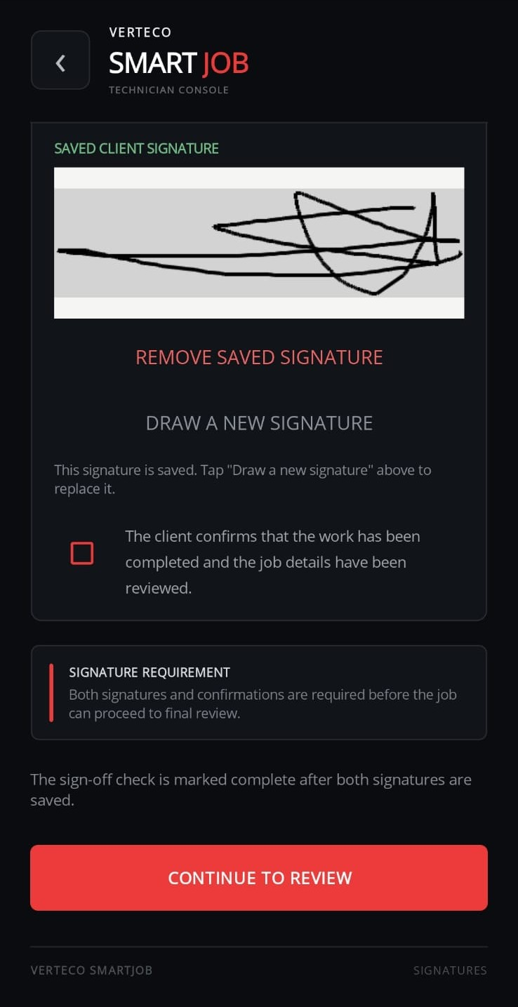
Technician mobile application: client confirmation and signature (Customer Sign-Off stage)
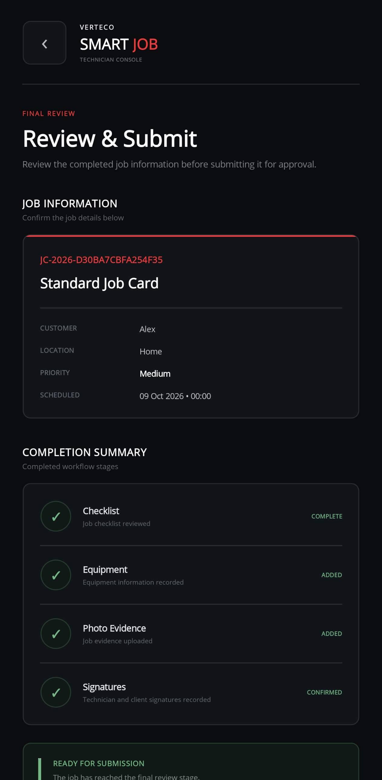
Technician mobile application: Review and Submit, summarising a completed job card (Validate Job Card stage)
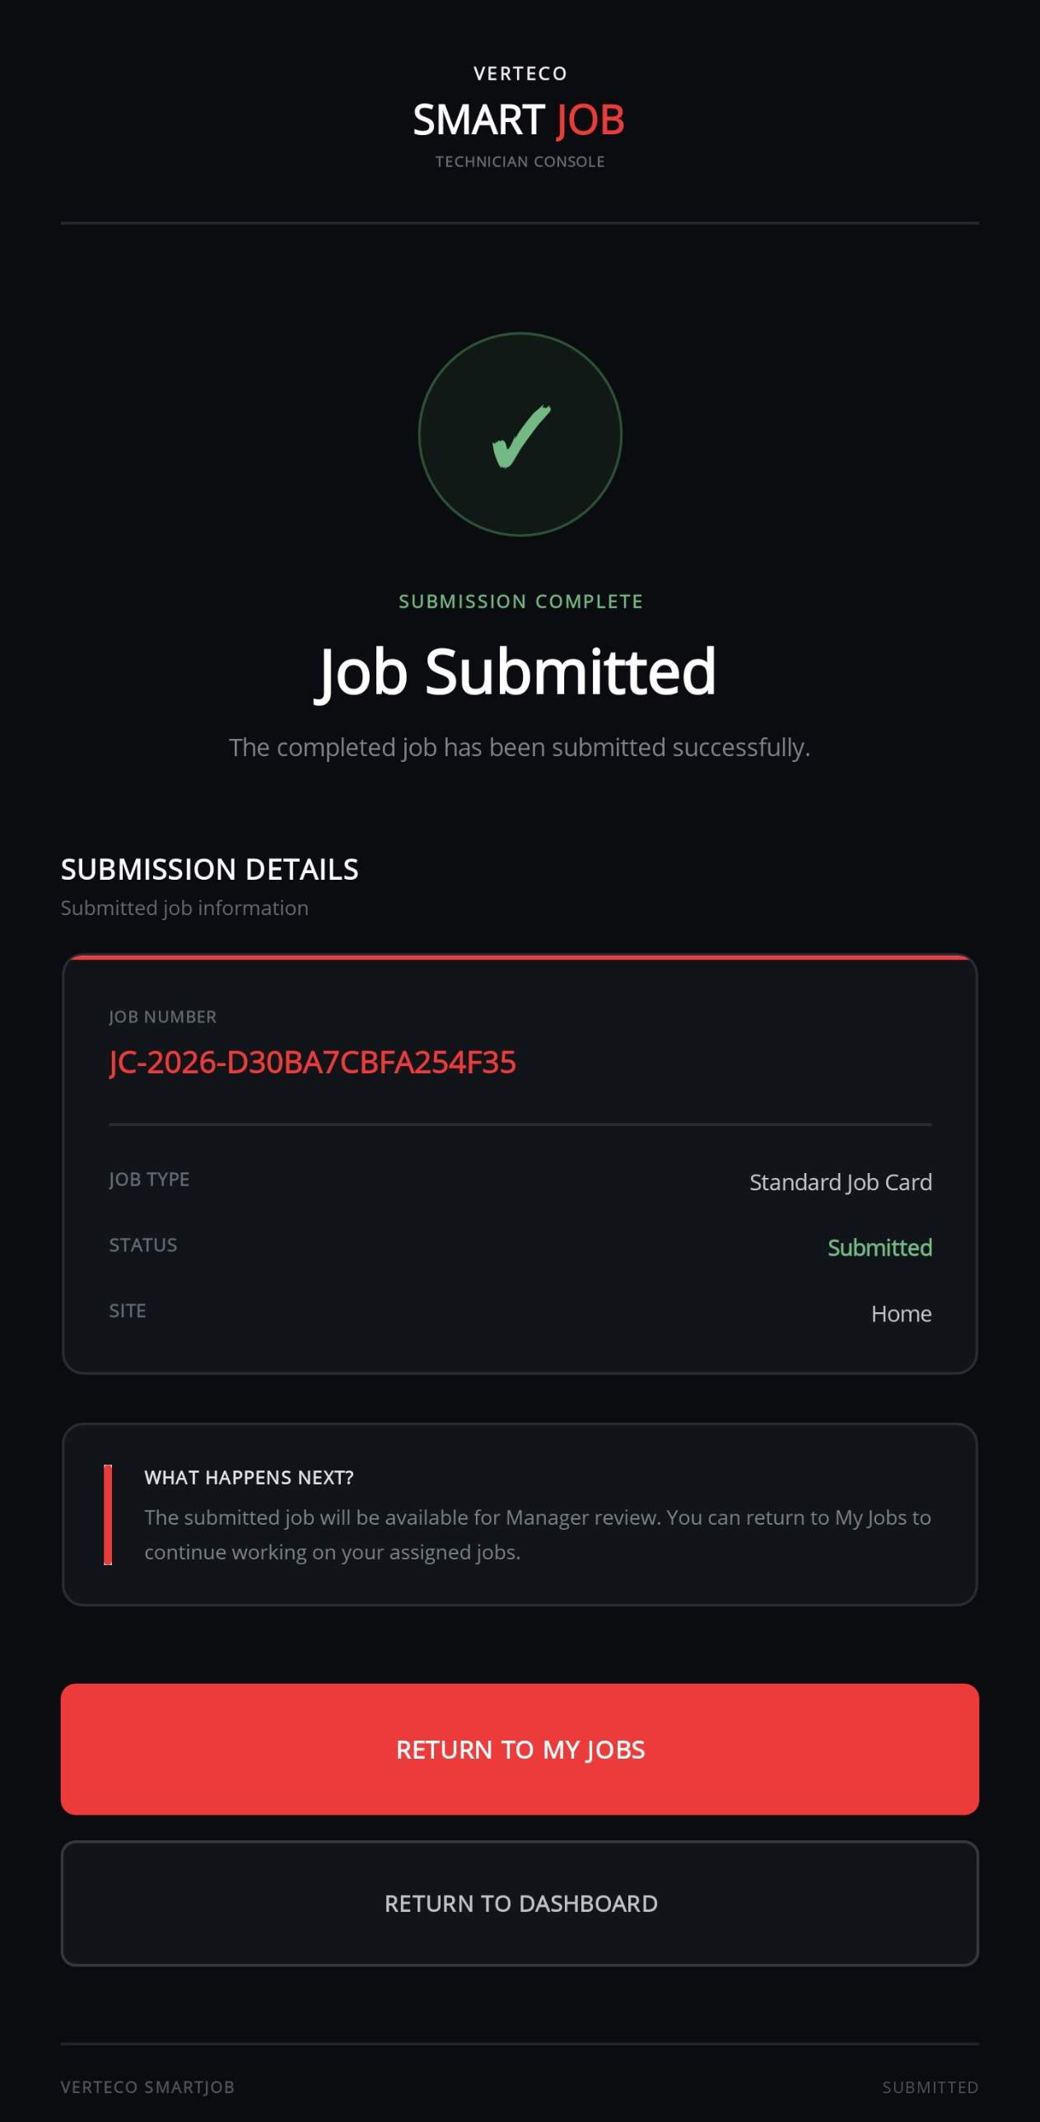
Technician mobile application: Job Submitted confirmation (Submit Job stage)

Work Breakdown Structure
A Work Breakdown Structure (WBS) divides a large project into smaller tasks that are easier to plan, assign and manage. For SmartJob, the WBS shows how Task 1 is divided between the six group members, which tasks depend on other tasks.
The tasks are arranged in a logical order so that later work is based on requirements and designs that have already been agreed on. For example, the prototypes should only be completed once the group has agreed on the main user roles, job-card workflow and terminology.

SmartJob Task 1 WBS
ID | Task | Description | Estimated Duration | Predecessor | Responsible Member | Resources Required
1.0 | Project Planning | Confirm the SmartJob project scope, client requirements, team responsibilities and Task 1 deliverables. | 1 day |  | Whole Group | Client information, Task 1 brief, WIL requirements, Microsoft Teams/WhatsApp
  None
1.1 | Review Verteco Information | Review the Verteco company profile, sample job card, client Q&A and existing workflow. | 1 day | 1.0 |  | Verteco company profile, sample job card, client responses
  Person 1
1.2 |  | Agree on what SmartJob will include for Task 1 and what will remain outside the current scope. | 1 day | 1.1 | Whole Group | Requirements notes, meeting discussion
  Confirm
  System
  Scope
1.3 | Confirm User Roles | Finalise the Manager and Field Technician roles and permissions. | 0.5 day | 1.2 | Person 1 + Whole Group | Client Q&A, WIL requirements
1.4 | Confirm Job Workflow | Agree on the job-card workflow and the final status names that will be used throughout the project. | 0.5 day | 1.3 |  | SmartJob proposal, workflow notes
  Whole Group
2.0 |  | Write the project introduction covering Verteco, the current job-card process, the main problem and the proposed SmartJob solution. | 1 day |  | Person 1
  Introduction
  1.2
  Company profile,
  SmartJob proposal,
  sample job card
2.1 |  | Define what the Manager and Technician must be able to do in SmartJob. | 2 days | 1.3, 1.4 | Person 1 | Client Q&A, WIL build requirements
  Functional
  Requirements
2.2 | User Roles | Document the responsibilities and access levels of the Manager and Field Technician roles. | 1 day | 2.1 | Person 1 | Functional requirements
2.3 | User Stories |  | 1 day |  | Person 1 | Functional requirements, role definitions
  Create user
  stories for
  the Manager
  and Field
  Technician.
  2.2
2.4 | UX Journey Maps | Create Manager and Field Technician UX journey maps showing the main actions, screens and system responses. | 2 days | 2.3 | Person 1 | User stories, Word, diagrams
2.5 | Navigation Flow Diagrams | Create navigation flow diagrams for the Manager, Field Technician, offline technician process and overall SmartJob workflow. | 1 day | 2.4 |  | Draw.io/Figma/diagram tool
  Person 1
2.6 | Non-Functional Requirements | Define the main non-functional requirements for performance, usability, compatibility, security, reliability, offline functionality, scalability and maintainability. | 2 days | 2.1 | Person 1 | Client Q&A, WIL requirements
2.7 | Work Breakdown Structure | Create and document the WBS for Task 1. | 1 day | 1.0 | Person 1 | Task allocation, project requirements
3.0 | Domain Class Diagram | Identify the main business entities and relationships used in SmartJob. | 2 days | 2.1 | Person 2 | Requirements, draw.io/Lucidchart
3.1 | Design Class Diagram | Expand the domain model into implementation classes, attributes, methods, access modifiers and relationships. | 3 days |  | Person 2 | UML tool, architecture requirements
  3.0
3.2 | Database Technology Choice | Research and justify the selected database technology for SmartJob. | 1 day | 2.1 | Person 2 | SQL Server/Azure SQL information
3.3 | ER Diagram | Design the SmartJob database structure including entities, primary keys, foreign keys and cardinalities. | 3 days | 3.0, 3.2
  Person 2
  dbdiagram.io/draw.io/SQL modelling tool
3.4 | Data Model Explanation | Explain the entities, relationships and database design decisions. | 1 day | 3.3 | Person 2 | ERD, requirements
4.0 | Sequence Diagrams | Model the main system interactions such as job creation, assignment, field completion, submission and approval. | 3 days |  | Person 3 | UML tool, user stories
  2.1, 3.0
4.1 | State Diagram |  | 1 day | 1.4 | Person 3 | UML tool
  Model the
  states and
  transitions
  of a SmartJob
  job card.
4.2 |  | Define and explain the architecture used by SmartJob. | 2 days |  | Person 3 | Architecture research, requirements
  Architecture
  Pattern
  3.1
4.3 | Design Patterns | Select and explain suitable design patterns used in SmartJob. | 2 days | 4.2 | Person 3
  UML/design pattern
  resources
4.4 | Cloud Architecture | Design how the web application, API, database, mobile application and cloud services will work together. | 2 days | 4.2 | Person 3 | Azure architecture tools
4.5 | Deployment Plan | Explain development, testing and production deployment for SmartJob. | 1 day | 4.4 | Person 3 | Azure, GitHub, deployment research
5.0 |  | Identify the security requirements and risks affecting SmartJob. | 3 days | 2.1, 4.2 | Person 4 | WIL security requirements, OWASP resources
  Security
  Analysis
5.1 | Security Controls | Document authentication, authorisation, password security, encryption, validation, secure uploads and POPIA considerations. | 2 days | 5.0 | Person 4 | Security research
5.2 | DevOps Plan | Define repository structure, branch strategy, pull requests, code review and CI/CD approach. | 2 days | 1.0 | Person 4
  GitHub
  GitHub Actions
5.3 | GitHub Actions Design | Design the CI workflow for building and testing SmartJob. | 1 day |  | Person 4 | GitHub Actions
  5.2
5.4 | Running Costs | Estimate Azure hosting, database and storage costs against Verteco’s monthly budget. | 2 days | 4.4 | Person 4 | Azure pricing tools, client budget
5.5 | Change Management Plan | Explain how SmartJob can be introduced alongside SafetyCulture and adopted by Verteco users. | 2 days |  | Person 4 | Client requirements, rollout planning
  2.1
5.6 | Handover and Support Plan | Explain the training, support, documentation and final handover of SmartJob to Verteco. | 1 day | 5.5 |  | User guide outline, support plan
  Person 4
6.0 | Desktop Prototype Planning | Identify the Manager screens and navigation required for the desktop prototype. | 1 day | 2.4, 2.5 | Person 5 | UX journey, user stories
6.1 | Desktop Wireframe / Structure | Create the initial layout and structure of Manager screens. | 2 days | 6.0 | Person 5 | Figma or chosen IDE
6.2 | Manager Dashboard Prototype | Build the Manager dashboard and job overview screens. | 2 days | 6.1 | Person 5 | Figma/IDE, dummy data
6.3 | Job Management Prototype | Build job creation, assignment, job details and tracking screens. | 3 days | 6.1 | Person 5 | Figma/IDE
6.4 |  | Build customer, site and job-card template management screens. | 2 days |  |  | Figma/IDE
  Customer
  and Template Screens
  6.3
  Person 5
6.5 | Reports and Historical Records | Build report, history, filtering and search screens. | 2 days | 6.3 | Person 5 | Figma/IDE
6.6 | Desktop Prototype Integration | Connect screens into a clickable Manager workflow | 1 day | 6.2-6.5 | Person 5 | Figma prototype tools
7.0 | Mobile Prototype Planning | Identify the main Technician screens required on the mobile application. | 1 day |  | Person 6 | UX journey, user stories
  2.4, 2.5
7.1 | Mobile Wireframe / Structure | Create the initial layout of the technician mobile application. | 2 days | 7.0 | Person 6 | Figma or chosen IDE
7.2 | Technician Dashboard and Jobs |  | 2 days | 7.1 | Person 6
  Build the
  Technician
  dashboard,
  My Jobs and
  Job Details
  screens.
  Figma/IDE
7.3 | Checklist and Equipment Screens | Build checklist, equipment and serial-number capture screens. | 2 days | 7.1 | Person 6 | Figma/IDE
7.4 | Evidence and Sign-Off Screens | Build photo capture, commissioning evidence, comments and signature screens. | 2 days |  | Person 6 | Figma/IDE
  7.3
7.5 | Offline and Synchronisation Screens | Show the offline mode and synchronisation status in the mobile prototype. | 1 day | 7.3 | Person 6
  Client offline requirement
7.6 | Mobile Prototype Integration | Connect the screens into a complete technician workflow from assignment to submission. | 1 day |  | Person 6 | Figma prototype tools
  7.2-7.5
8.0 | Prototype Consistency Review | Compare the desktop and mobile prototypes to ensure that branding, terminology, dummy data and workflows match. | 1 day | 6.6, 7.6 | Persons 5 and 6 | Both prototypes
8.1 | Documentation Cross-Check |  | 1 day |  | Whole Group
  Check that the
  requirements,
  diagrams,
  architecture
  and prototypes use the same terminology and workflow.
  2.0-7.6
  Complete Task 1 documentation
8.2 | Referencing and Formatting | Check referencing, headings, numbering, diagrams and document presentation. | 1 day | 8.1 |  | Word, reference list
  Whole Group
8.3 |  | Review the completed Task 1 submission against the assessment criteria. | 1 day | 8.2 |  | Task 1 assessment criteria
  Final Quality
  Review
  Whole Group
8.4 | Final Submission | Compile and submit the final Task 1 document and supporting prototype links/files. | 0.5 day | 8.3 | Whole Group | Submission platform, final files

Team Member Responsibility Across the WBS
Formal responsibility for each phase of work was assigned at the Task 1 planning stage and carried through, with adjustments, into Task 2 and Task 3 implementation:
- Keeran Perumal - requirements and UX documentation (functional requirements, user roles and stories, UX journeys, the Work Breakdown Structure and non-functional requirements) at Task 1; Mobile Security, DevOps and Hosting Lead for Task 2 and Task 3 (mobile authentication, Android and iOS release engineering, CI/CD, and Azure hosting preparation).
- Moegammad Alexander - analysis and data design (class diagrams, the ERD, and data-storage design) at Task 1, and group coordination as Group Leader throughout; Security, Identity and Notifications Lead for Task 2 and Task 3 (authentication, password reset, the audit trail, in-app and email notifications, and security hardening).
- Alexandro Ornelas - implementation and architecture (UML sequence and state design, architecture, deployment and cloud planning) at Task 1; Backend Core Lead for Task 2 and Task 3 (the API, Application, Domain, Infrastructure and reporting projects).
- Isaac Phiri - security, DevOps, GitHub Actions, Azure running costs, change management and handover and support planning at Task 1; DevOps, Hosting and API Platform Lead for Task 2 and Task 3 (the mobile backend, API and offline synchronisation).
- Caleb Forbes - the Manager and Desktop Figma prototype at Task 1; Web Front End Lead for Task 2 and Task 3 (the ASP.NET Core MVC manager console).
- Erin Sarjoo - the Technician and Mobile Figma prototype at Task 1; Mobile Lead for Task 2 and Task 3 (the .NET MAUI technician application).
This mapping is also reflected in the per-person sections of the project README, which documents each member’s Task 2 and Task 3 contribution in detail alongside the code itself.

WBS Phase Grouping
The WBS can also be grouped into 8 main phases:
Phase 1 - Planning and Requirement Confirmation
Our group confirms the scope of SmartJob, the main requirements and the terminology that will be used throughout the project.
Phase 2 - Requirements and UX Design
The functional requirements, user roles, user stories, UX journey maps, navigation flows and non-functional requirements are completed.
Phase 3 - System and Data Analysis
The main system entities, class diagrams and database design are created.
Phase 4 - Architecture and Implementation Planning
Our group plans how the different parts of SmartJob will communicate and documents the architecture, design patterns, cloud environment and deployment approach.
Phase 5 - Security and Operations Planning
Security, DevOps, hosting costs, change management and system support are planned.
Phase 6 - Manager/Desktop Prototype
The Manager-facing web prototype is designed and connected into a complete workflow.
Phase 7 - Technician/Mobile Prototype
The Technician mobile prototype is created, including the normal field-work process and offline functionality.
Phase 8 - Integration and Finalisation
The group checks that all sections use the same requirements, terminology and workflow before the final Task 1 submission is completed

Non-Functional Requirements
Non-functional requirements describe how well SmartJob should operate rather than what individual functions the system performs. These requirements focus on areas such as performance, usability, security, reliability, compatibility and scalability.
They are especially important for SmartJob because technicians will use the system from different locations and may sometimes have a weak or unavailable internet connection. The system will also store important information such as job-card records, photographs, equipment details and digital signatures.
The following requirements describe the expected quality and technical standards for SmartJob based on the client’s requirements and the project brief.

Performance
NFR-01: Response-Time
Under normal operating conditions, standard web and mobile requests should return a response within approximately three seconds, excluding operations that depend on large file uploads or external services.
NFR-02: Search Performance:
Searching, filtering or sorting normal job-card records should return results within approximately three seconds under the expected project workload.
NFR-03 - File Upload Feedback:
When photographs or other supporting evidence are uploaded, the system must display a progress indicator so that the user can see that the upload is still in progress.
These targets are intended to keep the system responsive during normal use and prevent unnecessary delays for managers and technicians.

Availability
NFR-04 - System Availability:
The SmartJob web application and back-end API should target at least 99% monthly availability, excluding planned maintenance.
NFR-05 - Planned Maintenance:
Where possible, planned maintenance should take place outside normal working hours. Users should also be informed before maintenance that may temporarily affect access to SmartJob.

Offline Capability
Offline functionality is a confirmed Verteco requirement because technicians may work at sites with weak or unavailable internet connectivity.
NFR-06 - Offline Field Operation:
The technician mobile application must allow technicians to continue completing the main job-card activities when no internet connection is available.
This should include:
- viewing previously downloaded assigned job information;
- completing checklist fields;
- capturing equipment information;
- capturing photographs;
- adding comments;
- capturing signatures; and
- saving job-card progress.
NFR-07 - Local Offline Storage:
Information captured while offline must remain stored on the technician’s device until it has been successfully synchronised with the central SmartJob system.
NFR-08 - Synchronisation:
When an internet connection is restored, information captured offline must synchronise with the central SmartJob system without requiring the technician to enter the same information again.
NFR-09 - Synchronisation Status:
The mobile application must clearly show whether SmartJob is Online, Offline or Synchronising so that the technician knows the current connection status.

Compatibility
Verteco confirmed that technicians may use both Android and iOS devices.
NFR-10 - Mobile Compatibility:
The SmartJob technician application must support both Android and iOS.
NFR-11 - Responsive Mobile Interface:
The technician interface must adapt correctly to common smartphone screen sizes without requiring horizontal scrolling during normal use.
NFR-12 - Web Browser Compatibility:
The Manager web application should operate correctly on modern versions of commonly used browsers such as Google Chrome, Microsoft Edge and Safari.

Scalability
Verteco expects SmartJob usage to increase over time, so the system must be designed to handle more users, job cards, photographs and supporting evidence as the company starts using it more widely.
The client has not yet confirmed whether the job-card figures represent total, monthly or yearly job cards. This should be clarified before the final hosting and capacity calculations are completed.
The expected usage provided by the client is:

Period | Expected Users | Expected Job Cards
Initial implementation | 5-10 | Approximately 50
After 1 year | 10-50 | Approximately 50-200
After 2 years | 51-100 | 201+
NFR-13 - User Scalability:
SmartJob must support growth from the initial 5-10 users to at least 100 users without requiring a complete redesign of the system.
NFR-14 - Data Scalability:
The database and file-storage design must support the expected growth from approximately 50 job cards during the initial implementation to more than 201 job cards after two years, while keeping existing records available.
NFR-15 - Cloud Scalability:
The Azure environment should allow additional computing, database and storage resources to be added if SmartJob usage grows beyond the current user and job-card estimates.

Usability
SmartJob will be used by office-based managers and technicians working in the field. The system should therefore be easy to understand and should not require users to have advanced technical knowledge.
NFR-16 - Simple Navigation:
Managers and Field Technicians should be able to reach the main functions for their role through clear and consistent navigation without having to move through unnecessary screens.
NFR-17 - Mobile Usability:
Common technician activities such as starting a job, answering checklist questions, taking photographs and submitting a job card should require as few unnecessary steps as possible.
NFR-18 - Clear Feedback:
The system must provide clear feedback after important actions such as:
- saving information;
- assigning a technician;
- uploading evidence;
- submitting a job card;
- synchronising offline data; and
- approving or returning a job card.
NFR-19 - Error Messages:
Validation and system error messages must explain what went wrong and, where possible, what the user needs to do to correct the problem.
For example, instead of displaying:
Error 400
the system should display a message such as:
Please capture the required installation photograph before submitting the job card.

Security
SmartJob will store company information, customer and site details, user accounts, photographs, signatures and completed job cards. The system therefore needs suitable security controls to protect this information and prevent unauthorised access.
NFR-20 - Secure Authentication:
Only authenticated SmartJob users must be able to access protected system information.
NFR-21 - Role-Based Access:
Managers and Field Technicians must only be able to access functions allowed by their assigned role. These permissions must be enforced by the back-end API and not only by hiding options in the user interface.
NFR-22 - Password Protection:
Passwords must never be stored as plain text and must be securely hashed using the authentication technology selected by the development team.
NFR-23 - Secure Communication:
Communication between the SmartJob web application, mobile application and back-end API must use HTTPS when the system is deployed.
NFR-24 - Secure Input Handling:
User input must be validated on both the client and server sides to reduce the risk of invalid or malicious information entering the system.
NFR-25 - File Upload Security:
Uploaded photographs and documents must be checked for allowed file types and file sizes on the server before being accepted.
NFR-26 - Secret Management:
Database credentials, authentication secrets, email credentials and AI API keys must be stored using environment variables and must not be hard-coded into the SmartJob source code.
NFR-27 - Login Protection:
The login process must protect against repeated failed login attempts using a method such as throttling or temporary account lockout.

Privacy and POPIA
Because SmartJob stores information about users, customers and site representatives, the system must take POPIA and data privacy into account. Personal information should only be collected when it is needed for SmartJob and should only be available to authorised users.
NFR-28 - Personal Information Protection:
SmartJob must only store personal information that is needed for the system to operate.
NFR-29 - Restricted Access:
Personal information, signatures and customer information must only be accessible to authorised users.
NFR-30 - Privacy Information:
The completed system should provide a privacy notice explaining what user information is collected and why it is needed.

Reliability and Data Integrity
Completed job cards may later be needed for maintenance, customer support or proof of work completed. The information stored by SmartJob must therefore remain accurate, complete and reliable.
NFR-31 - Data Integrity:
SmartJob must prevent incomplete or invalid required information from being submitted where validation rules have been defined.
NFR-32 - Offline Data Protection:
Information captured while offline must not be lost when the application is closed unexpectedly or when connectivity changes.
NFR-33 - Duplicate Prevention:
The synchronisation process should prevent duplicate records from being created when offline data is uploaded after connectivity is restored.
NFR-34 - Transaction Reliability:
When an operation involves several related database changes, SmartJob must prevent incomplete updates from leaving a job card in an inconsistent state.

Backup and Recovery
Job cards, photographs and signatures may be important to Verteco long after a technician has completed the original job. SmartJob therefore needs suitable backup and recovery measures so that important records are not permanently lost if a system failure occurs.
NFR-35 - Database Backup:
The production database must use a suitable backup or recovery method so that important SmartJob information can be recovered if data is accidentally lost or corrupted.
NFR-36 - Evidence Storage:
Photographs and supporting evidence must be stored in a reliable location and remain linked to the correct job card.
NFR-37 - Historical Records:
Approved job cards should be archived instead of being permanently deleted so that previous records remain available when needed.

Maintainability
SmartJob will be developed by a group of students and may need to be maintained or improved after the first version is completed. The source code and documentation should therefore be organised in a way that allows another developer to understand how the system works.
NFR-38 - Separation of Concerns:
The system must maintain separation between the presentation, business-logic and data-access layers.
NFR-39 - Code Quality:
The project should use consistent naming conventions, formatting and coding practices across the development team.
NFR-40 - Documentation:
Important system components, API endpoints, deployment instructions and configuration requirements must be documented so that another developer can understand and maintain the system.
NFR-41 - Version Control:
All project source code must be maintained using Git and GitHub, with a genuine commit history and the use of branches and pull requests.

Cost Efficiency
Verteco confirmed that Microsoft Azure is its preferred cloud platform and indicated an expected hosting budget of approximately R1,500-R2,000 per month. The proposed cloud setup should therefore balance the technical requirements of SmartJob with the amount Verteco is prepared to spend.
NFR-42 - Azure Deployment:
The proposed SmartJob production architecture should use Microsoft Azure services where suitable.
NFR-43 - Hosting Budget:
The initial production setup should be designed to stay as close as possible to Verteco’s expected R1,500-R2,000 monthly hosting budget.
NFR-44 - Cost Scalability:
If increased system usage causes cloud costs to go above the original budget, the extra cost should be identified and justified before additional resources are added.

Logging and Monitoring
Logging will help the development and support team identify problems when something goes wrong. SmartJob should therefore record important technical errors and key business activities without exposing sensitive information.
NFR-45 - Application Logging:
The back-end application must record important application errors and system events to assist with troubleshooting.
NFR-46 - Auditability:
Important business actions must record which authorised user performed the action and when it happened.
This is particularly important for actions such as:
- job creation;
- technician assignment;
- job-card updates;
- status changes;
- job approval; and
- record archiving.

Overall Non-Functional Requirement Summary
The non-functional requirements help make sure that SmartJob not only performs the required functions but is also suitable for Verteco’s working environment. The most important areas include reliable offline operation, Android and iOS support, secure handling of information, support for future growth and an Azure deployment that stays within the client’s expected hosting budget where possible.
These requirements will also be used during testing because they provide clear targets that can be checked against the completed system.

Domain Class Diagram
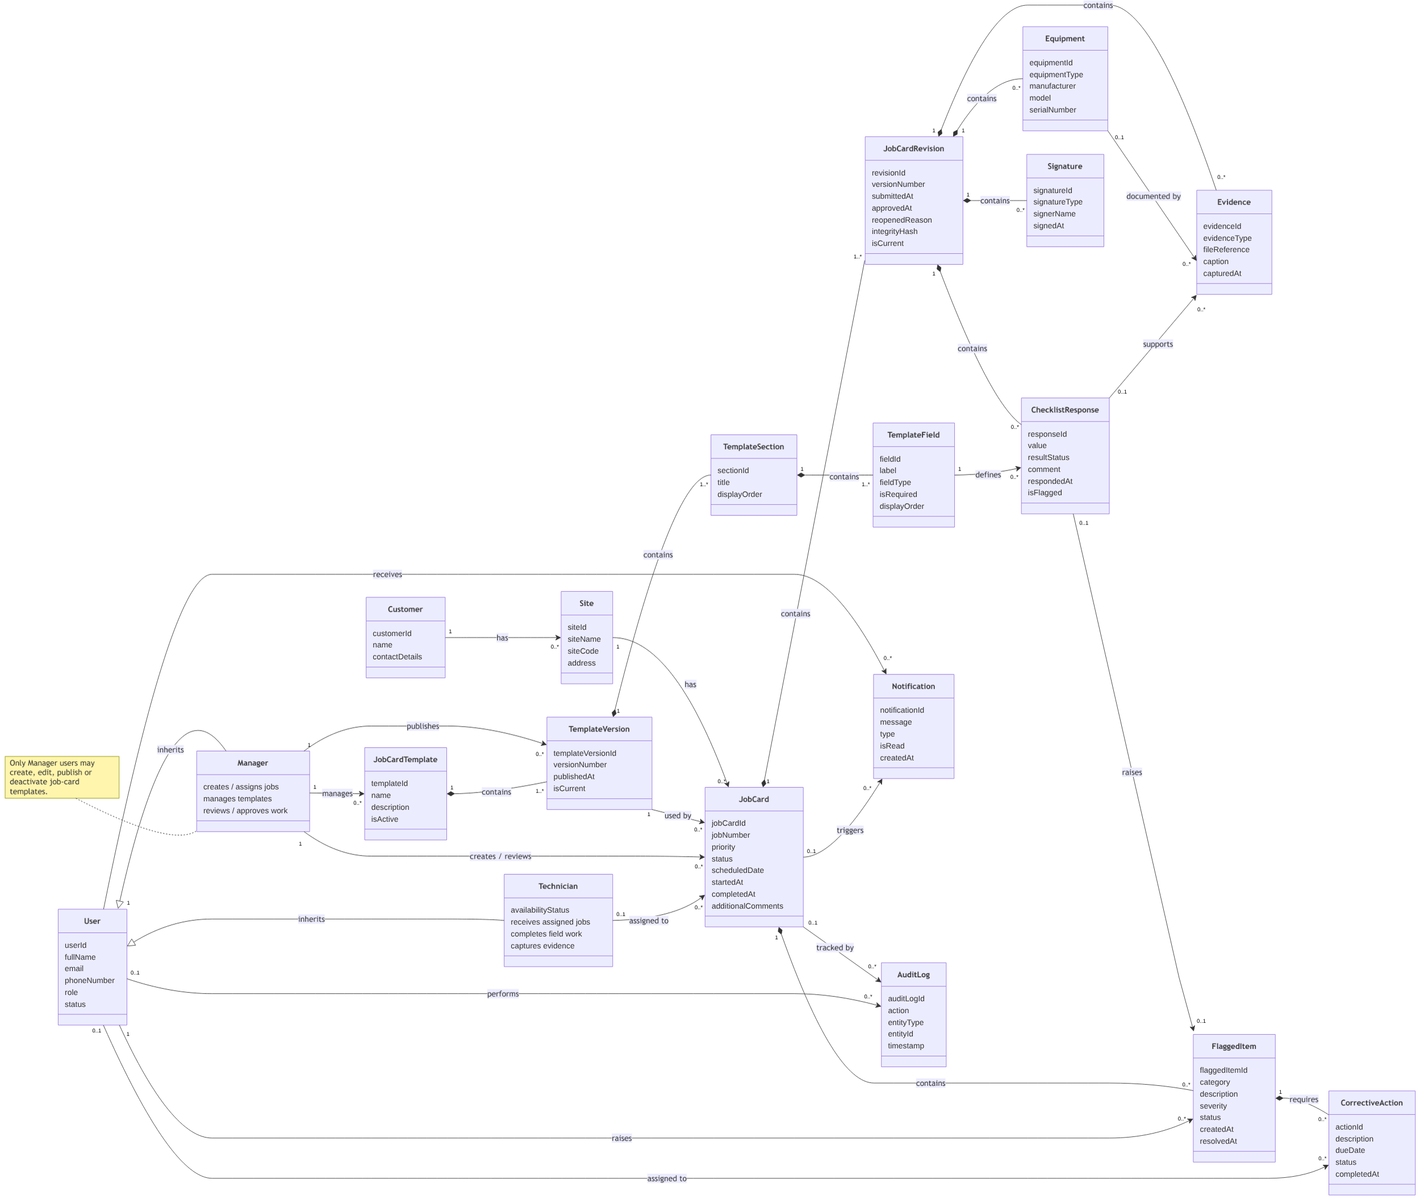
Figure 5 Domain Class Diagram

Core user role
The user will represent an authenticated person within the Smartjob and will then store the shared identity information. The manager then makes the job cards, creates the job cards and manages these job cards that then gets approved and reviewed by the manger for the work that was completed. The technician then receives the job cards that were assigned, captures the supporting evidence and then also performs the field activities.
There is an availability concept that is included by the technician as the manager prototype talks about technicians who are then available, on job or off duty. The availability is different from the job status; it describes the technician rather than the lifecycle of the job.
The domain model that was updated carefully connects the manager to the JobCardTemplate and Template version. The manger takes care of all the reusable templates and then publishes them. The manger only template constraint is shown as the client has said/confirmed that only the mangers can create, edit, publish or deactivate job card templates.

Customer, Site and JobCard
Customer represents a Verteco client and Site represents a physical location belonging to that customer. A customer may have many sites, while each site belongs to one customer. A site may accumulate many job cards over time, supporting historical maintenance and service records without repeating customer or site data in every job.
JobCard is the central business aggregate. It identifies the work, site, priority, schedule and lifecycle state. A job may exist before a technician is assigned, so technician assignment is optional until the manager selects a technician.

Job Lifecycle
The lifecycle terminology is Draft, Assigned, Accepted, In Progress, Awaiting Approval, Completed, Reopened and Cancelled. Flagged is not a job status. A flag represents an issue associated with a job and may coexist with another lifecycle state, for example an In Progress job with a flagged issue.

Template Versioning
JobCardTemplate identifies a reusable type of job card. TemplateVersion preserves each published version, with each version containing TemplateSections and TemplateFields. A JobCard references a specific TemplateVersion rather than only the current template. This prevents later template edits from silently changing the structure of historical jobs.

Job Revisions, Responses and Evidence
JobCardRevision preserves submitted and reopened versions of a job so reviewed or signed submissions remain traceable rather than being overwritten. ChecklistResponse stores the technicians answer to a specific TemplateField for a particular revision. Equipment stores equipment handled during the job, including serial numbers. Evidence stores photographs or supporting files and can be associated with the revision, a checklist response or equipment. Signature stores technician and client sign off records distinguished by signature type.

Flags, Corrective Actions, Notifications and Audit
FlaggedItem stores issues raised during work, including category, severity and status. CorrectiveAction records follow up work arising from a flag. Notification informs users of events such as assignment, submission or reopening, while AuditLog records important business actions for traceability.

Domain Relationship Summary
Parent | Child | Cardinality | Reason
User | Manager / Technician | Generalisation | Manager and Technician inherit shared User identity information.
Customer | Site | 1 : 0..* | One customer may have many sites; each site belongs to one customer.
Site | JobCard | 1 : 0..* | A site may have many jobs over time.
Manager | JobCard | 1 : 0..* | A manager may create and review many jobs.
Technician | JobCard | 0..1 : 0..* | A job may be unassigned; a technician may receive many jobs.
Manager | JobCardTemplate | 1 : 0..* | Managers manage reusable job-card templates.
Manager | TemplateVersion | 1 : 0..* | Managers publish template versions.
JobCardTemplate | TemplateVersion | 1 : 1..* | Each reusable template maintains one or more versions.
TemplateVersion | TemplateSection | 1 : 1..* | A published version contains one or more sections.
TemplateSection | TemplateField | 1 : 1..* | A section contains one or more fields/questions.
TemplateVersion | JobCard | 1 : 0..* | Each job is tied to the exact template version used when created.
JobCard | JobCardRevision | 1 : 1..* | The job identity remains stable while revisions preserve versions.
JobCardRevision | ChecklistResponse | 1 : 0..* | Responses belong to a particular job revision.
TemplateField | ChecklistResponse | 1 : 0..* | A response is recorded against a defined template field.
JobCardRevision | Equipment | 1 : 0..* | A revision may document multiple equipment items.
JobCardRevision | Evidence | 1 : 0..* | A revision may contain multiple evidence files.
ChecklistResponse | Evidence | 0..1 : 0..* | Evidence may support a particular checklist response.
Equipment | Evidence | 0..1 : 0..* | Evidence may document a particular equipment item.
JobCardRevision | Signature | 1 : 0..* | Technician/client sign-offs are stored independently.
JobCard | FlaggedItem | 1 : 0..* | A job may contain multiple issues.
ChecklistResponse | FlaggedItem | 0..1 : 0..1 | A checklist response may raise an issue.
User | FlaggedItem | 1 : 0..* | A user may raise multiple issues.
FlaggedItem | CorrectiveAction | 1 : 0..* | One issue may lead to several follow-up actions.
User | CorrectiveAction | 0..1 : 0..* | A corrective action may optionally be assigned to a user.
User | Notification | 1 : 0..* | A user may receive many notifications.
JobCard | Notification | 0..1 : 0..* | A notification may optionally relate to a specific job.
User | AuditLog | 0..1 : 0..* | An audit event may record the responsible user.
JobCard | AuditLog | 0..1 : 0..* | An audit event may optionally relate to a specific job.

Design Class Diagram
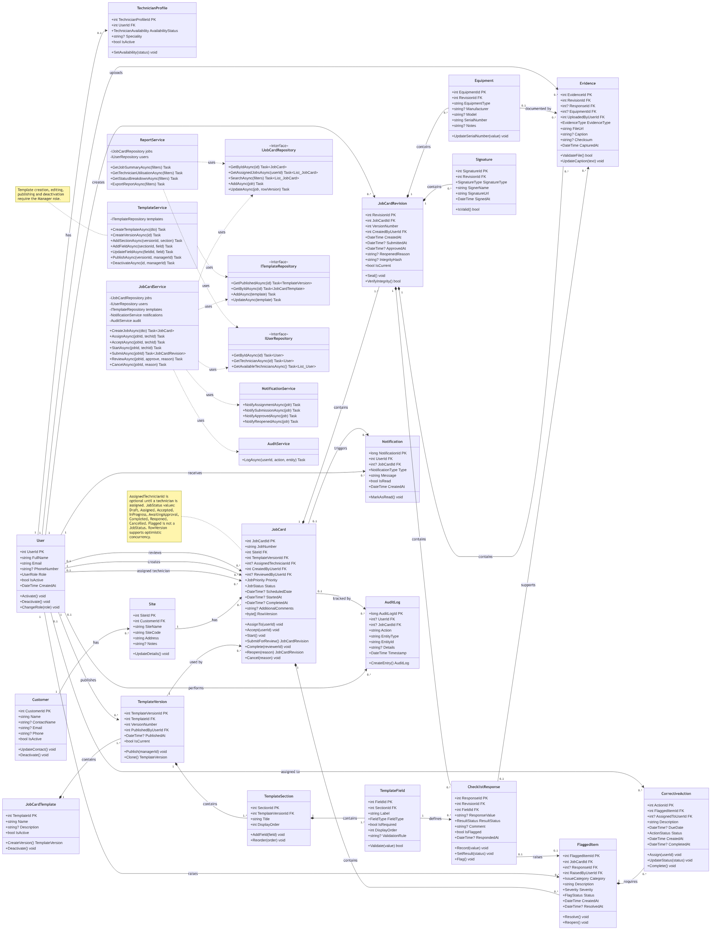
Figure 6 Design Class Diagram

Entity Classes and Operations
The implementation entities have data types, PK/FK annotations and business operations. The user stores the shared account information. The TechnicianProfile stores technician specific availability and speciality without duplicating identity data. Customer and Site model the client and physical location structure.
JobCard contains AssignTo(), Accept(), Start(), SubmitForReview(), Complete(), Reopen() and Cancel(). These methods correspond directly to the lifecycle transitions rather than allowing presentation code to change the status. JobCardRevision contains Seal() and VerifyIntegrity() so that a submitted or signed version can be kept and verified. TemplateVersion provides Publish() and Clone() to support controlled template changes.
ChecklistResponse, Equipment, Evidence and Signature represent structured field work data. Evidence includes the uploader, optional links to a checklist response or equipment item, a file URL, caption and checksum. FlaggedItem and CorrectiveAction represent issues and follow up work, while Notification and AuditLog provide traceability and user communication.

Specialised Repository Interfaces
The final design uses specialised repository interfaces rather than one generic repository. IJobCardRepository exposes job specific queries such as retrieving assigned jobs, searching/filtering, adding and optimistic concurrency updates. ITemplateRepository handles templates and published versions. IUserRepository provides user, technician and availability queries. This aligns with Vertecos clean architecture direction because application services depend on abstractions rather than on a particular SQL or ORM implementation.

Service Layer
JobCardService coordinates multi step use cases such as job creation, assignment, technician acceptance, starting work, submission, manager review and cancellation. It depends on IJobCardRepository, IUserRepository and ITemplateRepository, as well as NotificationService and AuditService. The template repository dependency is important because job creation must validate and retain the published TemplateVersion used by the new job.
TemplateService controls template creation, versioning, section/field management, publication and deactivation, with the Manager role restriction shown explicitly. NotificationService centralises assignment, submission, approval and reopening notifications. AuditService centralises audit event creation. ReportService supports job summaries, technician utilisation, status breakdowns and report export without introducing an unnecessary REPORTS database table.

AI Report Analysis
AI report analysis does not add an entity to the data model. When a Manager opens the analysis on the Reports page, the report statistics are summarised by the AI service at request time and the commentary is shown with the report; if the external provider is unavailable, locally generated insights are shown instead. The output is advisory only. Required fields, evidence, signatures and manager approval remain governed by deterministic business rules and human review.

Offline and Synchronisation Alignment
Offline mobile behaviour is supported by local SQLite/private app storage in the technician application and later synchronisation with the central service. The detailed synchronisation workflow belongs to the wider architecture design. This class/data design supports that workflow by keeping stable identifiers, revision history and concurrency information that can be reconciled when connectivity returns.

Optimistic Concurrency
JobCard contains RowVersion so the API and database can detect when an offline or stale client attempts to overwrite a newer server version. When a conflict is detected the change can be rejected or routed for review rather than silently overwriting valid data.

Key Enumerations
Enumeration | Representative values
UserRole | Manager, Technician
JobStatus | Draft, Assigned, Accepted, InProgress, AwaitingApproval, Completed, Reopened, Cancelled
TechnicianAvailability | Available, OnJob, OffDuty
JobPriority | Low, Medium, High, Urgent
FieldType | Text, Number, YesNo, Select, Date, Photo/Evidence where required by template
ResultStatus | Implementation-defined checklist result values, e.g. Completed/Outstanding/NotApplicable
EvidenceType | Photo, Document or other supported evidence type
SignatureType | Technician, Client
IssueCategory | RoofDamage, WiringFault, EquipmentDefect, SiteAccessIssue, CustomerConcern, SafetyHazard, Other
Severity | Low, Medium, High; Critical only if retained by the final group implementation
FlagStatus | Open, UnderReview, Resolved
ActionStatus | Open, InProgress, Completed
NotificationType | Assignment, Submission, Approval, Reopened and other workflow notifications
ReportingAiStatus | Available, LocalInsights, NotConfigured, RateLimited, Unavailable (runtime status, not stored)

Choice of Technology for Data Storage

Primary Data Store: SQL Server / Azure SQL Database
The recommended data store for SmartJob is Microsoft SQL Server during development and Azure SQL Database in the deployed Azure environment. SmartJob contains strongly structured and highly related information. Customers have sites, sites have jobs, templates have versions, sections and fields and jobs have revisions, responses, equipment, evidence and signatures.
A relational database supports primary keys, foreign keys, unique constraints, transactions and indexes to enforce consistency. This is important when submissions affect several related records and when historical signed revisions must remain linked to the correct job and template version.

Media Storage: Azure Blob Storage
Photographs, PDFs, generated reports and signature images should be stored in private object/blob storage rather than as large binary values inside the SQL database. SQL stores metadata, ownership, file references/URLs, checksums and relationships. This keeps the relational database focused on structured business data while allowing media to remain precisely associated with revisions, responses and equipment.

Offline Mobile Store: SQLite / Private App Storage
The technician application requires local persistence because offline work is a confirmed requirement. SQLite is suitable for cached structured job information on the device, while evidence files can remain in private local application storage until synchronisation succeeds. The central Azure SQL database remains authoritative.

Scalability, Indexes and Schema Evolution
The model supports the clients growth estimates because high volume tables such as JOB_CARD_REVISIONS, CHECKLIST_RESPONSES, EVIDENCE, NOTIFICATIONS and AUDIT_LOGS can grow without duplicating customer, site, template or user data. Schema migrations should be version controlled with the application so development, test/UAT and production environments remain consistent.
Suggested index | Purpose
JOB_CARDS.JobNumber | Unique lookup for a known job number.
SITES.SiteCode | Unique lookup when selecting or locating a site.
JOB_CARDS.AssignedTechnicianId + Status | Technician ‘My Jobs’ and manager assignment views.
JOB_CARDS.Status | Status tracking and dashboard filtering.
JOB_CARDS.ScheduledDate | Daily/weekly scheduling queries.
JOB_CARDS.SiteId | Site history and customer-service queries.
TEMPLATE_VERSIONS.TemplateId + IsCurrent | Retrieve the currently published version.
NOTIFICATIONS.UserId + IsRead | Unread-notification queries.
JOB_CARD_REVISIONS.JobCardId | Retrieve revision history efficiently.
Child-table RevisionId foreign keys | Fast joins from a revision to responses, evidence, signatures and equipment.

Alternatives Considered
Alternative storage technologies were considered before selecting the final SmartJob data-storage approach. A document oriented database such as Azure Cosmos DB could provide flexible schemas and horizontal scalability however, SmartJob contains strongly structured and highly related business data, including customers, sites, job cards, template versions, revisions, checklist responses, equipment and corrective actions. Azure SQL Database is therefore more appropriate because the system depends heavily on relational integrity, foreign-key relationships, transactions, structured querying and reporting.
Storing photographs, signatures, PDFs and other evidence directly as binary data within SQL Server/Azure SQL Database was also considered. Although this would provide a single storage location, it would increase the size and cost of the relational database as evidence volumes grow. Azure Blob Storage was selected instead because it allows unstructured evidence to scale independently while Azure SQL retains the associated metadata, ownership, references and relationships.
A fully online mobile architecture without local storage was also considered. This approach would simplify data management but would not satisfy the confirmed requirement for technicians to continue working at sites with unreliable or unavailable connectivity. SQLite and private application storage were therefore selected for temporary local persistence, with the central Azure SQL Database remaining authoritative after synchronisation.

Entity Relationship Diagram
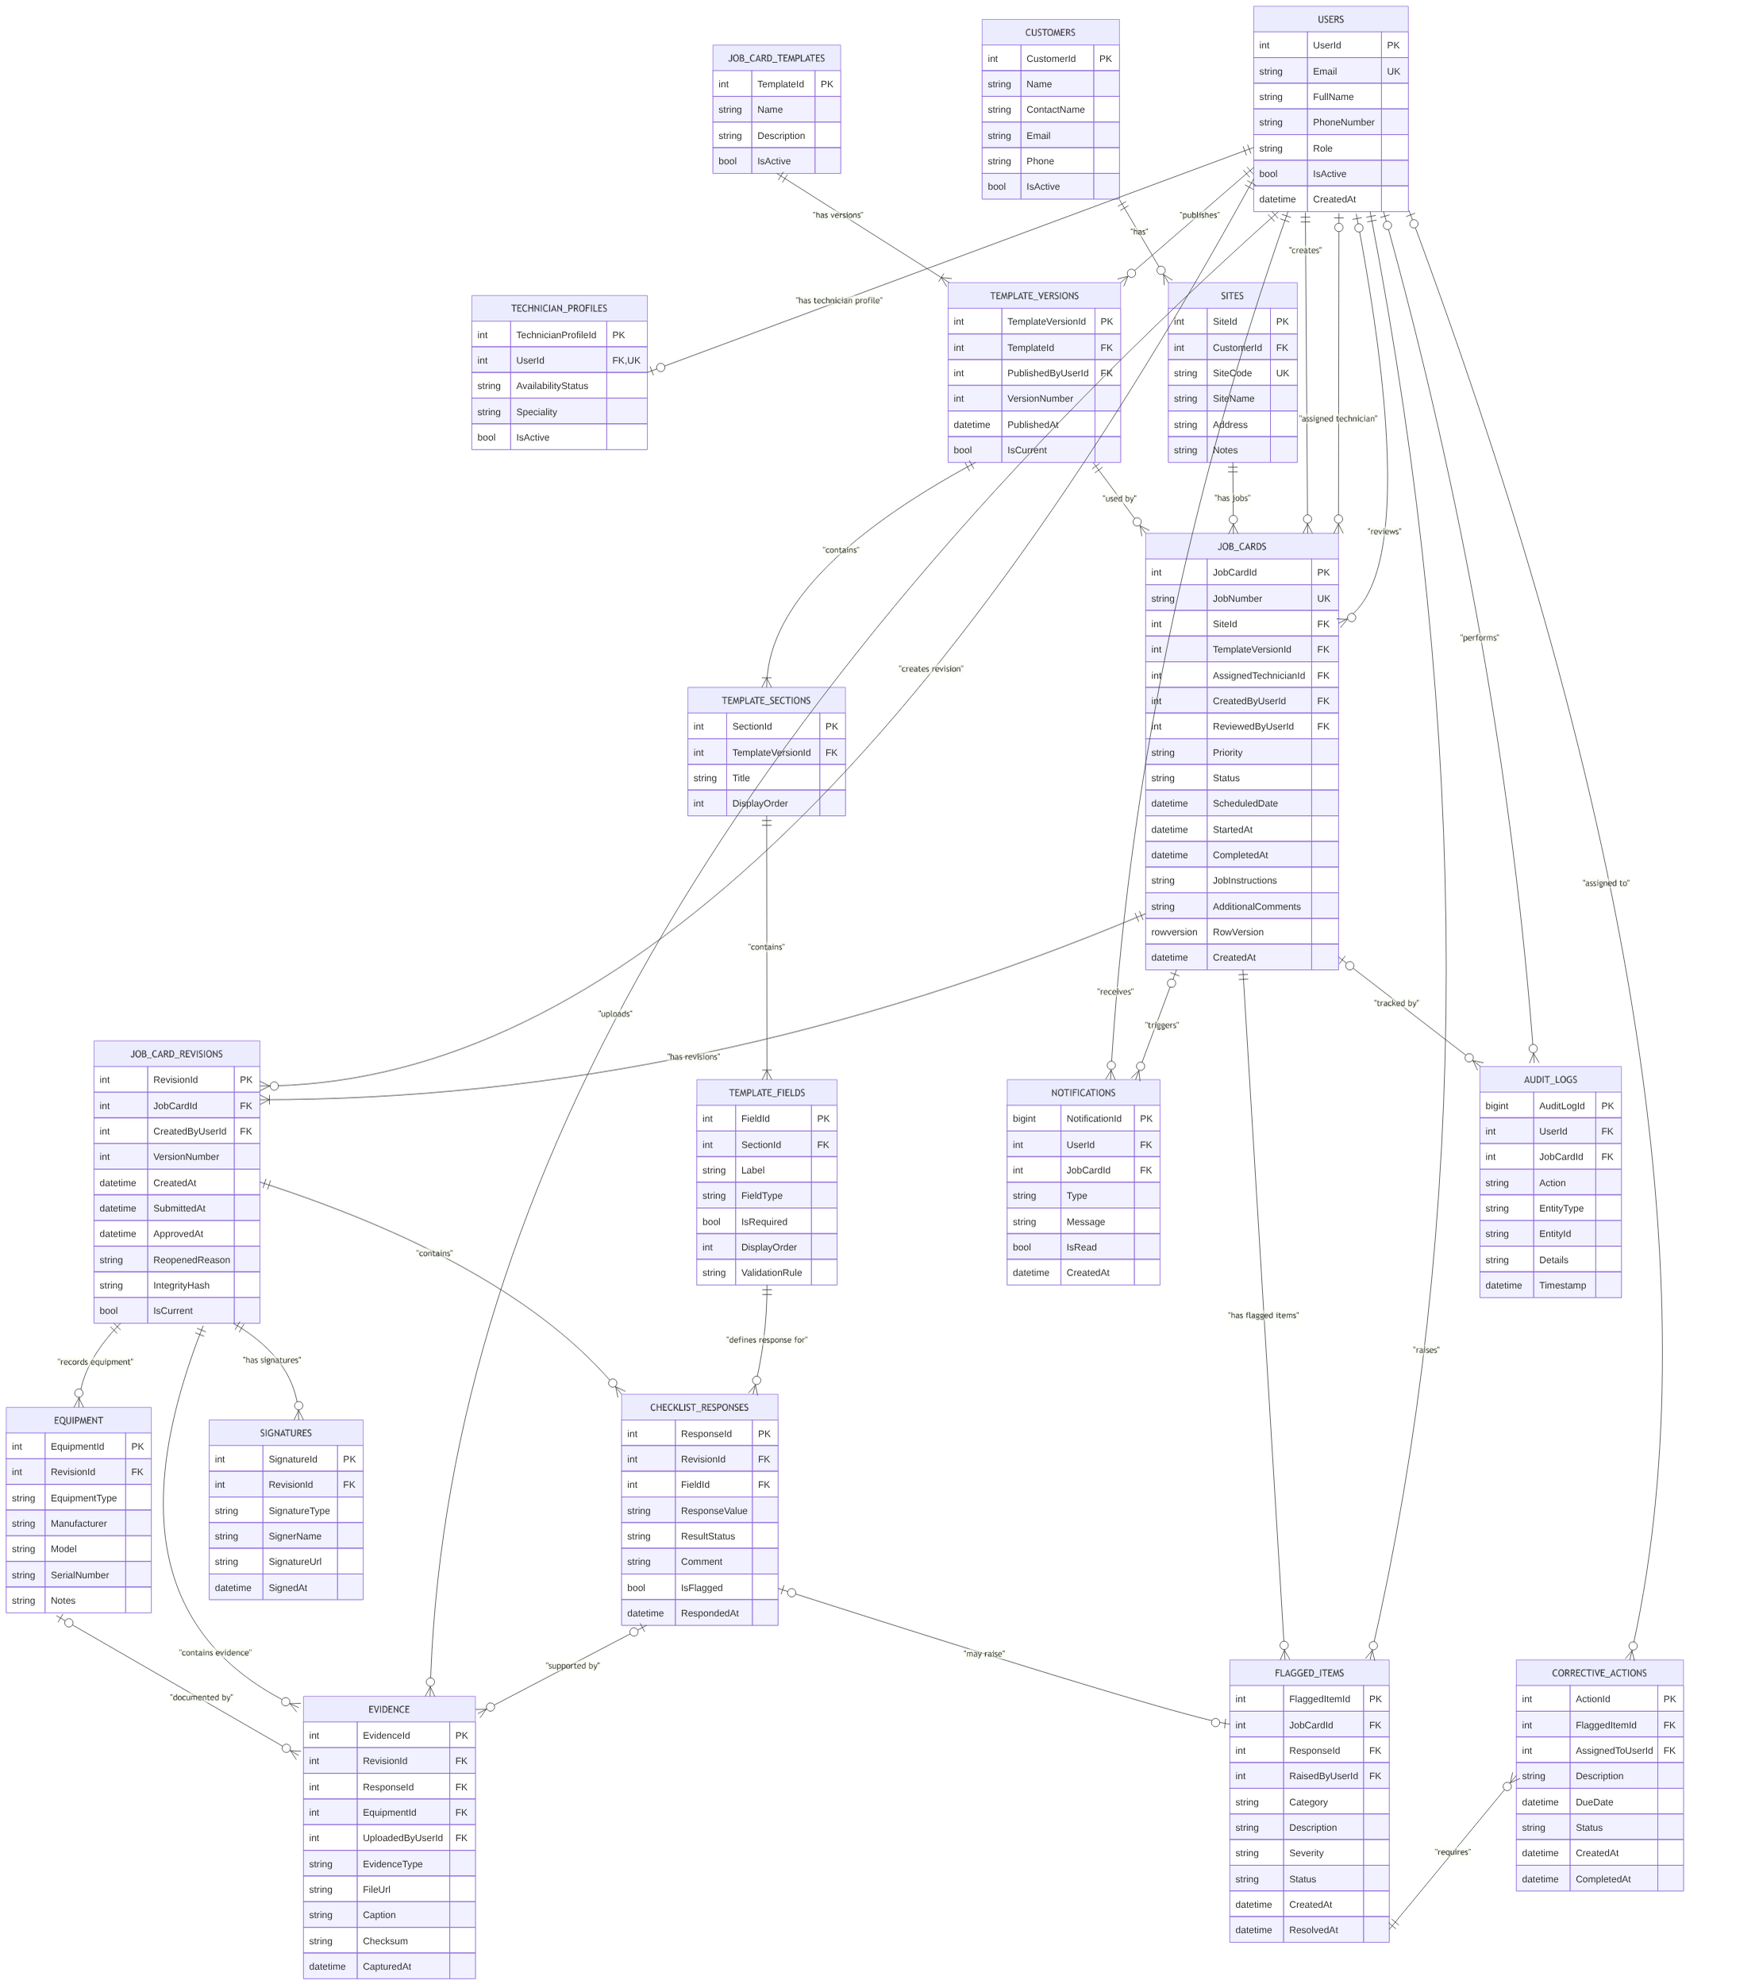
Figure 7 Entity Relationship Diagram

Major Database Entities
Entity | Purpose
USERS | Shared authenticated user identity and role information.
TECHNICIAN_PROFILES | Technician specific availability and speciality without duplicating user identity.
CUSTOMERS | Verteco client/customer records.
SITES | Physical customer locations; each belongs to one customer.
JOB_CARD_TEMPLATES | Stable reusable template identity.
TEMPLATE_VERSIONS | Published versions so historical jobs retain the exact template used.
TEMPLATE_SECTIONS | Ordered sections inside a template version.
TEMPLATE_FIELDS | Questions/fields inside a section.
JOB_CARDS | Stable identity and current lifecycle state of a job.
JOB_CARD_REVISIONS | Submitted/reopened versions of a job.
CHECKLIST_RESPONSES | Responses to template fields for a particular revision.
EQUIPMENT | Equipment and serial-number information recorded for a revision.
EVIDENCE | Metadata and private file references for photographs/documents.
SIGNATURES | Technician/client sign off records.
FLAGGED_ITEMS | Issues raised during work; independent from JobStatus.
CORRECTIVE_ACTIONS | Follow up actions for a flagged issue.
NOTIFICATIONS | User facing system notifications.
AUDIT_LOGS | Append-style business audit events.
REFRESH_TOKENS | Hashed refresh tokens that keep users securely signed in. Each records its expiry, revocation and the token that replaced it.
PASSWORD_RESET_TOKENS | Hashed, single-use password reset tokens with an expiry time and a used time.
MOBILE_SYNC_OPERATIONS | A record of each offline operation processed by the API (operation, type and result) so a retried upload is never applied twice.
MOBILE_SYNC_CHANGES | A record of which job changed and when, so the mobile app can pull only the changes since its last sync.

Referential Integrity
Foreign key | References
TECHNICIAN_PROFILES.UserId | USERS.UserId
SITES.CustomerId | CUSTOMERS.CustomerId
TEMPLATE_VERSIONS.TemplateId | JOB_CARD_TEMPLATES.TemplateId
TEMPLATE_VERSIONS.PublishedByUserId | USERS.UserId
TEMPLATE_SECTIONS.TemplateVersionId | TEMPLATE_VERSIONS.TemplateVersionId
TEMPLATE_FIELDS.SectionId | TEMPLATE_SECTIONS.SectionId
JOB_CARDS.SiteId | SITES.SiteId
JOB_CARDS.TemplateVersionId | TEMPLATE_VERSIONS.TemplateVersionId
JOB_CARDS.AssignedTechnicianId | USERS.UserId (nullable)
JOB_CARDS.CreatedByUserId | USERS.UserId
JOB_CARDS.ReviewedByUserId | USERS.UserId (nullable)
JOB_CARD_REVISIONS.JobCardId | JOB_CARDS.JobCardId
JOB_CARD_REVISIONS.CreatedByUserId | USERS.UserId
CHECKLIST_RESPONSES.RevisionId | JOB_CARD_REVISIONS.RevisionId
CHECKLIST_RESPONSES.FieldId | TEMPLATE_FIELDS.FieldId
EQUIPMENT.RevisionId | JOB_CARD_REVISIONS.RevisionId
EVIDENCE.RevisionId | JOB_CARD_REVISIONS.RevisionId
EVIDENCE.ResponseId | CHECKLIST_RESPONSES.ResponseId (nullable)
EVIDENCE.EquipmentId | EQUIPMENT.EquipmentId (nullable)
EVIDENCE.UploadedByUserId | USERS.UserId
SIGNATURES.RevisionId | JOB_CARD_REVISIONS.RevisionId
FLAGGED_ITEMS.JobCardId | JOB_CARDS.JobCardId
FLAGGED_ITEMS.ResponseId | CHECKLIST_RESPONSES.ResponseId (nullable)
FLAGGED_ITEMS.RaisedByUserId | USERS.UserId
CORRECTIVE_ACTIONS.FlaggedItemId | FLAGGED_ITEMS.FlaggedItemId
CORRECTIVE_ACTIONS.AssignedToUserId | USERS.UserId (nullable)
NOTIFICATIONS.UserId | USERS.UserId
NOTIFICATIONS.JobCardId | JOB_CARDS.JobCardId (nullable)
AUDIT_LOGS.UserId | USERS.UserId (nullable)
AUDIT_LOGS.JobCardId | JOB_CARDS.JobCardId (nullable)
REFRESH_TOKENS.UserId | USERS.UserId (deleted with the user)
PASSWORD_RESET_TOKENS.UserId | USERS.UserId (deleted with the user)

Unique and Integrity Constraints
- USERS.Email is unique so two accounts cannot share the same login email.
- TECHNICIAN_PROFILES.UserId is unique so a user cannot have duplicate technician profiles.
- SITES.SiteCode is unique so a site can be referenced consistently.
- JOB_CARDS.JobNumber is unique to prevent duplicate business job identifiers.
- TEMPLATE_VERSIONS uses a unique (TemplateId, VersionNumber) pair.
- JOB_CARD_REVISIONS uses a unique (JobCardId, VersionNumber) pair.
- CHECKLIST_RESPONSES uses a unique (RevisionId, FieldId) pair for a normal single-value field.
- JOB_CARDS.AssignedTechnicianId and ReviewedByUserId are nullable because assignment and review may not yet have occurred.
- JOB_CARDS.RowVersion is a database concurrency token so stale/offline changes can be detected.
- EVIDENCE stores a checksum where available to support file integrity checks.
- REFRESH_TOKENS.TokenHash and PASSWORD_RESET_TOKENS.TokenHash are unique, and only the hash of a token is stored.
- MOBILE_SYNC_OPERATIONS uses a unique (TechnicianId, OperationId) pair so the same mobile operation cannot be processed twice.
- MOBILE_SYNC_CHANGES is indexed on (JobCardId, ChangedAtUtc) so delta pulls find changed jobs quickly.

Normalisation

First Normal Form (1NF)
Each table contains atomic values and is identified by a primary key. Repeating groups are separated. For example, photographs are not stored as Photo1, Photo2 and Photo3 columns on JOB_CARDS; they are separate rows in EVIDENCE.

Second Normal Form (2NF)
Where a relationship depends on more than one business concept, its data is placed in an associative or child table. CHECKLIST_RESPONSES links a particular job revision to a particular template field; the response does not belong to the field definition alone.

Third Normal Form (3NF)
Shared descriptive data is stored once in its authoritative table rather than copied into related records. Customer data remains in CUSTOMERS, site data in SITES, user data in USERS and template definitions in the template/version structure. This reduces update problems and inconsistent duplicated values.

Traceability to System Requirements and Design
Group/client requirement | Design evidence
Manager-only template changes | Manager relationship and TemplateService constraint; JOB_CARD_TEMPLATES/TEMPLATE_VERSIONS.
Customer may have multiple sites | Customer 1:M Site; CUSTOMERS -> SITES.
Manager creates and assigns jobs | JobCard + JobCardService + optional AssignedTechnicianId.
Technician Android/iOS and offline | SQLite/private local storage alignment plus stable identifiers, revisions and RowVersion.
Checklist based on job template | TemplateVersion -> TemplateSection -> TemplateField -> ChecklistResponse.
Equipment and serial numbers | Equipment entity/table.
Photos and commissioning evidence | Evidence entity/table plus external Blob file URL/checksum.
Technician and client sign-off | Signature entity/table plus SignatureType.
Manager review/approval/reopen | JobStatus + JobCardRevision + JobCardService.
Preserve historical submitted versions | JobCardRevision + IntegrityHash + version number.
Flag issues and corrective action | FlaggedItem -> CorrectiveAction.
Notifications | Notification + NotificationService.
Audit trail | AuditLog / AUDIT_LOGS.
AI report analysis | ReportingAiResult returned at request time; advisory only.
Search/filter/reporting | Normalised relational schema + ReportService + recommended indexes.
Unassigned scheduled jobs | AssignedTechnicianId nullable.
Concurrency and offline conflicts | RowVersion supports optimistic concurrency and conflict detection.

UML Sequence diagrams

The following diagrams represent the six most important interactions that occur in the part of the business we are working with. Calls between the clients and the API uses HTTPS and versioned REST endpoints. Every request that changes data within the system requires authentication, and idempotency key and version token where applicable.

Manager creates and assigns a JobCard
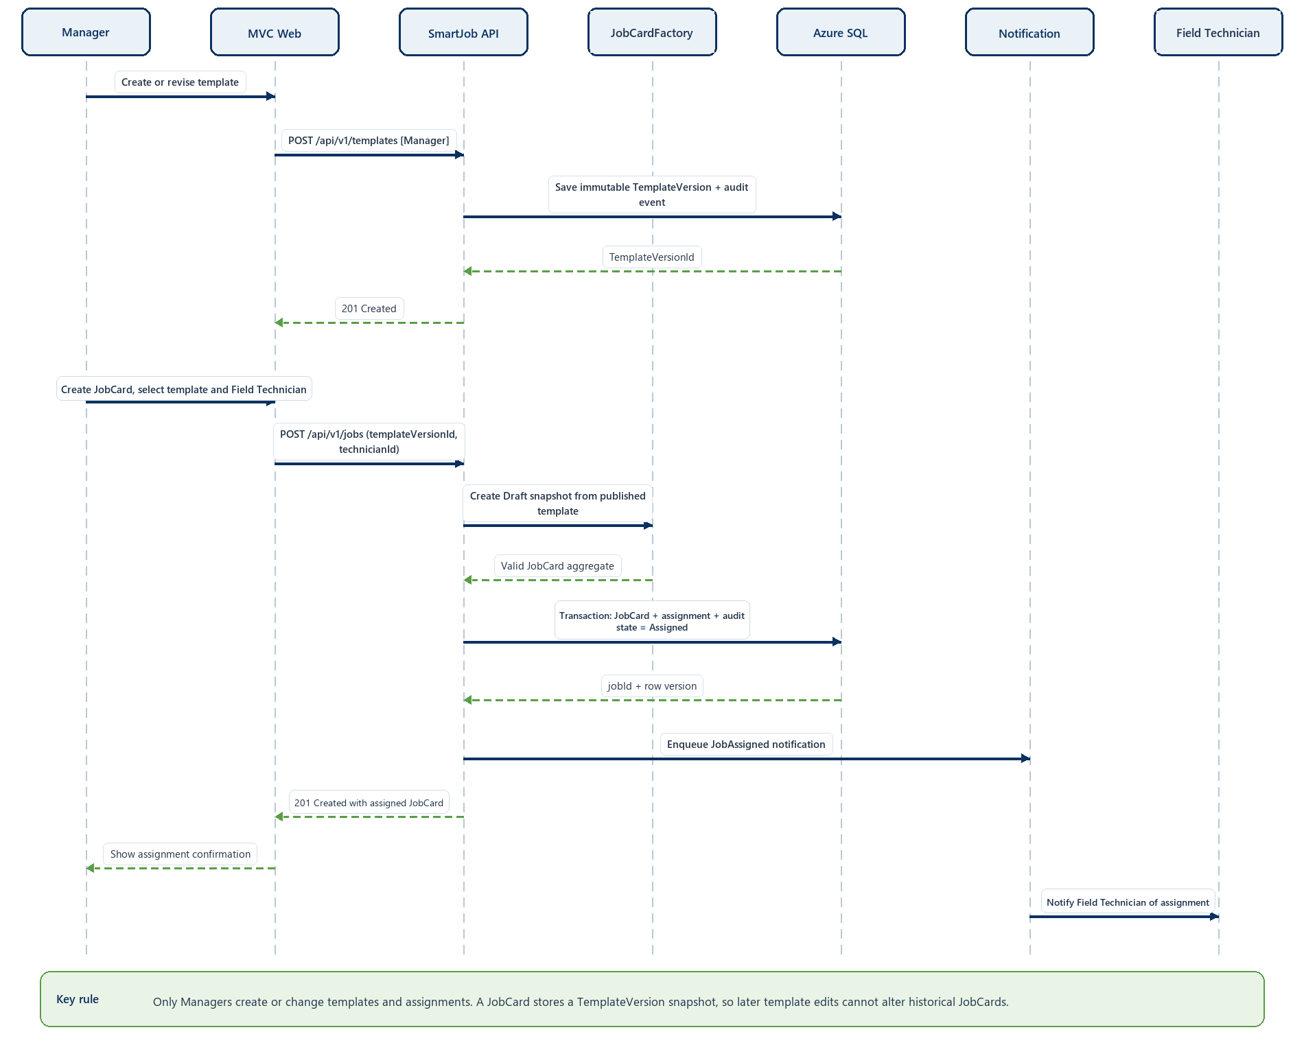
Figure 8 UML of manager creating a template version and assignment

- The manager handling the job must first be authenticated and authorised as well as the selected technician must have their account active.
- The system will create a snapshot of the selected template version so that any future template changes do not affect historical job cards.
- The job, technician assignment and the audit event are all stored together in one database transaction.
- If the notification fails, the job will still be created but the notification is retried separately.
- In the case of an invalid template, inactive technician, duplicate client reference or concurrency conflict the system returns an appropriate error message.

Field technician opens and updates a JobCard
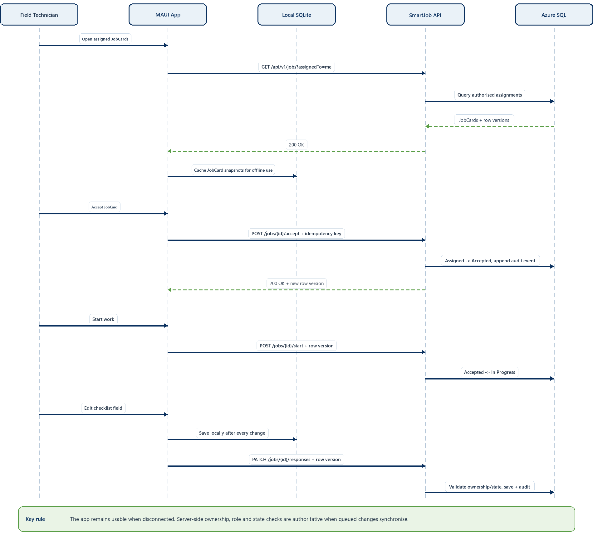
Figure 9 A field technician receives, caches accepts and updates their assigned job

- The API will only show assignments that belong to the authenticated technician. It will also verify ownership before allowing any access.
- The app stores the job card and template locally and will save progress after a field is updated.
- Accepting/ starting a job card is designed so that retrying the same request does not create duplicate state changes.
- If a technician is working on an outdated version of the job, the system will return a 409 conflict message and will send the changes through a merge or review process.

Field technician uploads evidence
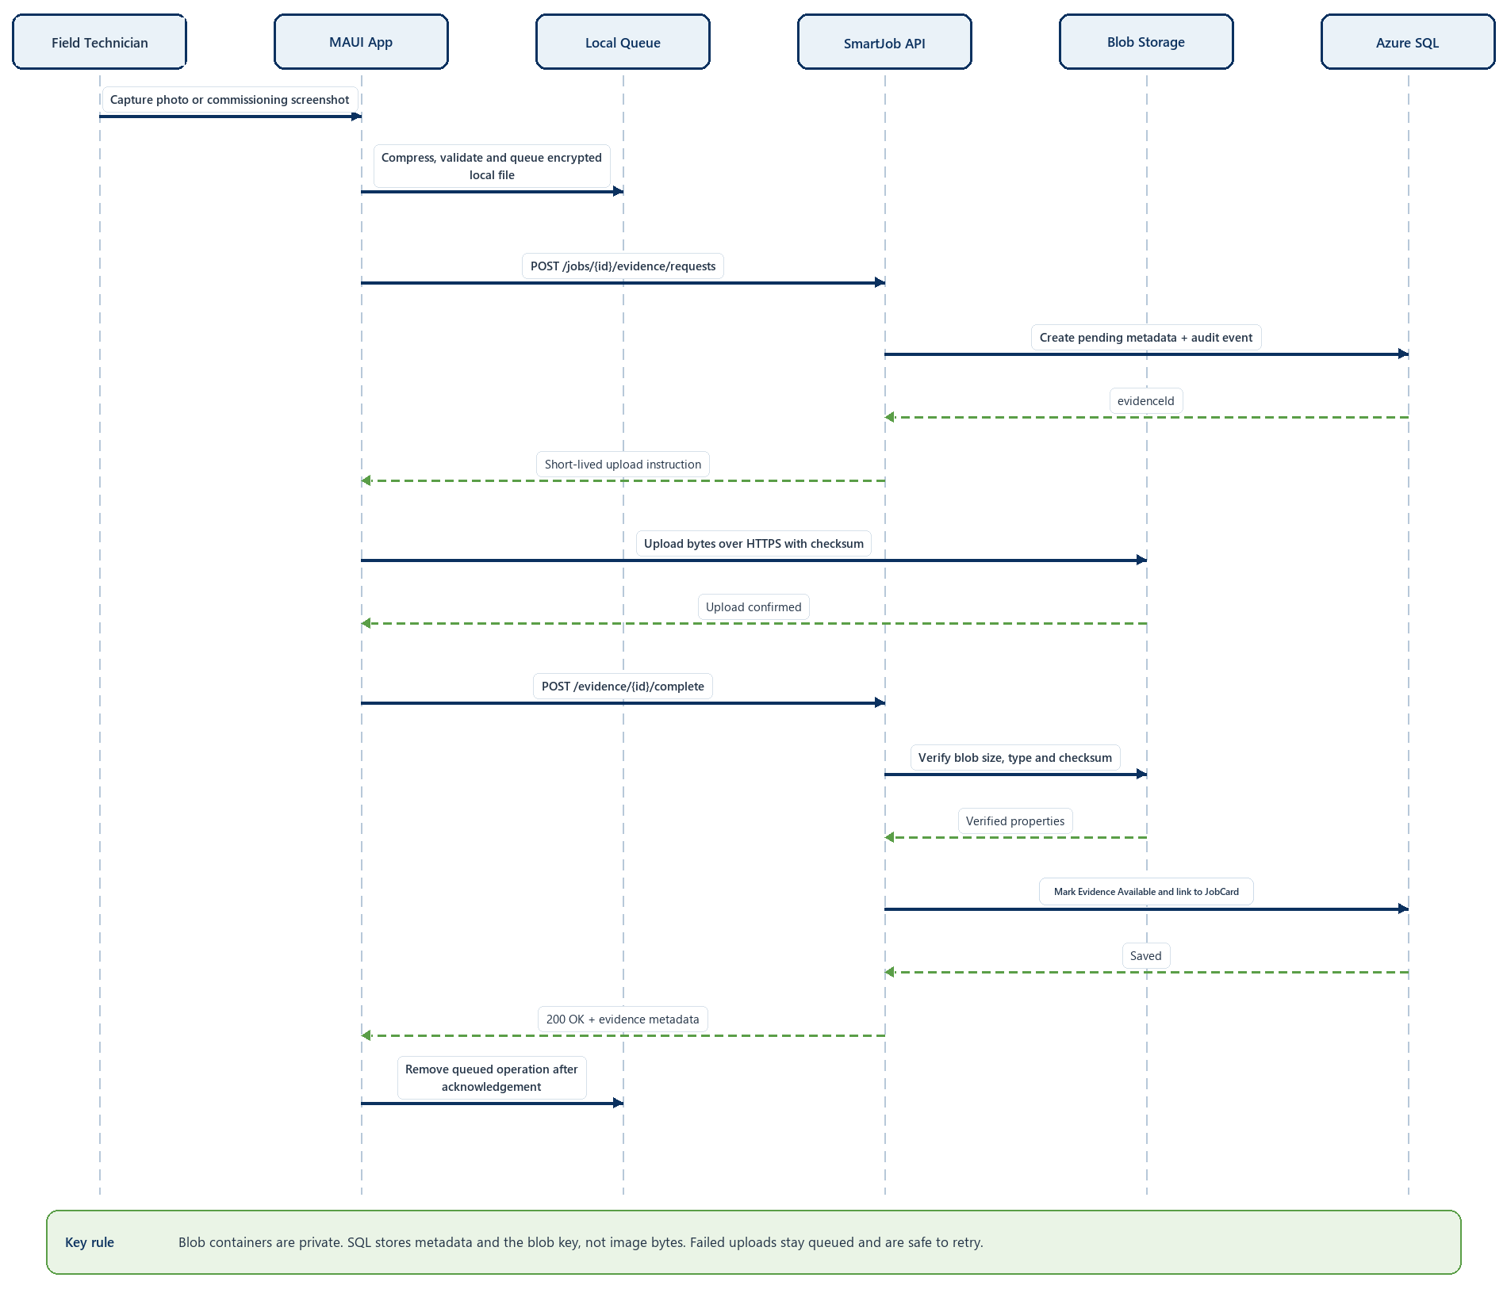
Figure 10 This shows the evidence capture, resumable and metadata persistence

- The app checks the file type, extensions and the size before uploading. The API will perform the same checks again to increase security and validation.
- Evidence files are all stored securely in a private Azure blob storage container. SQL will store the metadata (ownership, checksum, caption, and storage location).
- For Release 1 the evidence should be limited to compressed files with the file types: JPEG, PNG and PDF. The evidence will have configurable maximum files size and malware scanning.

JobCard submission and sign off
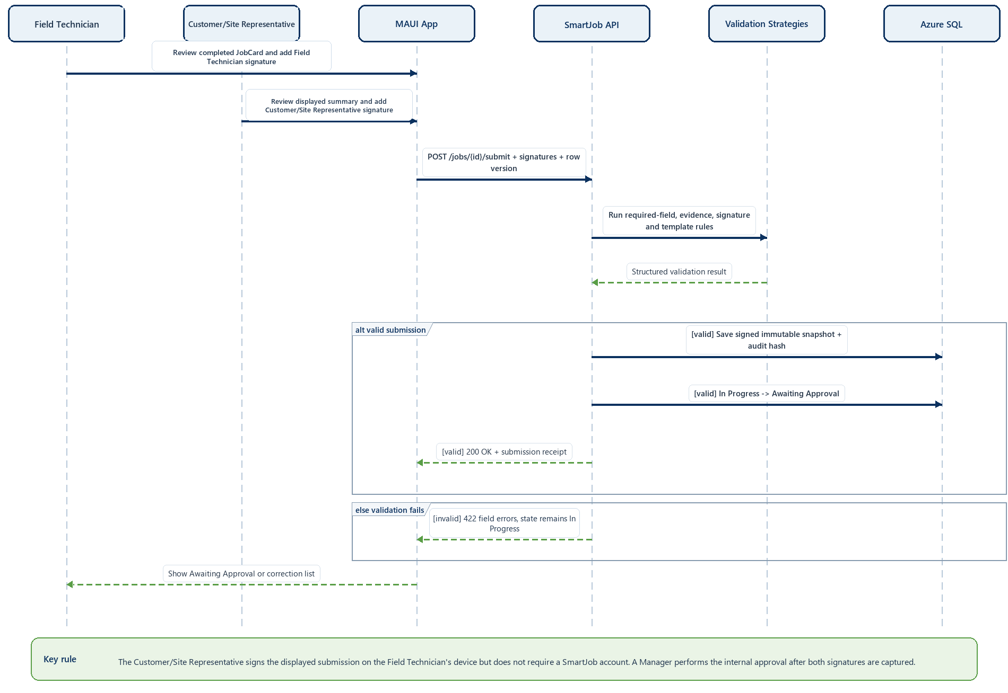
Figure 11 Field technician and Customer/Site Representative sign off followed by submission
- The device will display a clear and final summary of the job to the technician and client before either person signs it.
- The serve runs a series of validation strategies that checks that all required fields, evidence, signatures and template specific rules are filled out correctly.
- Once signed, the submission is to be saved as a specific version and then protected with a hash so that the signed record cannot be overwritten.
- If aby changes are needed, the system will create a new JobCardRevision while still keeping the original version.
- If any of the validation checks fail the JobCard stays In Progress and the API will show the specific fields that need correcting.

Manager approves or reopens JobCard
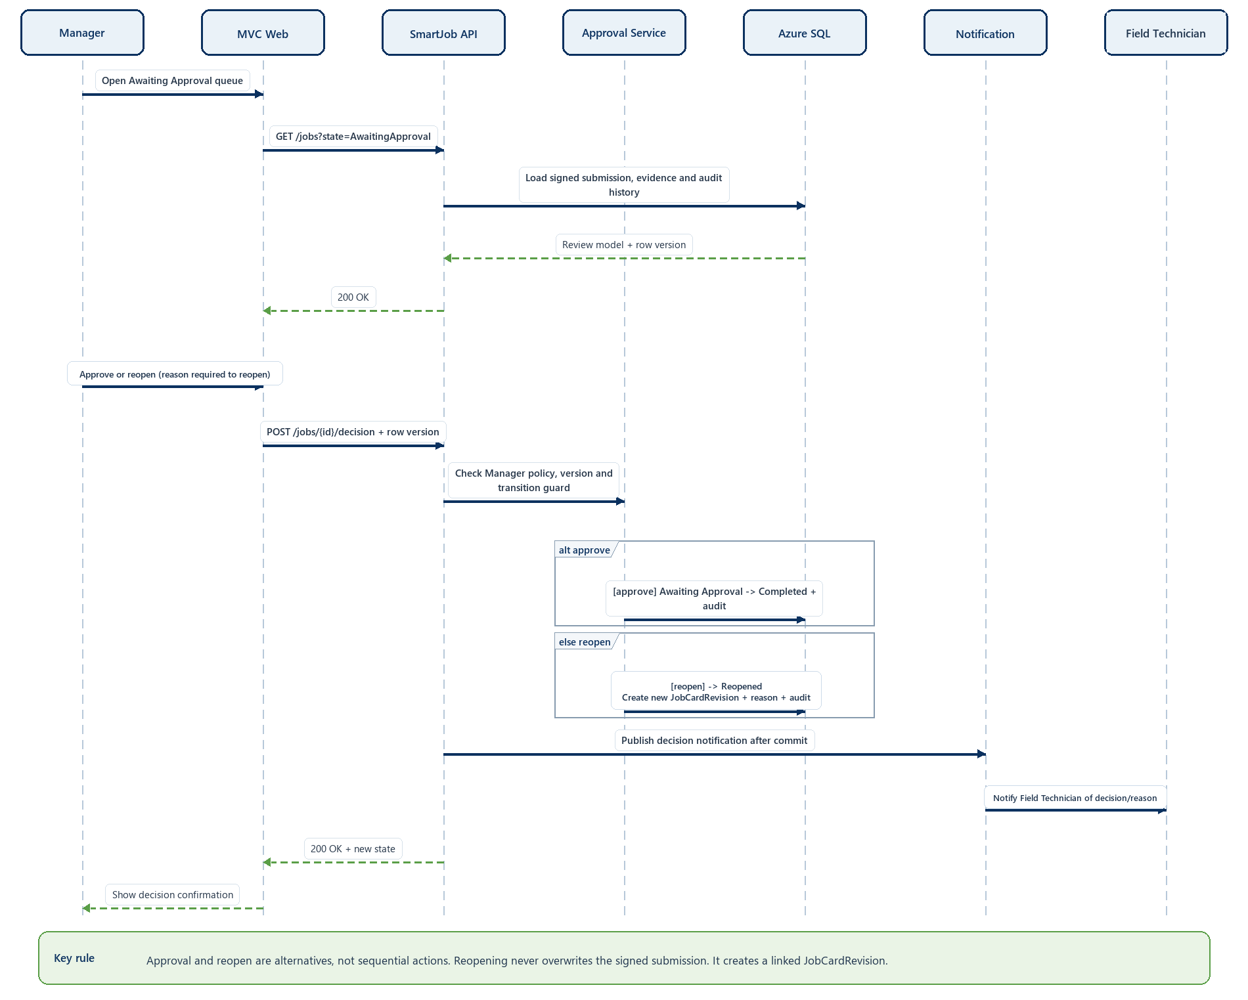
Figure 12 UML of manager approval decision and revision creation
- The manager can view all the submitted responses, media, signatures of the client and field technician as well as the audit trail.
- If the manager approves of the JobCard the status will change from Awaiting Approval to Completed.
- If the manager reopens the JobCrad, they must then provide a reason, and the system will then create a new Reopened revision.
- The technician will receive a notification on the manager’s decision and any reasoning for reopened JobCards.
- A manager cannot approve a submission if it has changed since they reviewed it. This ensures that they only approve the exact version that they have checked.
- A completed JobCard can only be opened by a manager, and the original version will always be kept for audit reasons.

Offline synchronisation
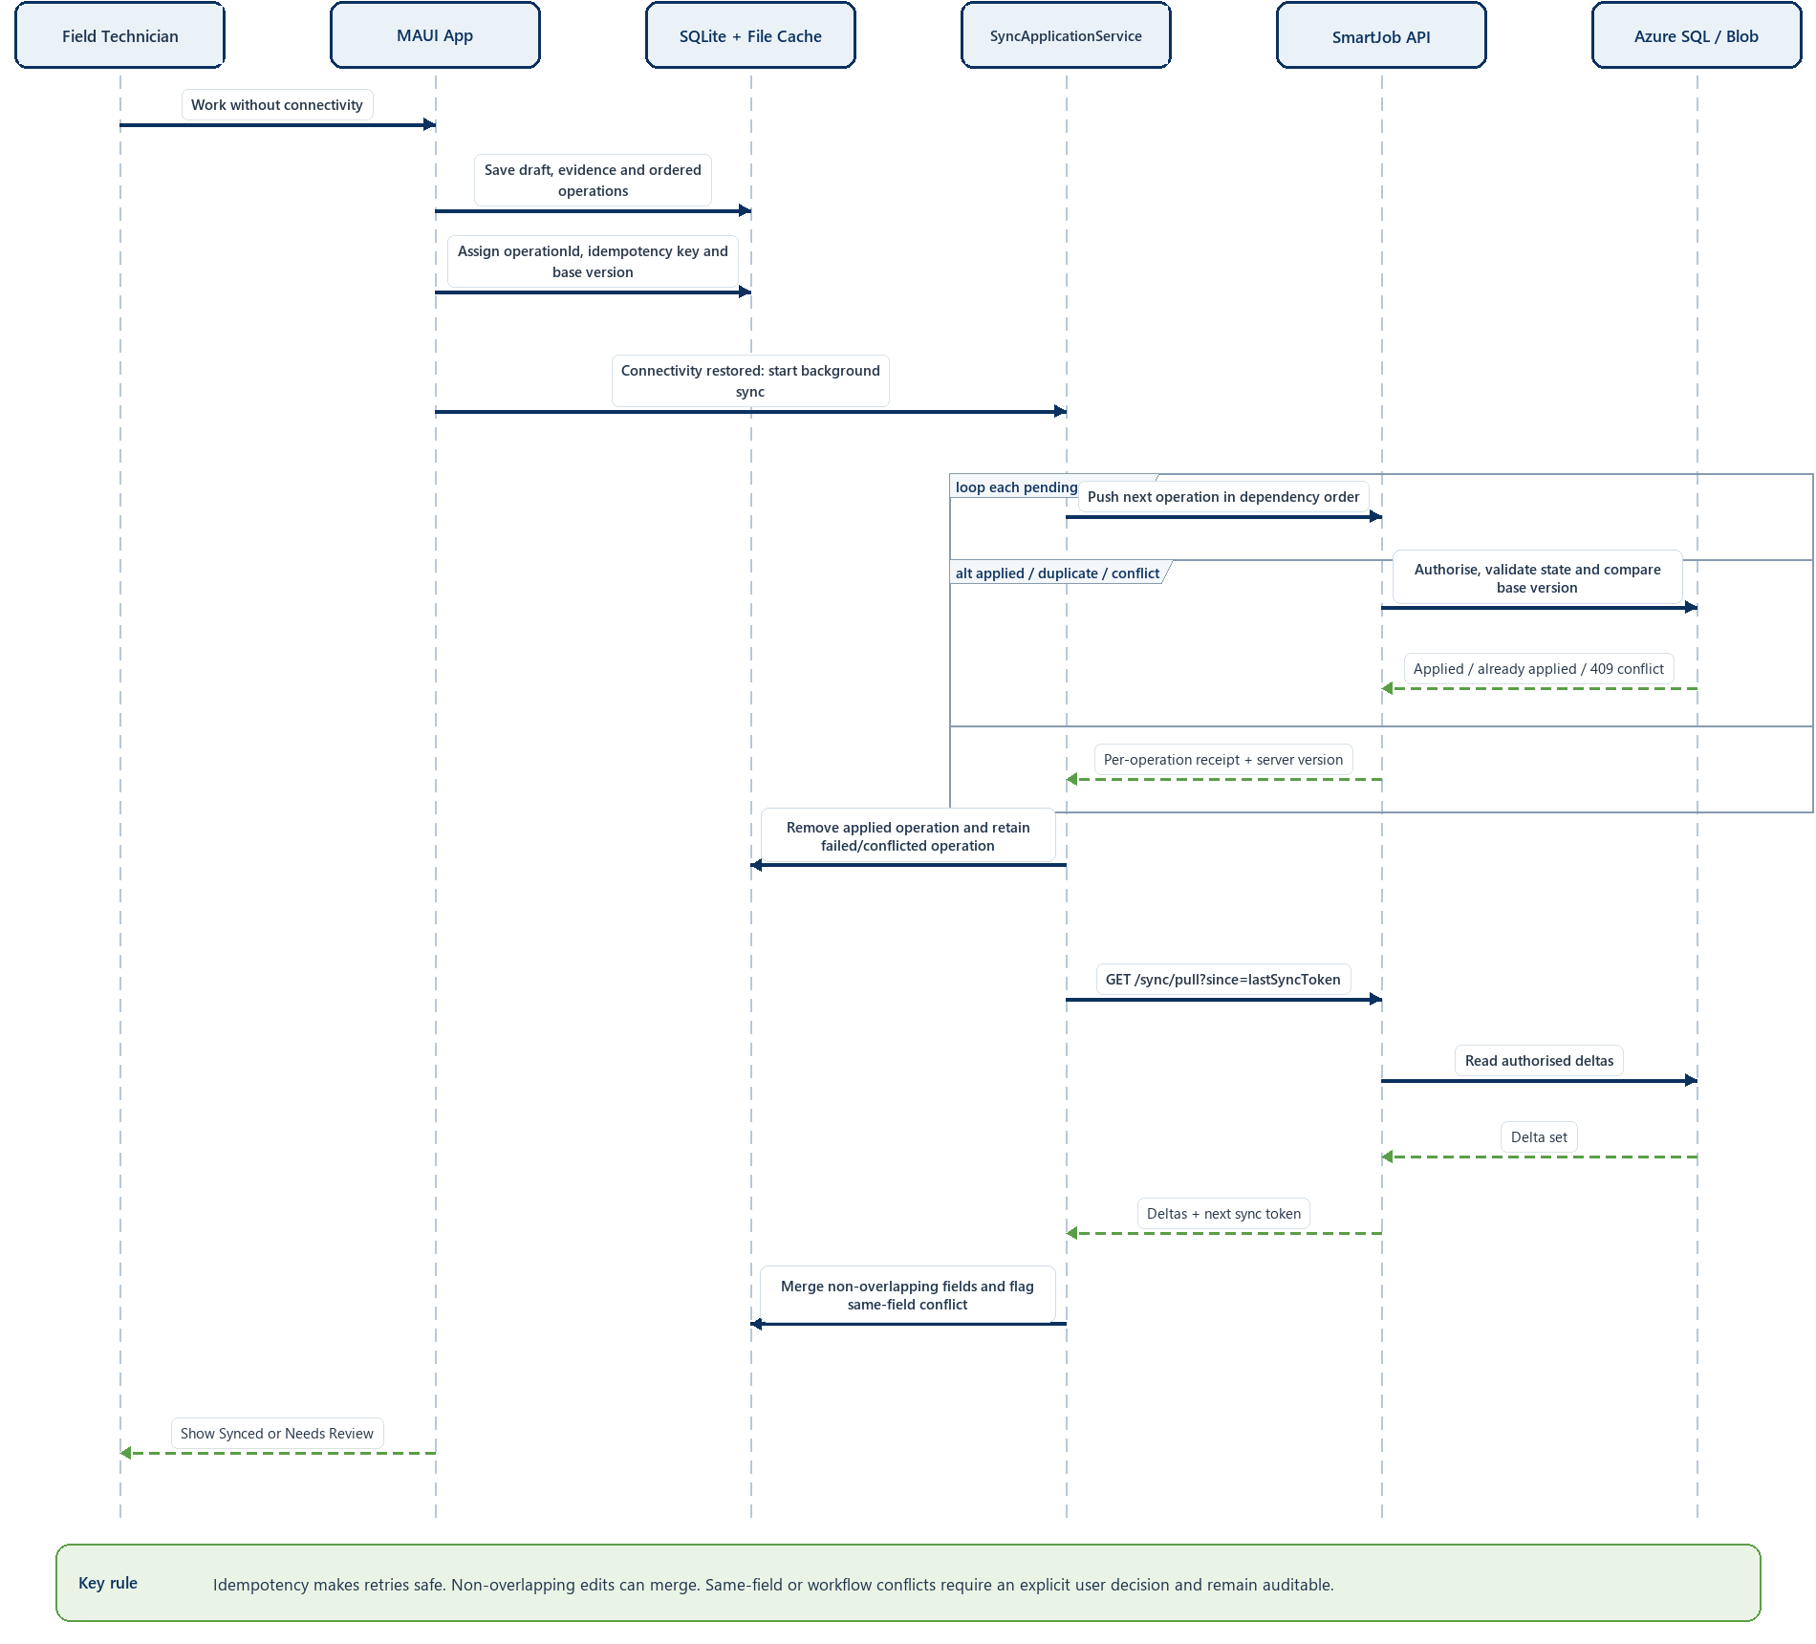
Figure 13 Offline operation queues and conflict handling UML
- SQLite stores the job details, responses, pending changes and synchronisation of information on the field technician’s device. Evidence files are securely kept in the app’s private storage.
- As soon as the device reconnects to the internet, all changes are synchronised in the correct order, with job response uploaded before the evidence is completed and the job is submitted.
- Idempotency keys will prevent repeated synchronisation requests from creating multiple of the same action. Concurrency checks detect weather the server version changed while the technician was working offline.
- Changes that have no conflicting issues will then be merged automatically.
- If the same field was changed in two places or if there was a workflow conflict, the change is then kept in the queue and are shown as Needs Review.

UML Job Card state diagram
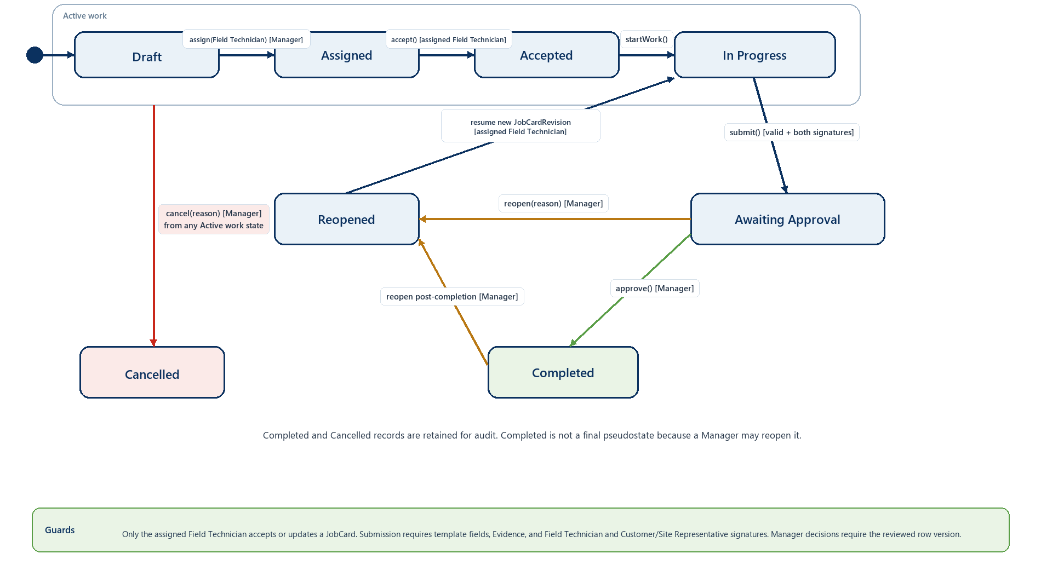
Figure 14 Job Card state machine with guarded manager and field technician transitions

State definitions
State | Meaning | Allowed owner action
Draft | Job exists but is not yet assigned. | Manager edits safe header fields, assigns or cancels.
Assigned | Field technician has been selected and notified. | Field technician accepts.  Manager may reassign/cancel before acceptance.
Accepted | Field technician acknowledges responsibility. | Field technician starts work.
In Progress | Checklist/evidence is being completed. | Technician updates, signs and submits.  Manager may cancel with reason.
Awaiting Approval | A signed immutable submission awaits internal review. | Manager approves or reopens.
Completed | Manager approved the submitted version. | Read/export except if manager reopen creates a revision.
Reopened | Manager rejected or reopened a version with a reason. | Assigned field technician resumes a new revision.
Cancelled | Work will not continue.  Record remains for audit. | This is read only.  Restoration requires a controlled new job or explicit policy.

Transition rules
Transition | Guard | Effects
Draft -> Assigned | Active field technician  Published template  Required header valid | Assignment, notification and audit event.
Assigned -> Accepted | Authenticated assigned field technician | Accepted timestamp and event.
Accepted -> In Progress | Assigned field technician.  Current version | Started timestamp and event.
In Progress -> Awaiting Approval | All required responses/evidence.  Field technician and client signatures | Immutable submission version, hash and manager notification.
Awaiting Approval -> Completed | Manager role  Reviewed version unchanged | Approval identity/time  Generated final report.
Awaiting Approval/Completed -> Reopened | Manager role  Non-empty reason | New revision linked to prior version.  Field technician notification.
Active -> Cancelled | Manager role  Non-empty reason  Policy permits state | Cancellation event.  Queued field technician edits rejected with explanation.

Architecture pattern

Client server and Clean Architecture
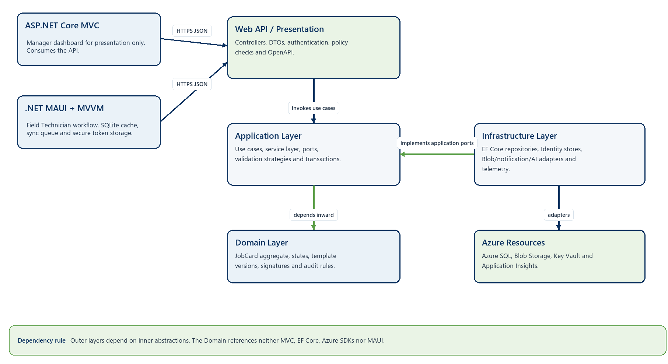
Figure 15 System level client server structure and inward dependency rule
At system level, SmartJob is a three client/component system. These components are the MVC manager web app, MAUI field technician app and a shared Web API. Inside the API Clean Architecture is implemented as pragmatic layers. The mobile application will use MVVM for screen state and commands. This will complement with the backend architecture rather than just replacing it.
Layer or component | Responsibilities | Must not do
Domain | JobCard aggregate, states/transitions and template versions, evidence/signature rules and domain events. | Reference EF Core, Azure SDKs, HTTP or UI frameworks.
Application | Use cases, services, validators/strategies, DTO mapping ports, authorisation requirements and transaction orchestration. | Contain SQL or Blob specific code.
Infrastructure | EF Core repositories, Identity persistence, Blob/notification/telemetry adapters and external AI adapters. | Decide business state transitions.
Web API | HTTP endpoints, authentication, role/resource policies, request validation, status codes and OpenAPI. | Expose entities directly or return raw errors.
MVC web | Manager dashboards, templates, assignment, approval and reporting UI  Consumes the API. | Access Azure SQL or Blob directly.
MAUI mobile | Field technician screens, MVVM, local SQLite/cache, evidence capture, sync and secure token storage (Microsoft, 2026a). | Treat offline state as authoritative over server policy.

Solution Structure
Project | Examples
SmartJob.Domain | Entities, value objects, state transition methods, domain exceptions and domain events.
SmartJob.Application | Commands/queries, interfaces, services, validators, strategies, mapping and policies.
SmartJob.Infrastructure | EF Core DbContext/migrations, repositories, ASP.NET Core Identity stores, Blob and notification adapters.
SmartJob.Api | Versioned controllers, authentication, filters/middleware, OpenAPI and health endpoints.
SmartJob.Web | ASP.NET Core MVC views/controllers/view models  Typed API client.
SmartJob.Mobile | .NET MAUI pages/view models, SQLite, sync engine, secure storage and platform services.
SmartJob.Tests. | Domain/application unit tests, APi integration tests, infrastructure tests and mobile sync tests.

Key architectural decisions
- The system will use a versioned REST API under /api/v1 with consistent error responses, pagination as well as filtering and OpenApi documentation. This keeps communication with the clients and the backend structured and reliable.
- Azure SQL will store any relational data because these records need strong relationships, reliable transactions and easy querying. The data includes jobs, assignments, template versions, users, responses and audit event.
- All photos, screenshots and any other evidence will be stored in Azure blob storage because of their large file size. If they were stored in SQL this would unnecessarily increase database size and backups.
- Optimistic concurrency uses row version or Etags to detect conflicting changes that can occur. Idempotency keys allow mobile requests to be safely retried without creating duplicates.
- Audit events will only be stored as append only records. This means previous events are preserved and new events are added instead of replacing existing history. Application logs will not be used as a replacement for this formal business audit trail.
- AI report analysis can summarise the report figures, but it does not take part in validation or approval. Required fields and submission rules are still checked using fixed rule-based validation before a job can be submitted.

Design patterns
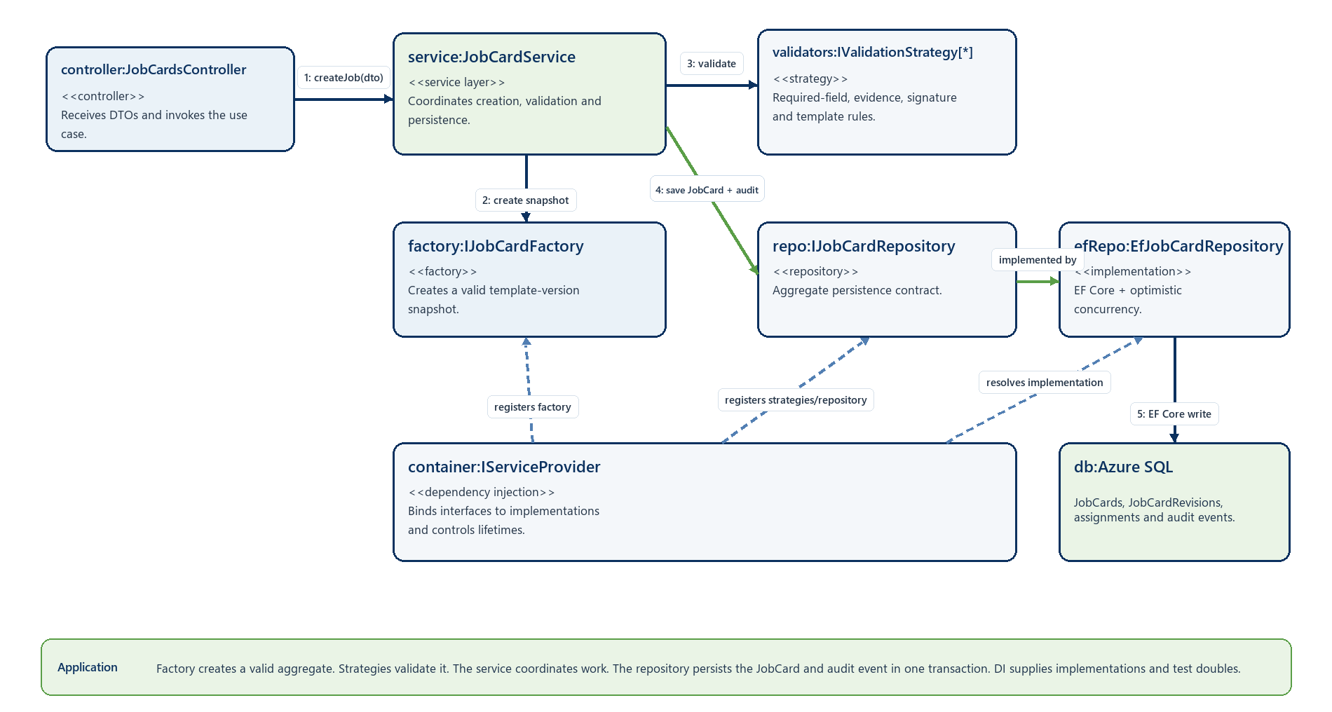
Figure 16 UML communication diagram showing the design pattern in the create/validate/persist use case
Pattern | Selection reason | Concrete SmartJob application
Repository | Keeps EF Core/storage mechanics outside domain/application logic and enables focused tests. | IJobCardRepository, ITemplateRepository and IUserRepository expose aggregate oriented methods. Avoid a generic repository that leaks IQueryable across layers.
Service Layer | Coordinates multi-step use cases and a transaction boundary without placing workflow logic in controllers. | JobCardService/CreateJobHandler, SubmissionService, ApprovalService and SyncApplicationService invoke domain methods, repositories and notifications.
Dependency Injection | Decouples abstractions from implementations, controls lifetimes and supports test doubles. | Register DbContext/repositories as scoped, stateless strategies/services as scoped or transient, and HTTP/Azure clients through typed factories.
Factory | Guarantees valid aggregate creation when inputs and template rules are non-trivial. | JobCardFactory creates a Draft snapshot from a published TemplateVersion, copies field definitions and initialises version/audit metadata.
Strategy | Allows different validation policies without a large conditional block. | RequiredFieldStrategy, EvidenceCountStrategy, SignatureStrategy and template/job-type strategies return structured validation failures.

Pattern interaction example
- The API controller maps request DTO and invokes the application service.
- The service will then ask the factory to create a valid JobCard snapshot from the selected template version.
- The request or submission is then validated and will return field addressable issues.
- Repository abstraction is called on by the service, and the JobCard is committed as well as the audit event. This all happens in one transaction.
- A domain/application event then triggers a notification after the transaction. A retry mechanism will send a notification later if the service is unavailable. The assigned job will not be reversed if a notification fails to deliver.

Deployment plan
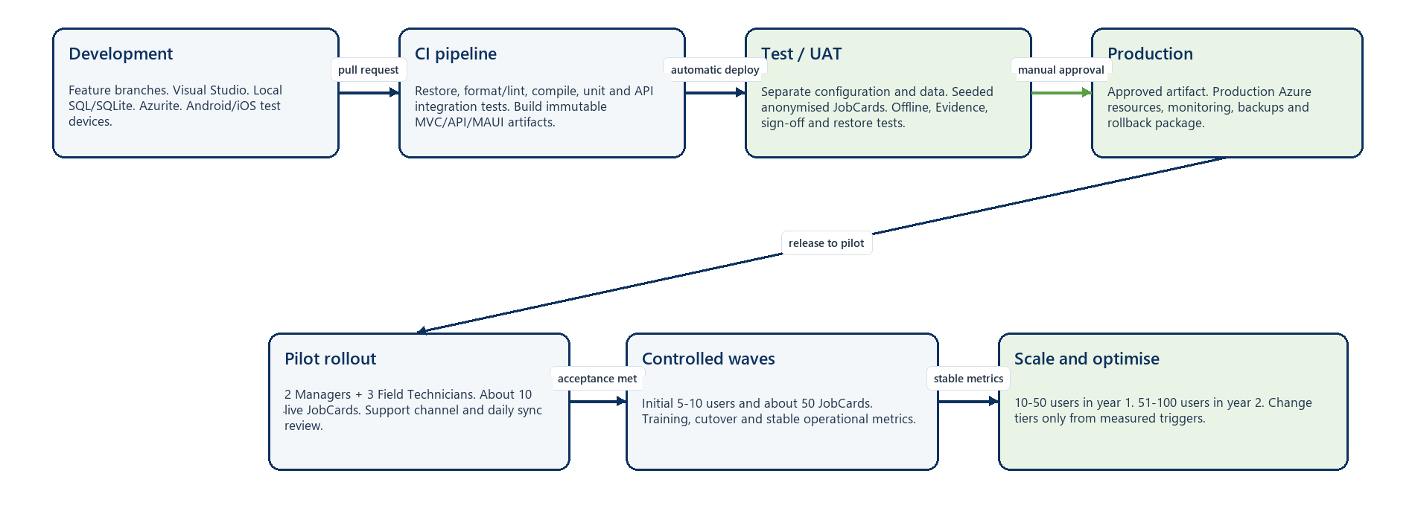
Figure 17 Diagram of the flow from development to rollout

Environments
Environment | Purpose and configuration | Data and access
Development | Local MVC/API with HTTPS development certificate  Visual Studio  LocalDB/SQL Server Developer Azurite  Android emulator and iOS simulator/paired Mac.  Local .env/user secrets. | Synthetic data only.  Developer accounts.  Migrations created and reviewed in source control.
Test / UAT | Deployed build from integration branch.  Separate app settings, SQL database and Blob container/account.  Seeded representative templates/jobs.  Same API contract as production. | Anonymised/synthetic data. Team and nominated Verteco pilot users. Lower-cost shared App Service plan where feasible.
Production | Approved tagged release.  Production SQL/Blob/Key Vault/telemetry,  Custom domain.  HTTPS only.  Monitored migrations and rollback package. | Real operational data.  Least-privilege user and Azure RBAC access. No developer shared credentials.

Rollout strategy
Phase | Users/jobs | Exit criteria
Internal alpha | Project team.  Synthetic and sample job card | All critical flows pass.  No unresolved P1/P2 defects.  Offline queue survives restart and retry.
Verteco pilot | 2 managers + 3 field technicians.  About 10 live representative jobs. | At least 95% successful sync without intervention.  Signatures/reports accepted.  Backups restore tested.  Support process works.
Initial release | 5-10 total users.  Up to about 50 cards. | Controlled cutover from the previous process.  Verified migration/reference handling.  Stable telemetry and user training complete.
Year 1 expansion | 10-50 users.  50-200 cards. | Capacity, support and cost review  Adjust App Service/SQL tier only from measured CPU, latency, storage and concurrency.
Year 2 | 51-100 users.  201+ cards. | Define the actual upper job/evidence volume.  Test load and restore targets  Consider higher redundancy and deployment slots.

How users will access the system
- Managers can access SmartJob through a modern browser by entering the correct HTTPS URL. The landing page will show the assignment, approval, progress, reporting, users and templates.
- Field technicians would need to install the .NET MAUI Android or iOS application on their mobile device. Android pilot builds can be managed using internal distribution, but iOS builds will require macOS/Xcode and Apple Developer/TestFlight path to be distributed.
- Bothe clients (Web and mobile applications) will consume the same versioned Web API and will not connect directly to Azure SQL or Blob storage.
- When the mobile app is online it will download the assigned job. Field technicians are then able to work offline using secure local storage and any changes made are synchronised through the API when connectivity returns.
- SmartJob will work alongside SafetyCulture within Verteco’s existing environment. SmartJob will be the main system for all installation job cards. SafetyCulture will continue to be used for other Verteco processes, but release 1 does not synchronise users, templates, job cards or evidence between the two systems. The existing job cards made by SafetyCulture will remain available as read only historical records unless a separate migration is approved by Verteco.

Rollback

Application rollback: If nay issues are discovered on deployment, the system can return to the last stable version of the application. Standar-tier deployment swaps can be used in the future to switch back to a previous version more quickly (Microsoft, 2026c).
Database rollback: All migrations should be backwards compatible where possible. If there is serious corruption or data loss to the database, a new Azure SQL database can be made, validated and connected back to the application.
Mobile rollback: The API should be backward compatible with supported older versions of the mobile app. If there are any issues with a mobile feature, feature flags or kill switches can be used to disable it without affecting the rest of the system.

Azure cloud architecture
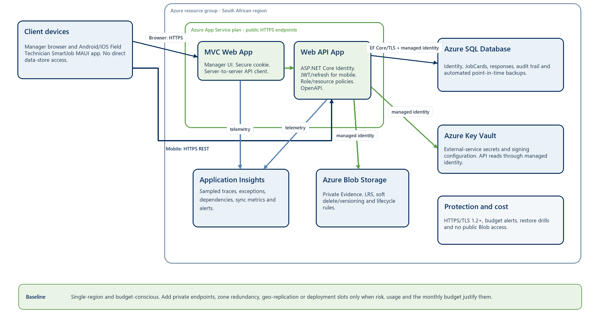
Figure 18 Budget conscious Azure production topology and trust boundaries

Azure service selection
Service | Purpose | Initial design choice
Azure App Service Plan | Compute for MVC and API apps. | One small shared production plan where feasible.  Separate Web and API apps.  Scale up/out only on metrics.  UAT can share a non-production plan or run on demand.
Azure SQL Database | Users/Identity, templates, jobs, responses, evidence metadata, signatures, versions and audit events. | Low-cost single database sized for the pilot.  EF Core migrations, indexes and automated backups.
Azure Blob Storage | Photos, screenshots, generated reports and optional documents. | General-purpose v2, private containers, LRS initially, soft delete/versioning and lifecycle rules.
Azure Key Vault | Secrets/signing configuration that cannot use direct managed-identity auth. | App Service managed identity with least-privilege secret access.  No secrets in appsettings or repository.
Application Insights / Azure Monitor | Request traces, exceptions, dependencies, sync health, custom business-safe metrics and alerts. | Sampling and retention caps to control cost.  Never log passwords, tokens, signatures or image content.
Azure DNS/custom domain | Friendly production address and managed TLS binding. | HTTPS-only.  Minimum TLS 1.2.  HSTS for web.

Authentication and Authorisation
- The mobile app will use short lived JWT access tokens as well as rotating refresh tokens to keep the users securely signed in. The token are stored in the secure storage of the device and any locally cached job data will remain private to the app and protected by device security.
- The MVC web application would use secure HttpOnly and SameSite cookies for user sessions and communicates with the API through the server. Bearer tokens will not be stored in the browser’s local storage.
- API endpoints enforce role policies and resource checks such as confirming that a technician is assigned to the job and that the job is in the correct state (Microsoft. 2026b).
- App service managed identity is separated from user authentication. It authenticates the deployed API to Azure SQL, Blob and Key Vault without storing cloud credentials inside the application (Microsoft, 2026e).

Network and Security Boundaries
- Internet clients would access only through secure HTTPS App Service endpoints and HTTP will redirect to HTTPS. Both the site and deployment/SCM endpoints should be set to a minimum of TLS 1.2 (Microsoft, 2026d).
- Azure SQL, Blob Storage and Key Vault are never directly accessed by mobile or web browser clients. Public Blob access is disabled.
- Service firewalls, managed identity and least privilege access are used to protect Azure resources.
- VNet integration and private endpoints could be added later if the security changes are needed and the budget allows for it.
- CORS permits only the approved web origin if browser APIs are required.

Backup, retention and recovery
Asset | Control | Verification
Azure SQL | Automated point-in-time backups (Microsoft, 2026f).  Retention configured to business need.  Optional long-term retention after policy approval. | Quarterly restore drill to a new database.  Record actual recovery time and data-loss window.
Blob evidence | LRS initially.  Soft delete and versioning  lifecycle policy,  Optional GRS when risk/budget grows. | Quarterly recovery sample.  Verify signed report links and checksums.
Configuration/IaC | Bicep or equivalent and environment configuration definitions in Git.  Secrets in Key Vault. | Recreate a non-production environment from source and documented runbook.
Mobile pending data | Local queue retained until acknowledged.  Users see information that hasn’t been synced count.  No promise that an unbacked-up lost device can be recovered. | Airplane-mode, app restart, low-storage and interrupted-upload tests.

Security
SmartJob will process operational and personal information relating to Verteco jobs, technicians, managers, clients, sites and equipment. The supplied job-card example includes site information, photographs, system details, commissioning evidence, equipment serial numbers and technician/client sign-off. Security controls are therefore required to protect confidentiality, integrity, availability and accountability.

Security Objectives
- Only authenticated users can access protected SmartJob functions.
- Users can perform only actions permitted by their assigned role.
- Job-card and inspection information is protected during transmission and storage.
- Uploaded site photographs and documents cannot be used to compromise the application.
- Important actions can be traced through audit logs.
- Personal information is handled in accordance with applicable privacy requirements, including POPIA considerations.

Authentication
Control | SmartJob implementation | Verification evidence
Account creation | Managers create or invite user accounts. The user must verify their email before gaining access to protected features. Where email confirmation is enabled. | Account lifecycle test and proof of confirmation
Password storage | When storing passwords, they are not stored as plain text, ASP.NET Core identity uses a strong secure password hash with a unique salt | System configuration and database inspections confirm that passwords are stored only as hashes
Password policy | Minimum length blocked common passwords, secure reset and no password disclosure in logs or support messages. | Positive and negative password tests
Brute-force protection | Rate limits, progressive delay or temporary lockout apply to repeated login and reset attempts. Security events are logged. | Automated lockout and rate-limit tests
Password reset | A short-lived, single-use reset token is delivered through the verified channel. Existing sessions can be revoked after reset. | Expired, reused and invalid-token tests
Mobile session | The system uses time reliant access tokens and rotating refresh tokens. If a devise is reported stolen or an account is disabled, the tokens are securely stored and revoked. | Expiry, refresh, reuse and revocation tests
Web session | Secure, HttpOnly and SameSite cookies. Session lifetime is the limited and state-changing requests that requires CSRF protection. | Cookie flag and CSRF integration tests
Privileged access | MFA is required for the privileged or administrative accounts where the selected identity setup supports it. | MFA enrolment and access test

Role-Based Access Control
Capability | Manager | Field Technician | Server rule
Users and roles | View, create, edit, suspend Deactivate and approve  Deletion | No access | Manager policy as well as audit event are required
Customers, sites and templates | Create and maintain | only ready when linked to an assigned job | Role plus resource relationship
Job assignment | Create, assign, reassign and cancel | View their own assignments | Active technician and valid template
Job execution | View progress | Accept, start and update only the assigned jobs. | Assignment ownership and valid state
Evidence and signatures | Review and export | They can capture and submit for assigned job | File, ownership, state and the required validations
Approval and reopen | Approve or reopen a JobCard with a reason | No approval authority | Manager policy and reviewed row version
Reports and audit | Access within the approved business scope | Own job history where permitted | Role, purpose and least privilege

Application and data security controls
Area | Control and mitigation | Verification
HTTPS | All browser, mobile and API traffic uses HTTPS with TLS 1.2 or later. HTTP redirects to HTTPS and production uses HSTS for the web application. | TLS configuration and redirect test
Input validation | The client validates and improves usability. The API then independently validates the identifiers, dates, numbers, text length, state, ownership and business rules. | Boundary, malformed and tampered-request tests
SQL injection | EF Core and parameterised queries are used. The user input is never linked into SQL. The database identity receives only required permissions. | Static review and injection tests
XSS | The user-controlled text is then outputted and encoded. Rich HTML is not accepted unless it is sanitised. The Content Security Policy and safe rendering reduce browser execution risk. | Stored and reflected XSS tests
CSRF | The Cookie-authenticated state changes require anti-forgery tokens. The SameSite and Secure cookie settings add a defence to be in depth. | Missing and invalid token tests
Secure file upload | This allows for listed JPEG, PNG and PDF only. Validate extension, signature, MIME type, size, ownership and checksum. Rename files, store outside web root in private Blob containers and scan before availability. | Invalid type, oversized, spoofed and malware-test-file cases
Encryption | The TLS protects data in transit. The Azure SQL and Blob encryption protects the data at rest. Device data then relies on app-private storage, platform encryption and secure key or token storage. | Configuration and device-storage review
Secrets | The production secrets are stored in Key Vault or secure environment configuration. Managed identity is preferred and secrets are never committed or printed in logs. | Secret scan and access-policy review
Audit logging | The login outcomes can be logged, user and role changes, job state changes, approvals, reopen reasons, exports and approved deletions with actor, time and record reference. Audit records are appended only. | Audit event tests and access review
Errors and logging | Return safe, consistent error messages. The detailed stack traces, tokens, passwords, signatures and image content are excluded from client responses and logs. | Error handling and log-content tests
Dependencies | There are lock dependencies that scan for known vulnerabilities and block unresolved high or critical findings in CI. | Dependency scan and approved exception record
Rate limiting | Apply limits to login, reset, upload, search and expensive report endpoints. Return a clear reply without leaking sensitive information. | Automated threshold and recovery tests

Mobile and Offline Security
- Only data and evidence needed for the assigned fieldwork should be cached on the device. This information must not be copied to public folders, photo galleries or unsecured backups. Cached data should be stored in protected application storage and removed when it is no longer required. These controls help reduce the risk of unauthorised access, accidental disclosure or data loss if a device is lost, stolen or shared with other users. Access and refresh tokens should be stored securely using Android Keystore or iOS Keychain. Tokens must never be stored as plain text in SQLite databases or application logs. The application should use private storage and the encryption provided by the device’s operating system. If an extra local encryption key is needed, it should be protected using hardware-backed secure storage where available.
- User sessions should expire after the approved period of inactivity or offline use, after which the user must sign in again. This reduces the risk of unauthorised access if a device is left unattended, lost or stolen. Session timeouts should now be enforced. If an account has been disabled, suspended or removed from from the organisation, the device should stop synchronising when it connects to the server.
- Offline changes should be queued with an operation ID, idempotency key, base version and checksum. When the device reconnects, the server must still validate the user’s role, ownership, record state and submitted data.
- The application should clearly show the number of pending and failed synchronisation attempts. Users must also be informed that unsynchronised data may not be recoverable if the device is lost, wiped or damaged.
- A clear lost-device procedure should be documented. This should include disabling the user’s account or refresh tokens, reviewing audit logs and checking whether any personal information may have been exposed.
- Devices that are unsupported or appear to be compromised should be blocked according to the approved mobile-device policy, where the platform provides the necessary controls. This is to help improve safety among the work.

POPIA Considerations
POPIA principle | SmartJob response
Purpose and minimality | Collect customer, site, location, pictures, signature and technician data only when required for the installation job-card process.
Transparency | Supply an authorized privacy notice detailing what information is gathered, the reasons for collection, who might have access, how long it is kept, and the process for raising concerns.
Access and correction | Utilise verified, authorized methods for access, modification, and account management requests.
Retention and deletion | Specify retention based on record category. Archive or delete solely according to approved procedures while maintaining legal, auditing, and signed-record requirements.
Security safeguards | Implement the least privilege, encryption, secure uploads, auditing, backups, access assessments, and incident management.
Operator and supplier control | Document the Azure services and other providers that handle data, including their purposes, regions, and contractual obligations.
Incident response | Contain the event, preserve evidence, assess affected information, notify the responsible person and follow legal or client notification duties.

Threat, Risk and Mitigation Table
Threat | Impact | Likelihood | Mitigation
Stolen/weak credentials | Unauthorised access to jobs and personal information | Medium | Strong password hashing, rate limiting, secure reset and MFA for privileged accounts.
Broken access control | Technician or other user accesses unauthorised records | Medium | Server-side RBAC, least privilege and automated permission tests.
SQL injection | Database disclosure or manipulation | Medium | Parameterised queries/ORM and server-side validation.
XSS | Malicious browser-side code | Medium | Output encoding, safe rendering and CSP.
Malicious upload | Application or storage compromise | Low | File validation, size limits, controlled storage and scanning where available.
Lost or a stolen device | Exposure of cached information | Medium | Minimal local storage, session expiry, device controls and account deactivation.
Data interception | Credentials or job data exposed in transit | Low | HTTPS/TLS for production traffic.
Insider misuse | Unauthorised changes or disclosure | Medium | Least privilege, audit logs and periodic access review.

Security Controls Implemented in the Final System
Task 1 identified a range of security risks and general mitigations at a planning level. The following controls are now implemented and live in the final system, mapped back to the risk each one addresses:
- Credential stuffing and brute-force login attempts: an account is locked for 15 minutes after five consecutive failed login attempts, enforced server-side regardless of which client (web or mobile) is used, and a dedicated rate-limit policy additionally limits requests to the login, forgot-password, reset-password and set-password endpoints to 10 per 5 minutes.
- Password exposure: passwords are never stored or logged in plain text; they are hashed with ASP.NET Core’s built-in PBKDF2 password hasher, which salts automatically so that the same password never produces the same stored value twice.
- Token theft and replay: access tokens are short-lived JSON Web Tokens (30 minutes), carrying the same claim shape as the original API-key scheme so that every existing authorisation check continues to apply regardless of which credential type authenticated the request; the mobile app stores tokens in platform secure storage rather than plain preferences.
- SQL injection: confirmed, by inspection of the full codebase, that no raw SQL is used anywhere outside the reviewed deployment migration script; all application queries go through EF Core’s parameterised query generation.
- Cross-site scripting (XSS): tested directly by entering a script tag into a job’s notes field and confirming, via the page’s actual HTML source rather than only the rendered page, that it is encoded as literal text rather than executed.
- Cross-site request forgery (CSRF): every mutating controller action in the web application carries anti-forgery token validation; this was checked against all twelve web controllers, not assumed.
- Clickjacking, MIME-sniffing and referrer leakage: X-Content-Type-Options, X-Frame-Options and a strict Referrer-Policy header are now set on both the API and the web application, with a Content-Security-Policy additionally applied to the web application.
- Unauthorised data access: role-based authorisation is enforced on both the API and the web app for every manager-only route; a gap found during this hardening work, a missing role check on one web action that had no effect at the API layer due to defence in depth, was identified and corrected.
- Password reset abuse: the forgot-password endpoint always returns the same response whether or not the supplied email is registered, so the system does not reveal which email addresses exist in it.
These controls were verified directly rather than only implemented: lockout was tested by making five wrong-password attempts in a row and confirming a 423 response together with a matching entry in the audit log, and a technician-role token was tested against a manager-only endpoint to confirm it is correctly rejected with 403.

DevOps
The SmartJob team will use GitHub for source control and collaboration. DevOps practices provide a controlled path from development to production, reducing accidental changes and allowing automated quality checks.

Repository and Branching Strategy
Branch | Purpose
main | Production-ready code only.
development | Integration branch for completed features before release.
feature | Individual features, e.g. feature/job-card.
hotfix | Urgent production fixes.

Pull Requests and Reviews
A developer creates a feature branch, implements the change, pushes it to GitHub and opens a pull request. Automated checks run and another team member reviews the change. Approved changes are merged. This creates a traceable review point before production code is changed.

CI/CD Pipeline
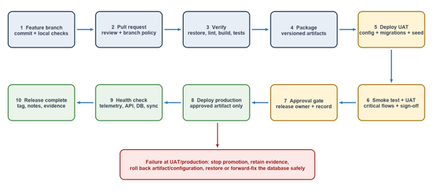
Figure 19 CI/CD pipeline flow

Testing within DevOps
- Unit tests for important business logic and validation.
- API/integration tests for authentication, authorisation, database operations and core job-card workflows.
- Security tests for access control and common input vulnerabilities.
- Mobile tests covering the core technician workflow.
- User Acceptance Testing with representative Verteco stakeholders.

DevOps in Practice: Final Status and Response to Task 2 Feedback
Task 1 described the intended branching strategy, pull-request process and CI/CD pipeline at a planning level. This subsection records what was actually used and built, and responds directly to the Task 2 Code and Implementation feedback (GitHub Branching & Workflow: 7/15; GitHub CI/CD & Pipelines: 9/20) and to the module lecturer’s follow-up reply that this needed to be “added to a Report (Document) and discussed.”
Branching and pull requests in practice. During Task 2, the six-member team collaborated in a dedicated Task 2 repository using one feature branch per person or per feature area (for example Web-Backend,-API-and-Reporting, Web-Front-End-Lead, Web-Security,-Identity-and-Notifications-Lead, mobile-integration, and person6-mobile-security-devops), each merged into main through a reviewed pull request; sixteen pull-request and branch-merge commits are recorded in the Task 2 repository’s history. This matches the branching discipline described at Task 1. Branch protection on the final-project repository requires a pull request, a review and passing CI checks before a change can reach main.
Where the discipline slipped. During the final days before the Task 3 deadline, several late-stage fixes and refinements - the offline-sync and multi-photo-capture work, the notifications redesign, the mobile app icon change, and documentation updates - were committed directly to main rather than through a feature branch and pull request. This was identified by the team while preparing this report, by reviewing the commit history, and is recorded here honestly rather than left unaddressed: under time pressure, the team prioritised getting working, tested changes merged quickly over maintaining the same branching discipline used earlier in the project. The team’s agreed correction, to apply from this point forward, is that every change - including a small or late-stage one - goes through a short-lived feature branch and a pull request before merging, so that the review and CI gate that branch protection is meant to provide is never bypassed, even under deadline pressure.
The final CI/CD pipeline. Five GitHub Actions workflows now run against the final-project repository:
- SmartJob CI - runs on every pull request and push to main or develop; restores the .NET 10 solution, runs static analysis at error severity, builds in Release configuration, and runs the automated test project.
- SmartJob All Tests - runs dotnet test across the whole solution with no filter, collects TRX results and code-coverage data, and uploads them as a retained artefact even when a test fails, so a failure is never silently lost. The full automated suite (63 tests at the time of writing) passes.
- SmartJob Main Tests - a reusable workflow, called by Main Deploy, that re-runs the full build-and-test gate specifically against the commit that is about to be deployed.
- SmartJob Main Deploy - triggered only by a push to main; calls Main Tests first, and only if that succeeds does it publish and deploy the API and the web application separately to their Azure App Services, then polls each application’s health-ready and health-live endpoints before considering the deployment successful. A concurrency group prevents two deploys from overlapping.
- SmartJob Android Build - builds an unsigned APK on a pull request, so pull-request builds never need the production signing secrets, or a signed release APK on a push or manual run, using a keystore and passwords stored as encrypted GitHub Secrets, and uploads the APK as a retained build artefact.
At the time of writing, all five workflows pass on the final-project repository’s main branch, and the hosted API and web application are both reachable and reporting healthy.

Running Costs
SmartJob is proposed as an Azure-hosted solution using managed cloud services. The final commercial estimate should be generated from Microsoft’s Azure Pricing Calculator because Azure costs depend on region, service tier, currency, storage, bandwidth and utilisation. Microsoft provides the calculator to estimate combinations of Azure products and supports changing the estimate currency.

Pricing basis and assumptions

Input | Pilot / initial | Year 1 | Year 2
Active users | 5-10 | 10-50 | 51-100
Job cards per month | 50 | 120 | 300
Evidence per job | 10 files | 12 files | 12 files
Average evidence size | 1.5 MB | 1.5 MB | 1.5 MB
New evidence/month | 0.75 GB | 2.16 GB | 5.40 GB

Month by month cost projection
Component | Pilot / initial | Year 1 | Year 2
App Service | R320 | R420 | R650
Azure SQL Database | R420 | R520 | R650
Blob Storage | R60 | R90 | R150
Key Vault | R20 | R20 | R25
Application Insights / Monitor | R80 | R110 | R150
DNS and bandwidth | R70 | R100 | R120
Contingency / price and usage variance | R180 | R180 | R165
Estimated monthly total | R1,150 | R1,440 | R1,910
Estimated annual total | R13,800 | R17,280 | R22,920

Scalability Estimate
Year 2 users / jobs | Estimated monthly cost | Interpretation and action
Up to 50 users / 150 jobs | R1,550 | Remain on lower tiers, review any under used resources.
51-100 users / 300 jobs | R1,910 | Within the ceiling but with little headroom. Budgets and alert need to be enabled.
101-150 users / 500 jobs | R2,550 | Exceeds the ceiling. Client approval or architecture/tier optimisation is required.

Cost Control
Azure Cost Management can be used to monitor spending, create budgets and alerts, identify anomalies and support rightsizing. Microsoft states that Cost Management is available at no additional cost for Azure customers.
- Set a monthly budget and alerts.
- Review resource utilisation and right-size services.
- Keep large photographs/documents in object storage rather than the relational database.
- Archive or delete data according to Verteco’s retention requirements.
- Review storage and bandwidth growth as usage increases.

Change Management and Handover
SmartJob represents a process change for Verteco because the supplied existing workflow includes job-card information, site photographs, commissioning evidence, serial numbers and technician/client sign-off. The change plan therefore focuses on moving users from the existing process toward a central SmartJob workflow while reducing disruption.

Adoption Objectives
- Make the SmartJob workflow more centralised than the existing process.
- Ensure technicians can complete required job information from site.
- Ensure managers can review and approve work.
- Ensure authorised managers can manage users, records and reports.
- Maintain business continuity during the transition.

Resistance to Change
Risk | Why it may occur | Response
Resistance to change | Staff are comfortable with the current process. | Early demonstrations, stakeholder involvement and a pilot.
Low technical confidence | Some users may be unfamiliar with the new interface. | Role-based hands-on training and simple guides.
Duplicate work during transition | Users may need to use existing and new processes temporarily. | Clearly define the parallel-run period and which system is authoritative.
Connectivity issues | Technicians may work at sites with poor connectivity. | Mobile-first design and an explicitly tested offline/poor-connectivity strategy.

Training
Training will be role-based. Technicians will practise the mobile job-card workflow, photographs, inspection information and submission. Managers will practise assignment, review, approval, reporting and user management functions. Training will use demonstrations, hands-on sessions, a quick start guide and FAQs.

Pilot Rollout
A small representative pilot will be conducted before full deployment. The pilot includes technicians and managers. The purpose is to test real job workflows, identify usability issues, verify security and permissions, and collect feedback before wider rollout.

Parallel Transition
Because SafetyCulture is part of the existing process described to the group, SmartJob should be introduced through a controlled transition. Where operationally appropriate, SmartJob and the existing SafetyCulture process can run in parallel for a defined period.

Handover Package
- Source-code repository and branch/release information.
- System architecture and deployment documentation.
- Database/ERD and schema documentation.
- API documentation and testing information.
- User guide and administrator guide.
- Configuration and environment-variable guidance without exposing secrets.
- Known issues, support contacts and maintenance procedures.

Post-Implementation Support
The project includes an agreed post-implementation support period covering critical bug fixes, user assistance, monitoring, issue resolution and feedback collection. After the agreed support period, operational ownership should transfer to Verteco’s nominated support personnel.

Adoption Roadmap
Phase | Activity | Duration
1 | Awareness and stakeholder communication | Week 1
2 | Training preparation | Week 2
3 | User training | Week 3
4 | Pilot deployment | Weeks 4-7
5 | Feedback and improvements | Week 8
6 | Controlled parallel transition | Weeks 9-12
7 | Full SmartJob deployment/cut-over | Week 13
8 | Support and handover | Weeks 14-18

Final Training, Handover and Support Status
Task 1 proposed a change-management and handover plan at a conceptual level (scored 14/20, short of “detailed training plans, handover, transition support and a clear roadmap”). For this final submission, that plan has been made concrete against the system as it was actually delivered:
- Training: the User Guide (Version 5) walks a new user through every screen of both the manager web console and the technician mobile app, including the demonstration sign-in accounts used for training sessions, and is the primary training artefact handed to Verteco.
- Handover package: the handover package provided to Verteco consists of the User Guide, the hosted web and API URLs, the GitHub repository (containing the full source, commit history and the CI/CD configuration itself), the Android release APK, and this report. Administrative access to the Azure resources and the GitHub repository remains with the team’s designated repository administrator for the support window described below, and will be transferred to a Verteco-nominated administrator as part of project close-out.
- Transition support: the team remains available to Verteco for a defined post-implementation support window following final submission, to assist with first-use questions, minor configuration changes such as adding further manager or technician accounts, and any defects found during early real-world use, consistent with the support model described at Task 1.
- Adoption roadmap: Verteco’s confirmed usage projections - around 5 to 10 users and roughly 50 job cards per year initially, growing to 10 to 50 users and 50 to 200 job cards per year within the first year, and 51 to 100 users with 201 or more job cards per year by year two, as confirmed directly by the client - continue to inform the system’s scaling plan. No change to the current Azure tier is required for the first year’s volumes, with the next review point at the start of year two.

References

Microsoft (2024) Azure Retail Prices REST API overview. Microsoft Learn. Available at: https://learn.microsoft.com/en-us/rest/api/cost-management/retail-prices/azure-retail-prices (Accessed: 17 August 2026).
Microsoft (2026a) Local databases with SQLite-.NET MAUI. Microsoft Learn. Available at: https://learn.microsoft.com/dotnet/maui/data-cloud/database-sqlite (Accessed: 13 August 2026).
Microsoft (2026b) ASP.NET Core authorization. Microsoft Learn. Available at: https://learn.microsoft.com/aspnet/core/security/authorization/ (Accessed: 13 August 2026).
Microsoft (2026c) Set up staging environments in Azure App Service. Microsoft Learn. Available at: https://learn.microsoft.com/azure/app-service/deploy-staging-slots (Accessed: 13 August 2026).
Microsoft (2026d) Manage minimum TLS versions in Azure App Service. Microsoft Learn. Available at: https://learn.microsoft.com/azure/app-service/tls-minimum-version (Accessed: 13 August 2026).
Microsoft (2026e) Managed identities for Azure App Service. Microsoft Learn. Available at: https://learn.microsoft.com/azure/app-service/overview-managed-identity (Accessed: 13 August 2026).
Microsoft (2026f) Restore an Azure SQL Database from automated backups. Microsoft Learn. Available at: https://learn.microsoft.com/azure/azure-sql/database/recovery-using-backups (Accessed: 13 August 2026).
Microsoft (2026g) Azure App Service on Windows pricing. Available at: https://azure.microsoft.com/en-us/pricing/details/app-service/windows/ (Accessed: 17 August 2026).
Microsoft (2026h) Azure Blob Storage pricing. Available at: https://azure.microsoft.com/en-us/pricing/details/storage/blobs/ (Accessed: 17 August 2026).
Microsoft (2026i) Azure pricing calculator. Available at: https://azure.microsoft.com/en-us/pricing/calculator/ (Accessed: 17 August 2026).
Microsoft (2026j) Azure SQL Database Single Database pricing. Available at: https://azure.microsoft.com/en-us/pricing/details/azure-sql-database/single/ (Accessed: 17 August 2026).
Microsoft (2026k) Product availability by region. Available at: https://azure.microsoft.com/en-us/explore/global-infrastructure/products-by-region/table (Accessed: 17 August 2026).

